VERITAS Netbackup

Table of Contents
1.1 Introduction 3
1.2 Pre requisite. 4
1.3 Architecture 4
1.4 Installation of VERITAS Software on Master Server. 5
1.5 Get license key 8
1.6 GUI of backup software 10
1.7 Configure the tape and policies. 11
1.8 Create policies 19
1.9 Client installation. 23
1.10 Add client. 26
1.11 Test Case. 29
1.11.1 Backup 29
1.11.2 Backup Restoration. 34

Introduction

This document summarizes the configuration done for VERITAS Backup.
In this document we will describe the Networker backup Software details which include version, client, backup schedule, media agent, media details, etc. The main purpose of this document is to understand the brief overview & purpose of Backup software & backup details.

Pre requisite.

- License availability according to Client machine and tape library quantity.
- Hostname configured on master and Clients server.
- Netback up software availability on master and Client machine.
- IP / hostname reachable between Master and Client machine.
- YUM Configuration.
- SAN Zoning configured between master backup servers Tape Lib and also if you have any eternal Storage.
- Backup policies

Architecture

Installation of VERITAS Software on Master Server.

Start the installation.

Go to the location of software, where copied.

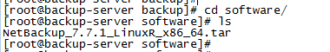

Untar the file with tar command.

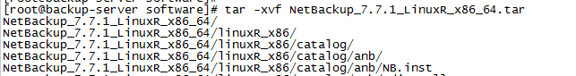

Once complete the tar process, in the same location we get the directory with same name.
Start Installation of Master backup software.

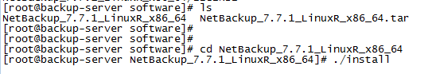

Then press Y for Continue the installation.

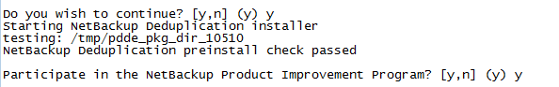

Path for installation, we have to allow using press y

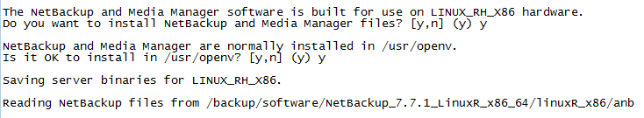

Adding license key during installation.

Add master backup license key to proceed the Installation.

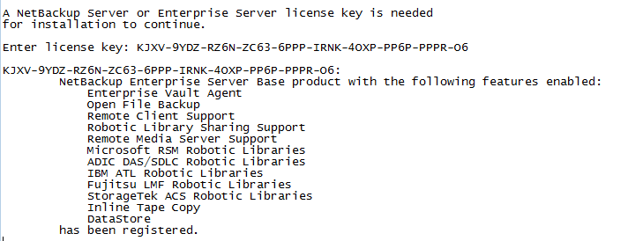

Adding additional license during master backup software installation for client machine or tape Library.

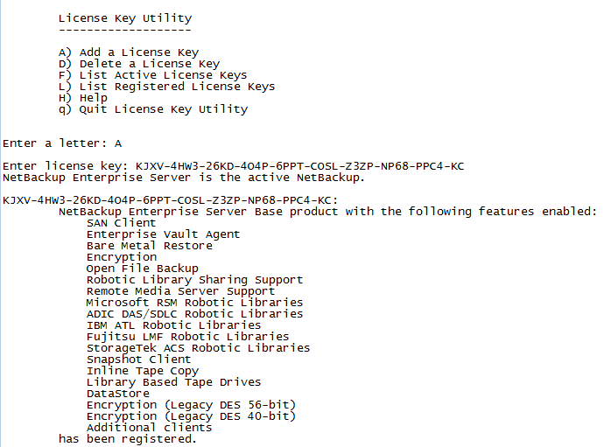

Adding additional license after Master backup software installation for client machine or tape Library etc.

Get license key

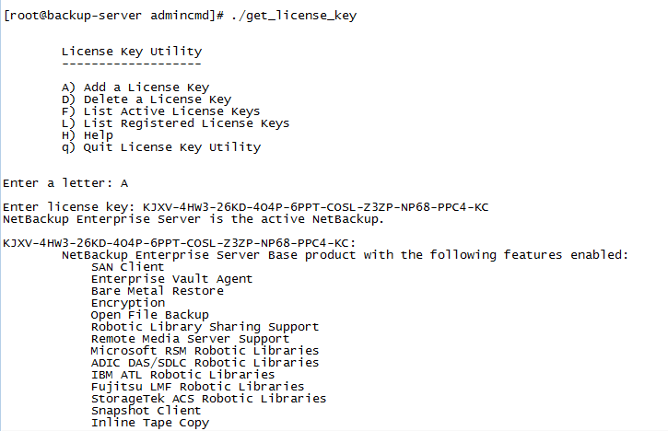

Confirm the backup servers hostname for proceed.
If any media servers need to add for SAN based backup we need to press “y” and mentioned the hostname,
If configuring LAN based backup please select “n”.

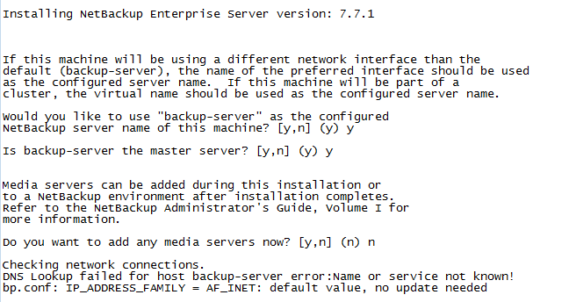

Software installation Completed on Master Server.
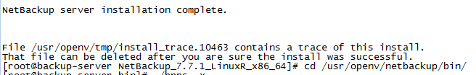

GUI of backup software

Go to the GUI of master backup using ILO or VNC.

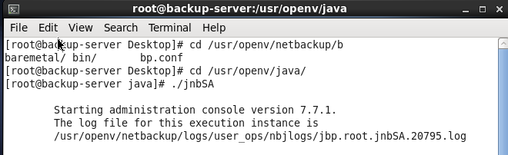

GUI will be Open, need to put root password for master server.

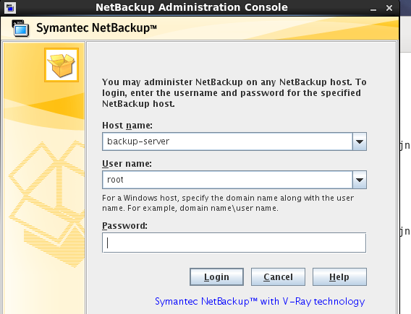

Configure the tape and policies.

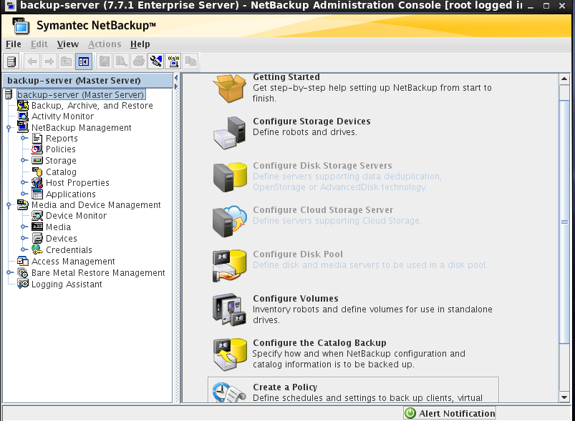

Reboot Configured with VERITAS software.

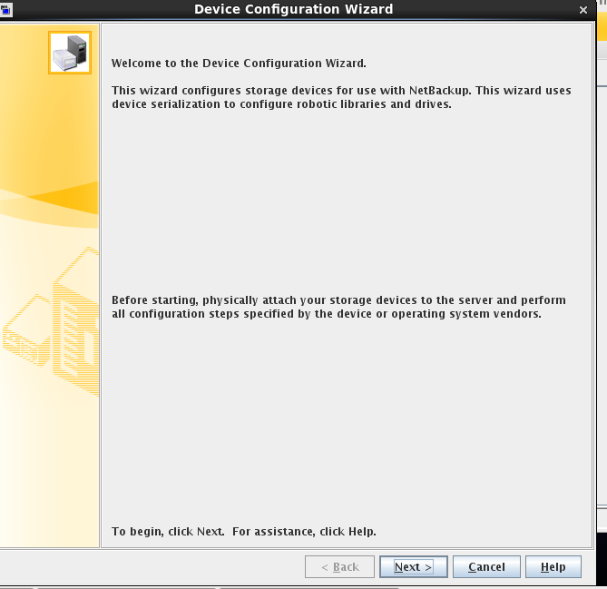

Tape detection with Backup sever.
Right click on backup and rescan and tape will auto discovered with Backup Server.
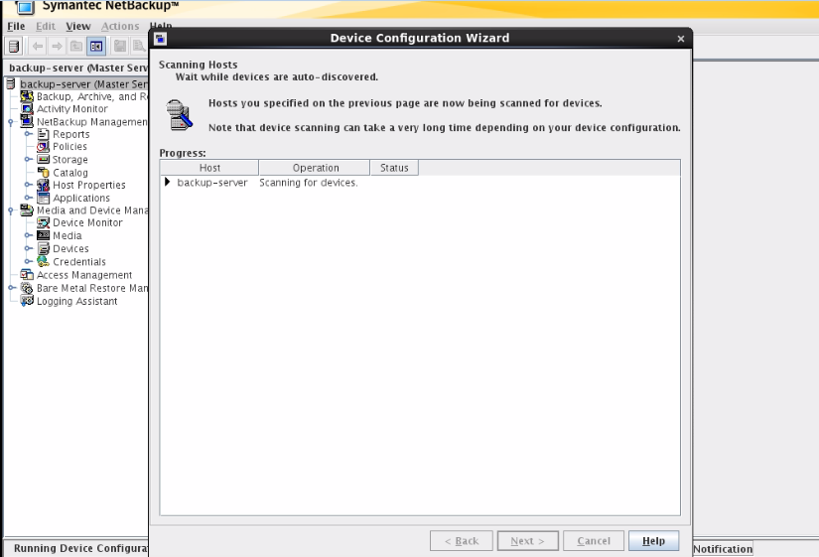

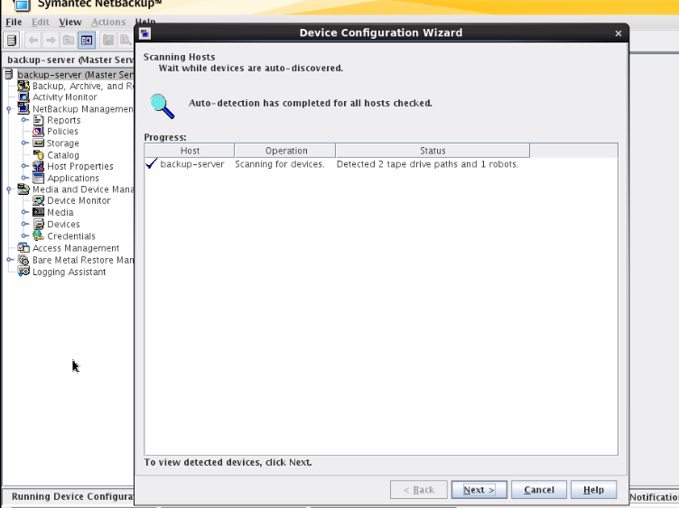

Click on Next.

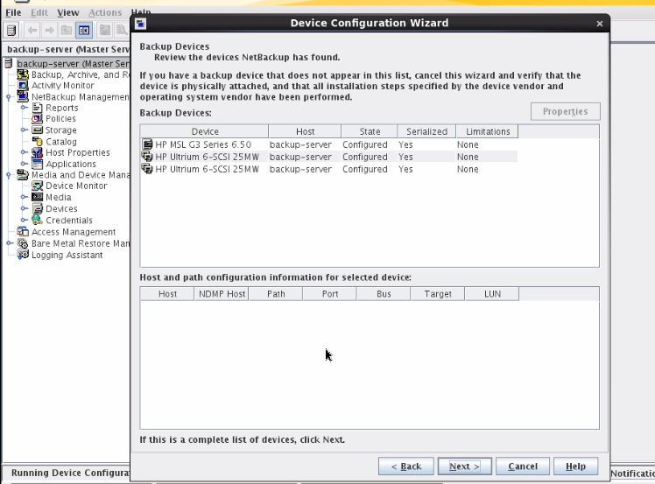

Select all the Drive then click on Next.

Click on Next then continue.

Click on continue for configure the drive.

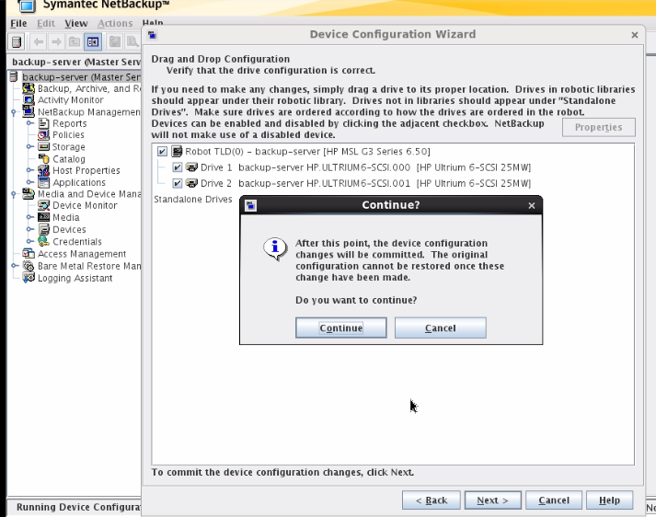

Next for configure the device with media Servers.

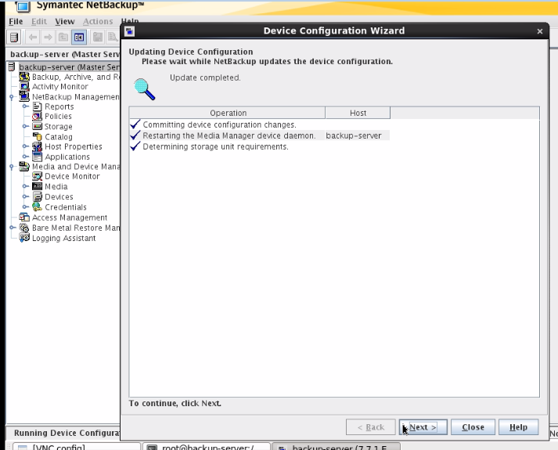

Next.

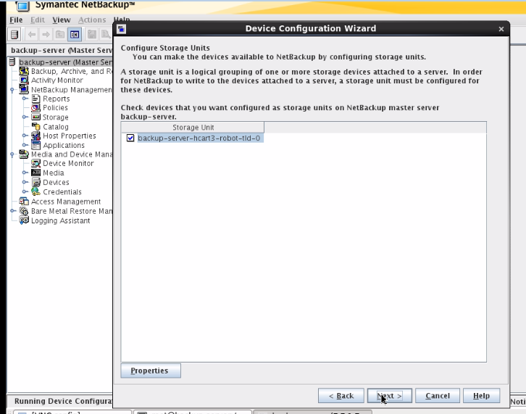

Next.
Display will come for successfully configured the Tape with backup server.

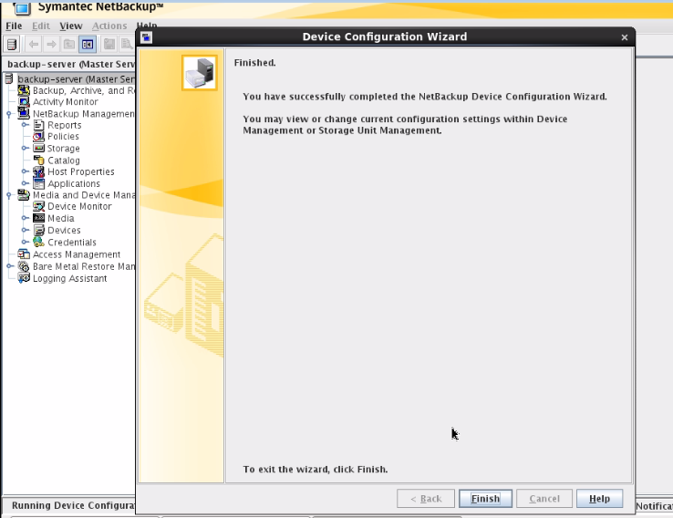

Go to Device Monitor to check external Tape Library.

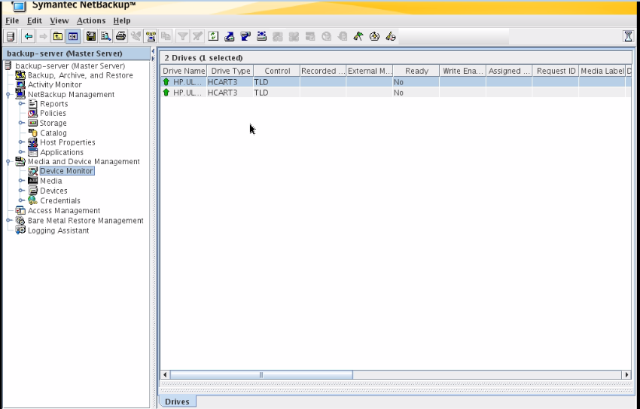

Create policies

S.No | Policy Name | Data to be Backed up | Backup Type | Backup Frequency | Backup Media Type | Name of Media Set | Backup client hostname | Mount Points (to be Backed up) | Backup window | Retention Period
1 | DB Backup | RMAN Backup | Full Backup | Daily | Storage Disk and Tape | DB_RMAN | Dbserver. | /backup/rman | 2:00 AM | 15 days
1 | DB Backup | Export Backup | Full Backup | Daily | Storage Disk and Tape | DB_EXPORT | Dbserver | /backup/export | 4:30 AM | 15 days

Right click on policies for new policy.
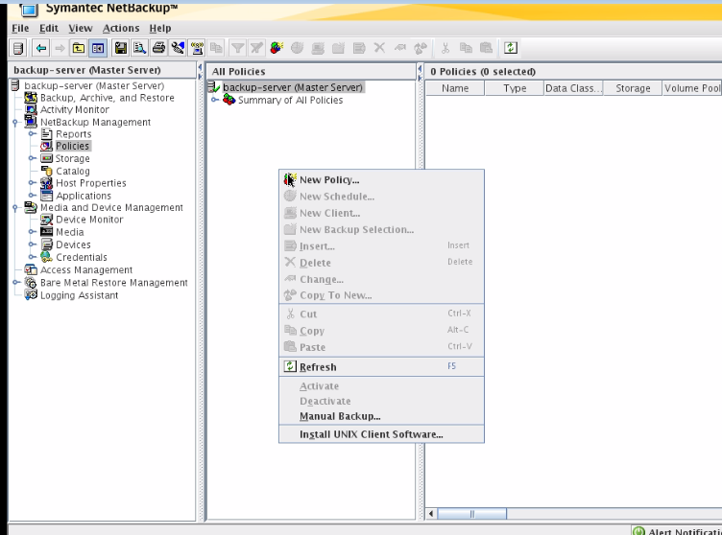

Define the policy name.
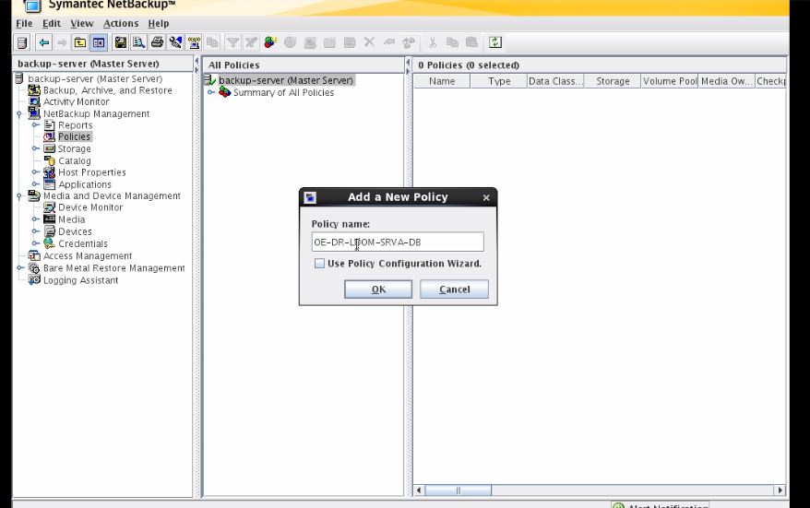

Select Tape Library for backup.

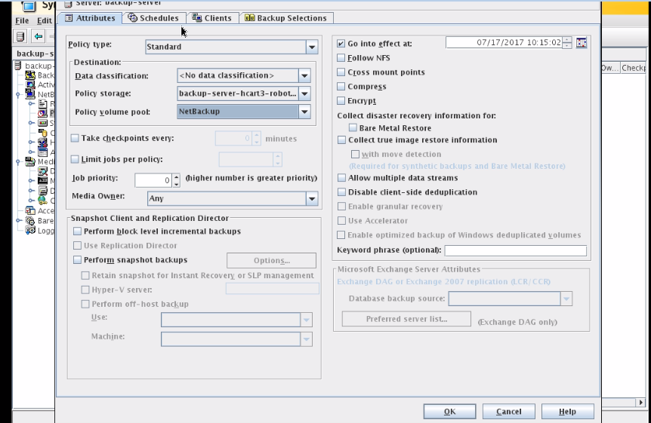

Policy schedule. For RMAN.

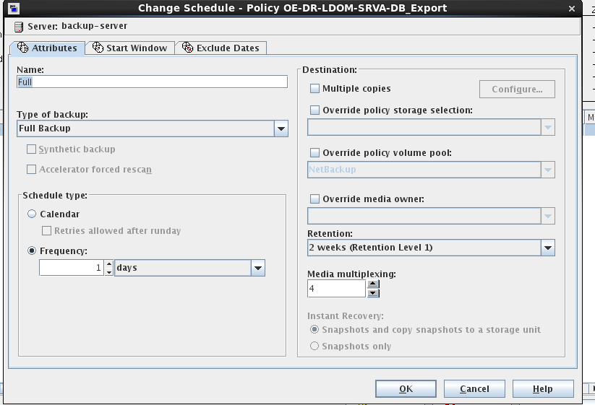

Select the timing/Day to start the backup.

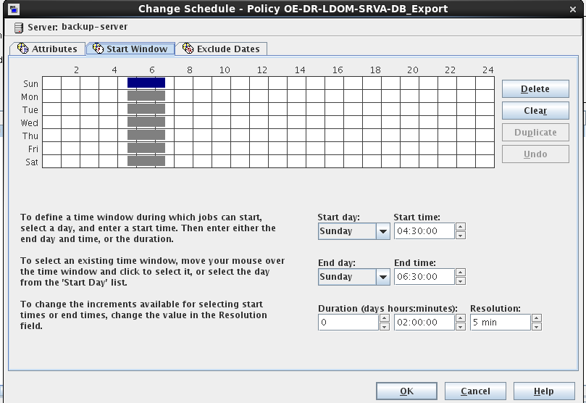

RMAN Backup will start every day from 4:30 AM to 6:30 AM.

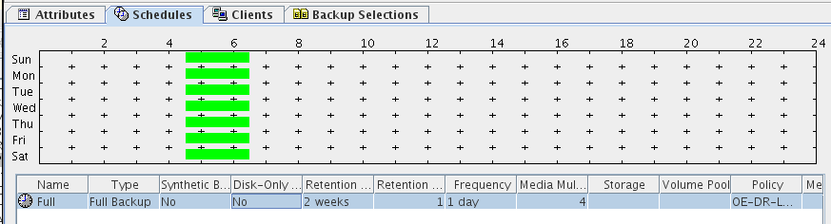

Client installation.

Go to the location of software, where copied.

cd /tmp

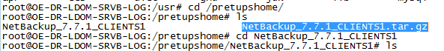

Untar the file.

tar –xvf “software name”

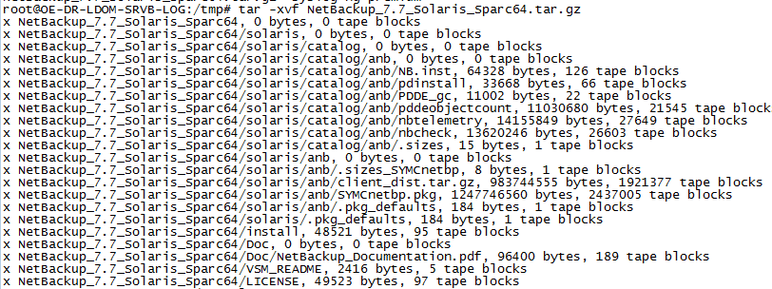

Installation of software.

cd “software name”
./install

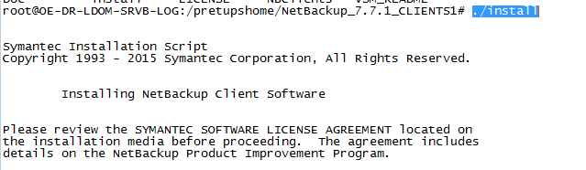

Then press Y for Continue the installation.

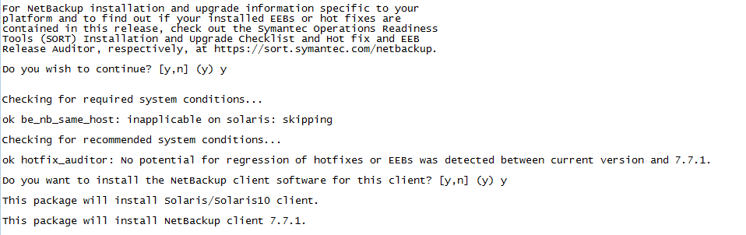

Add the hostname of backup server.

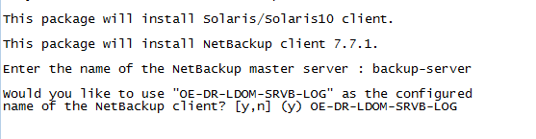

Press Y for proceed the Installation.

Successfully Completed Client Installation.
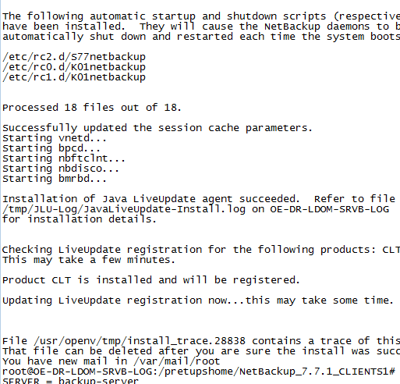

Add client.
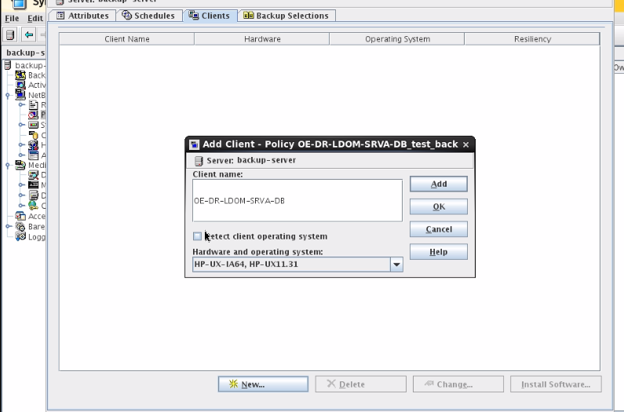

Selection of file system, which we need to take backup.
Go to the Browse.
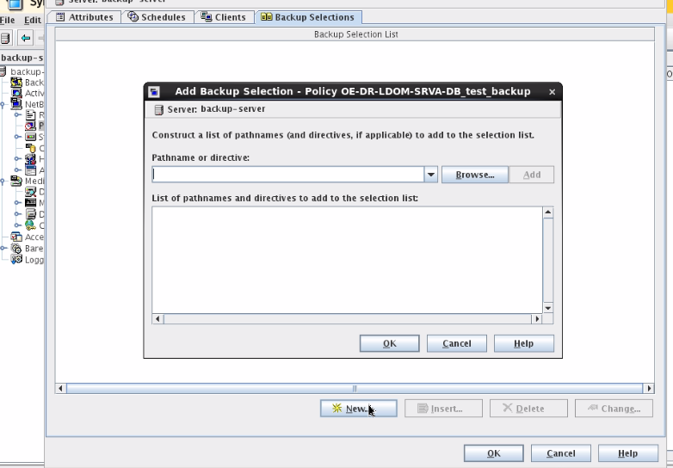

Select the file system for backup.

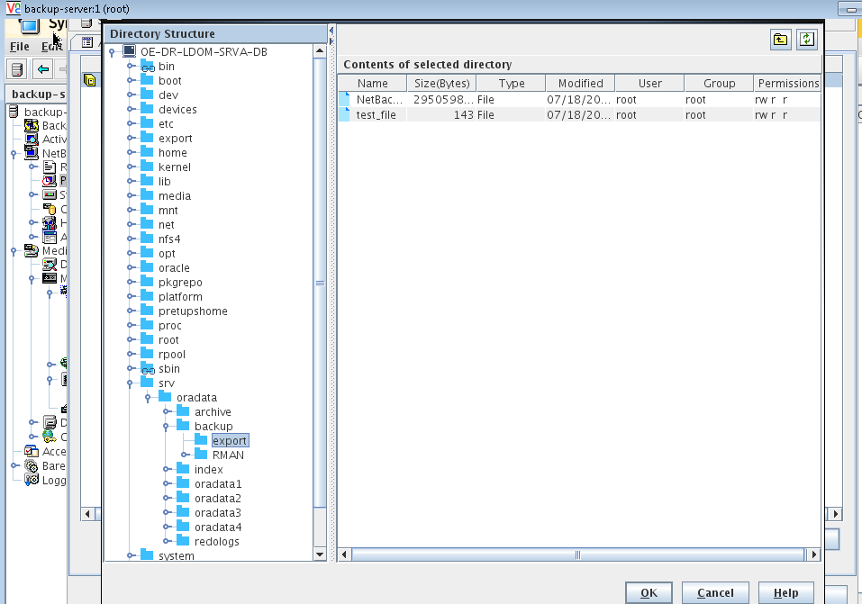

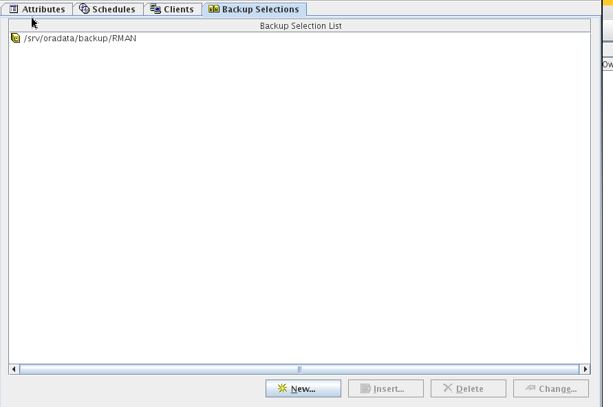

Click add and Ok.

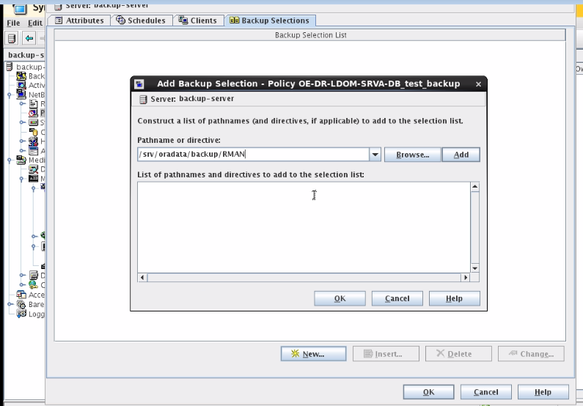

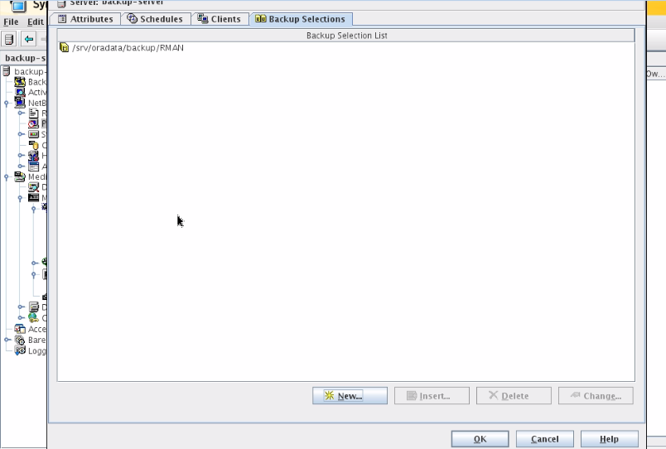

Test Case.

Backup

Start the manual backup.
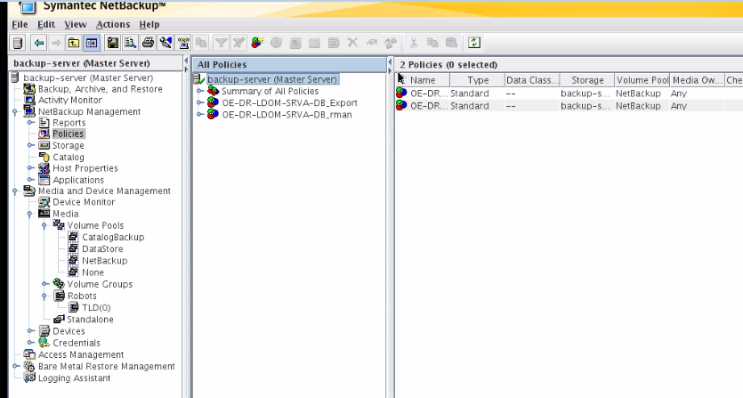

Activate the all the Media for Tape library.
Go to the Media => right click on TLD => inventory Robot.

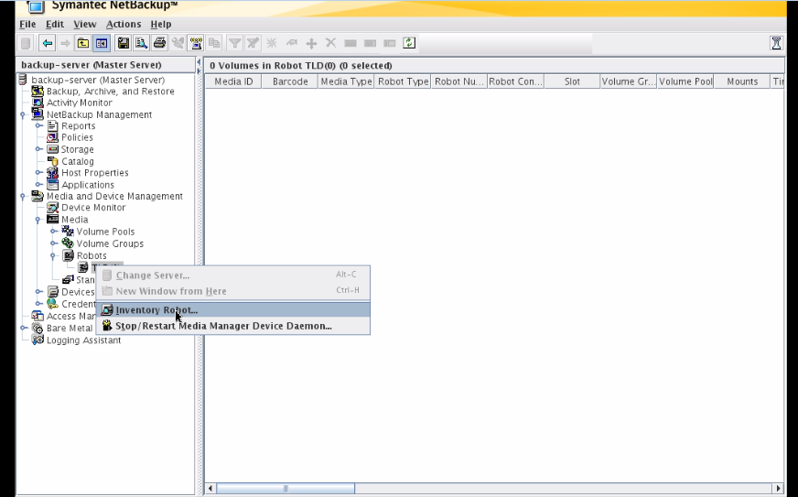

Start all the Media.

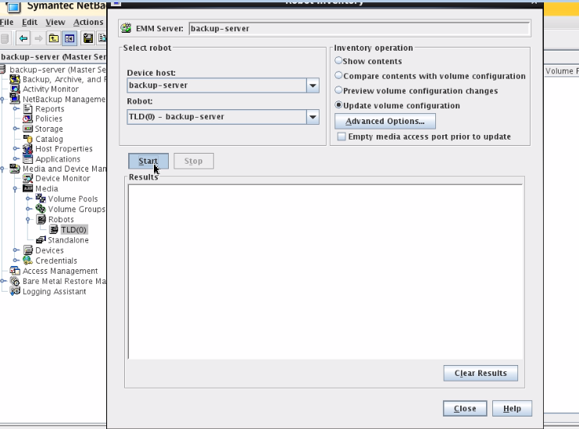

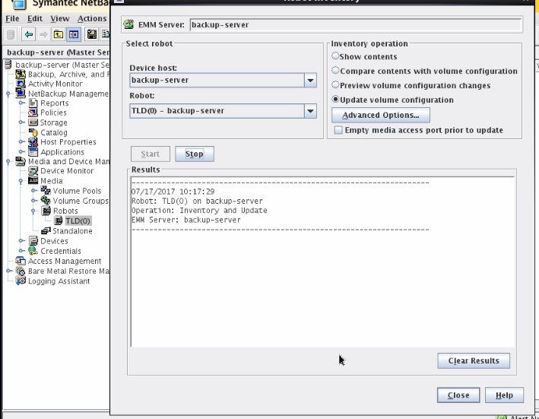

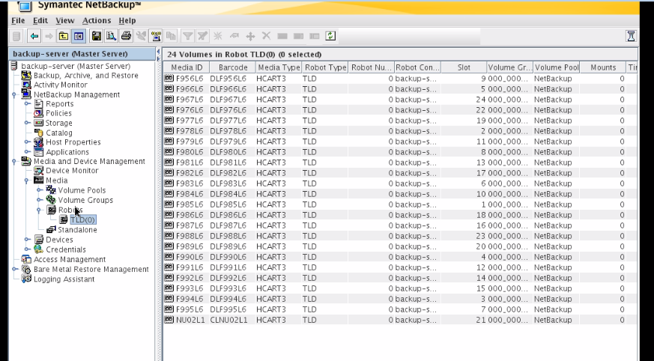

Then I can start manual backup.

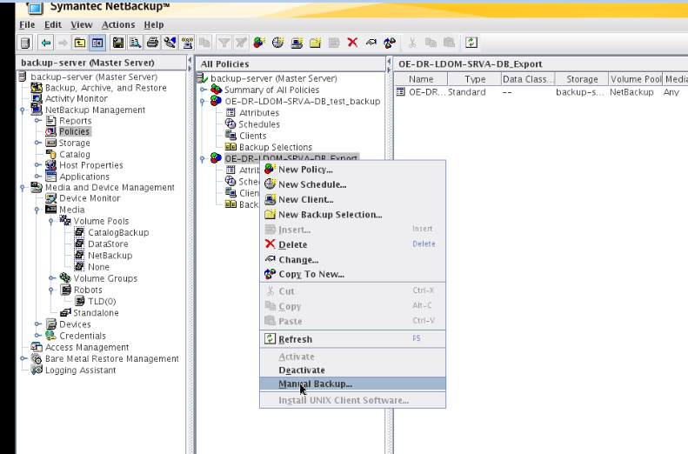

Click on OK.
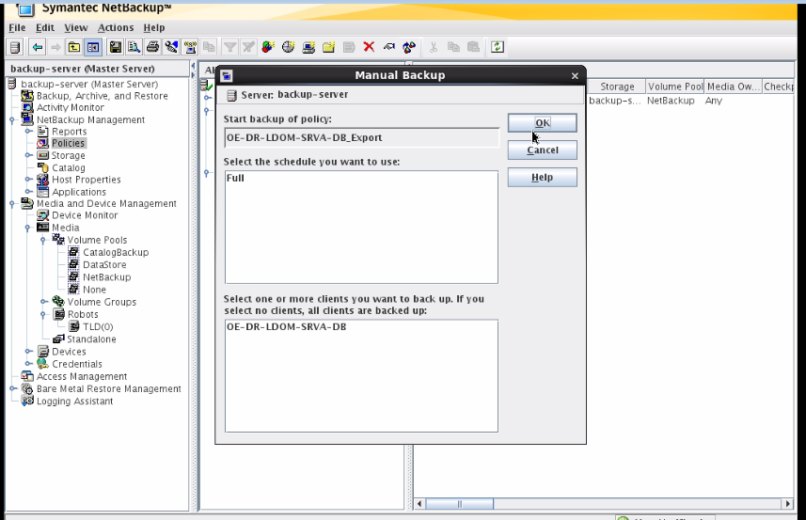

Go to the activity monitor and check the backup status.
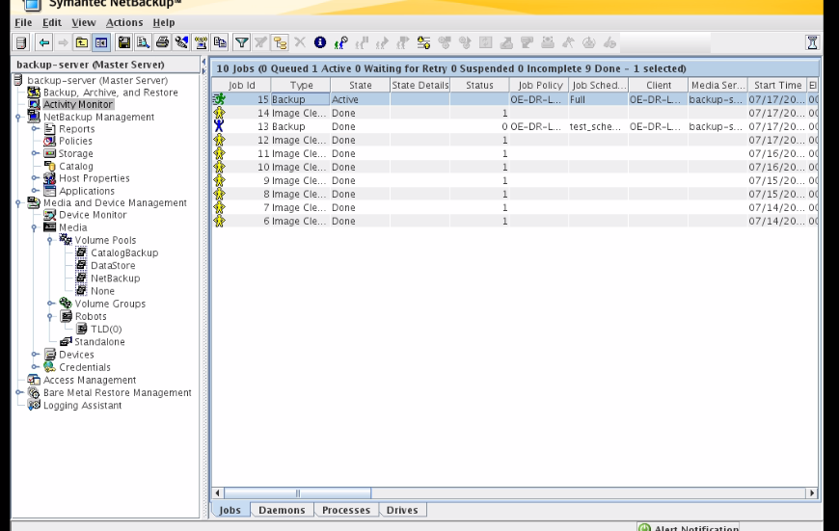

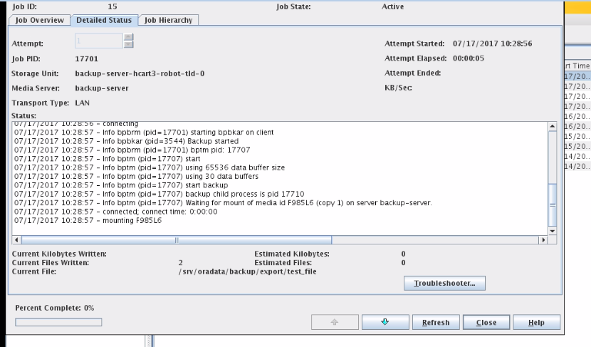

Backup successful.

Backup Restoration.
VERITAS portal is open now for restore the backup.

Click on backup, archive and restore.

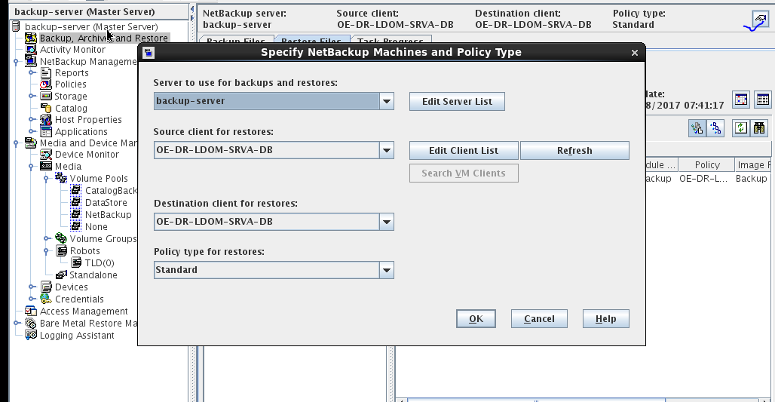

Select the Client server for restoring the data.

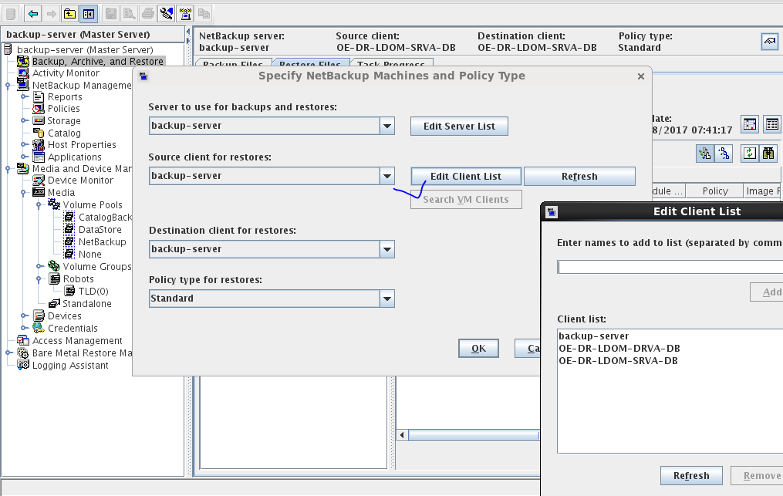

Backup file. Select which we will be restore.

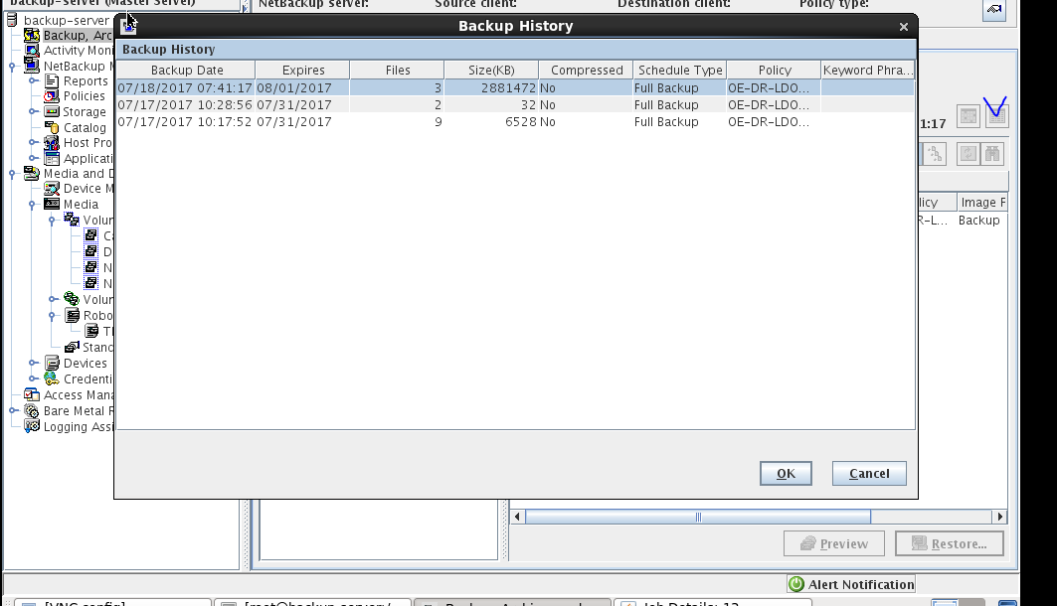

Selcect the third location where we will be restore.
Click on restore file.
Select browse directory.
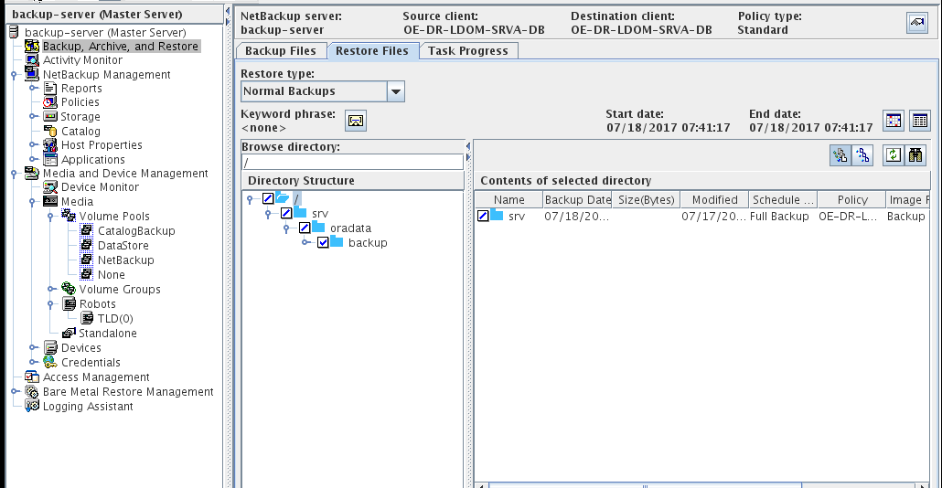

Start the restoration.

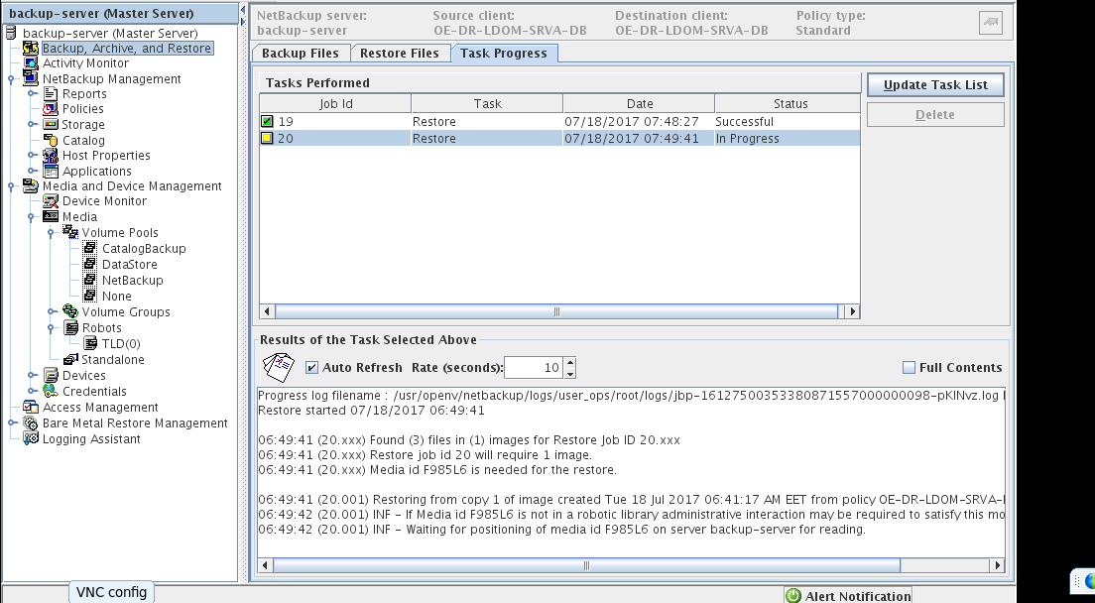

Successfully restore.

Disclaimer
Copyright © 2013: Comviva Technologies Ltd, Registered Office at A-26, Info City, Sector 34, Gurgaon-122001, Haryana, India.

All rights about this document are reserved and shall not be , in whole or in part, copied, photocopied, reproduced, translated, or reduced to any manner including but not limited to electronic, mechanical, machine readable ,photographic, optic recording or otherwise without prior consent, in writing, of Comviva Technologies Ltd (the Company).
The information in this document is subject to changes without notice. This describes only the product defined in the introduction of this documentation. This document is intended for the use of prospective customers of the Company Products Solutions and or Services for the sole purpose of the transaction for which the document is submitted. No part of it may be reproduced or transmitted in any form or manner whatsoever without the prior written permission of the company. The Customer, who/which assumes full responsibility for using the document appropriately. The Company welcomes customer comments as part of the process of continuous development and improvement.
The Company, has made all reasonable efforts to ensure that the information contained in the document are adequate, sufficient and free of material errors and omissions. The Company will, if necessary, explain issues, which may not be covered by the document. However, the Company does not assume any liability of whatsoever nature , for any errors in the document except the responsibility to provide correct information when any such error is brought to company’s knowledge. The Company will not be responsible, in any event, for errors in this document or for any damages, incidental or consequential, including monetary losses that might arise from the use of this document or of the information contained in it.
This document and the Products, Solutions and Services it describes are intellectual property of the Company and/or of the respective owners thereof, whether such IPR is registered, registrable, pending for registration, applied for registration or not.
The only warranties for the Company Products, Solutions and Services are set forth in the express warranty statements accompanying its products and services. Nothing herein should be construed as constituting an additional warranty. The Company shall not be liable for technical or editorial errors or omissions contained herein.

The Company logo is a trademark of the Company. Other products, names, logos mentioned in this document , if any , may be trademarks of their respective owners.

Copyright © 2013: Comviva Technologies Limited. All rights reserved.

Thank You
Visit us at www.mahindracomviva.com

Comviva Technologies Limited. All rights reserved.

