Networker Backup

Table of Contents

1.1 Introduction 3
1.2 Architecture 4
1.3 Prerequisite:- 4
1.4 Networker backup software installation 5
1.5 Configuration of backup server 15
1.6 Agent installation on client 18
1.7 Creating media pool and policy 19
1.8 Backup & Retention Policy. 21
1.9 Add Storage Device for backup. 27
1.10 Add Client and select path for backup 31
1.11 Test Case 36
1.11.1 Backup & Restoration 36

Introduction

This document summarizes the configuration done for Networker Backup.
In this document we will describe the Networker backup Software details which include version, client, backup schedule, media agent, media details, etc. The main purpose of this document is to understand the brief overview & purpose of Backup software & backup details.

Architecture

Scenario

Prerequisite:-
- 1 backup server details.
- Client Node details
- Networker software
- Java 1.8 or later.
- Yum configuration.
- Backup policies.

Networker backup software installation

Install networker rpm packages.
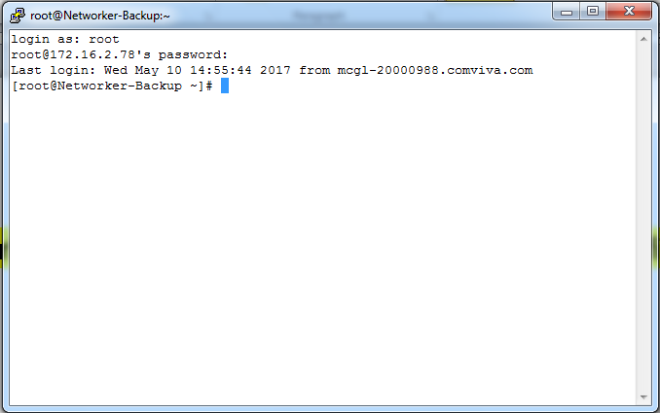

Client host entry in Backup server.
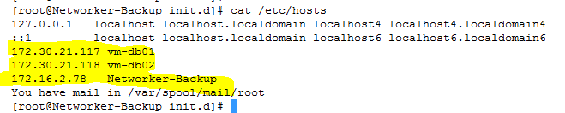

Package installation
#rpm –ivh lgtoclnt,
#rpm-ivh lgtonode,
#rpm –ivh lgroserv,
#rpm –ivh lgtonmc,
#rpm –ivh lgtoman
OR
# yum install lgtoclnt, lgtonode, lgroserv, lgtonmc, lgtoman
[root@Networker-Backup linux_x86_64]# yum install lgtoclnt-9.1.1.0-1.x86_64.rpm lgtonode-9.1.1.0-1.x86_64.rpm lgtoserv-9.1.1.0-1.x86_64.rpm lgtonmc-9.1.1.0-1.x86_64.rpm lgtoman-9.1.1.0-1.x86_64.rpm
#yum install lgtoserv-9.1.1.0-1.x86_64.rpm lgtoauthc-9.1.1.0-1.x86_64.rpm lgtoxtdclnt-9.1.1.0-1.x86_64.rpm
[root@Networker-Backup linux_x86_64]# yum install lgtoadpt-9.1.1.0-1.x86_64.rpm
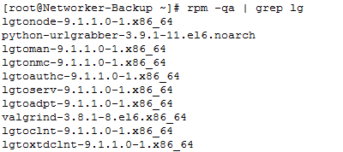
[root@Networker-Backup ~]# cd /etc/init.d/
[root@Networker-Backup init.d]# ./networker start
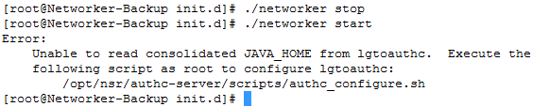

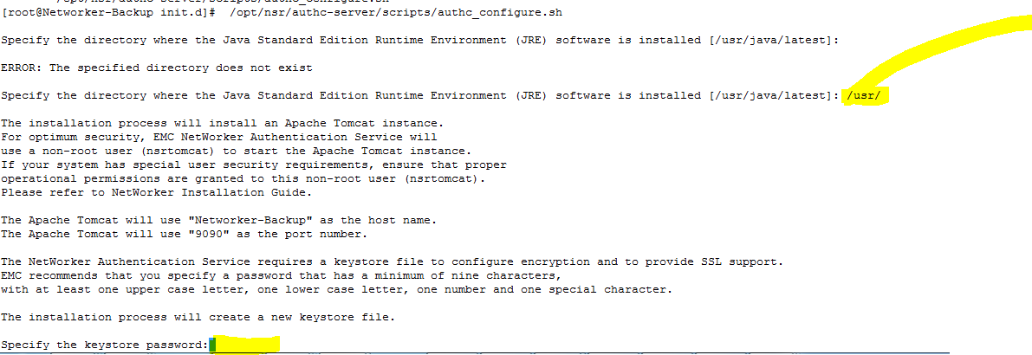
com@12345%
Com@12345%
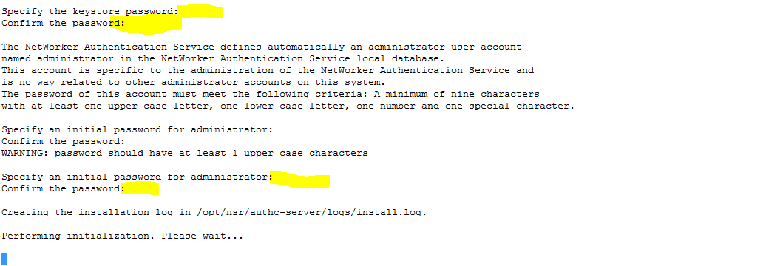
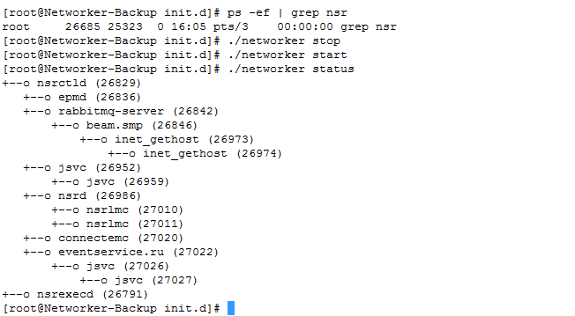
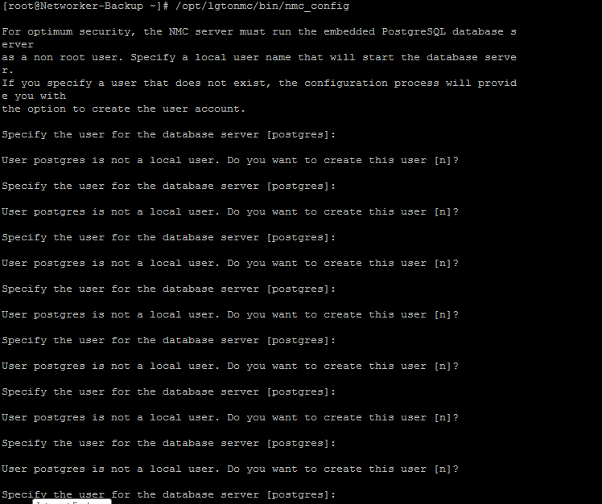
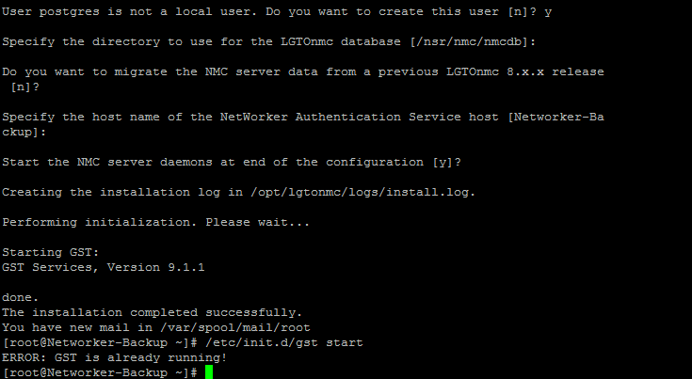
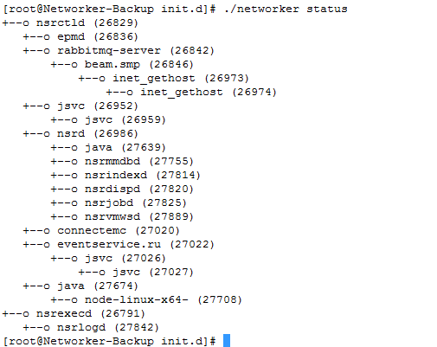

Now Go to Internet Explore and give the Networker Server IP and Port number https://172.16.2.78:9000 (PortNumber)
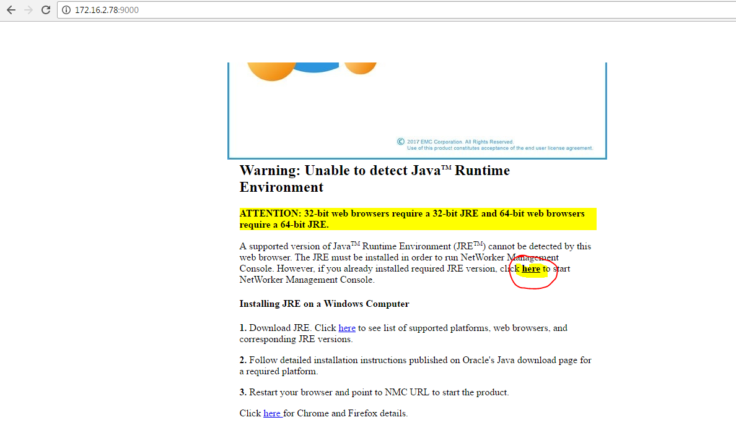
Provide “Userid & password”
Default Username: -administrator Password: - First Time Given by you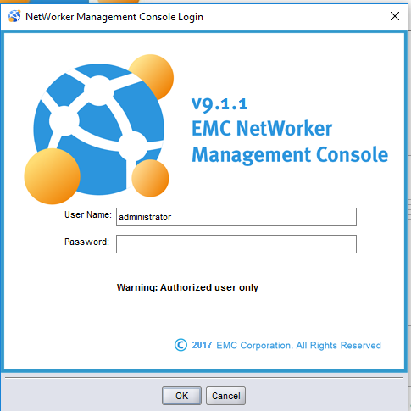
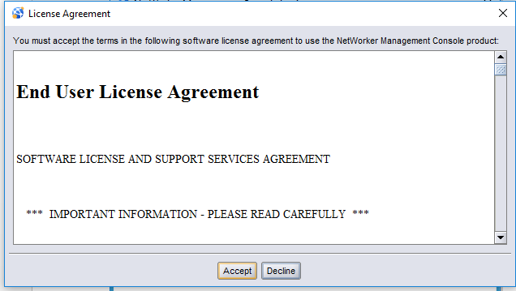

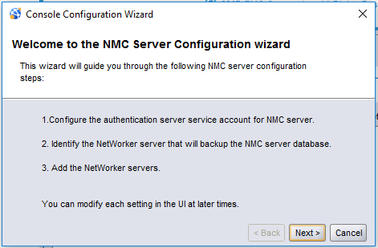
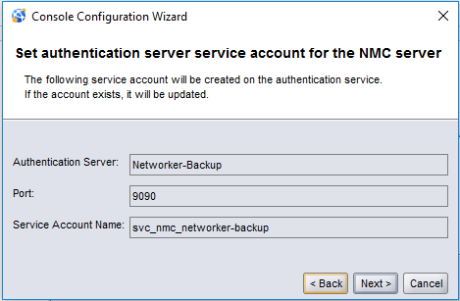

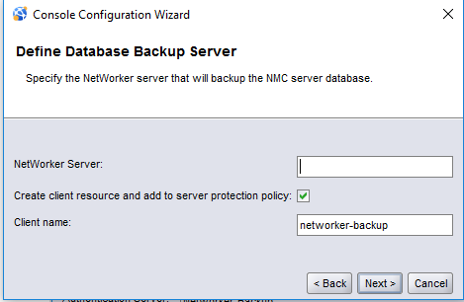
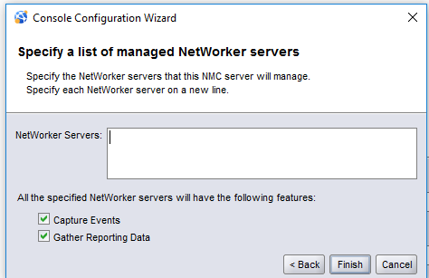

Configuration of backup server
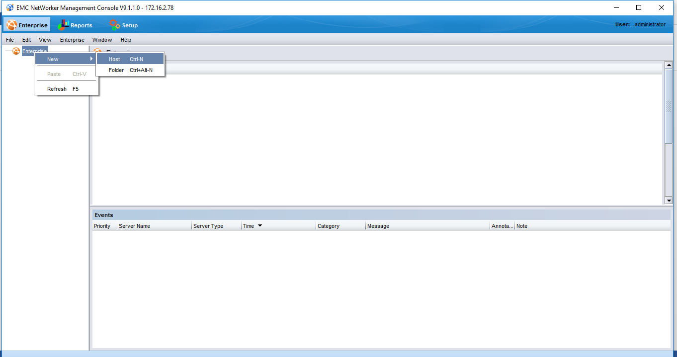
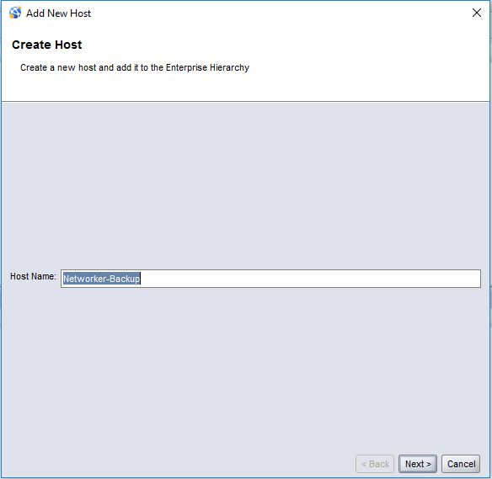
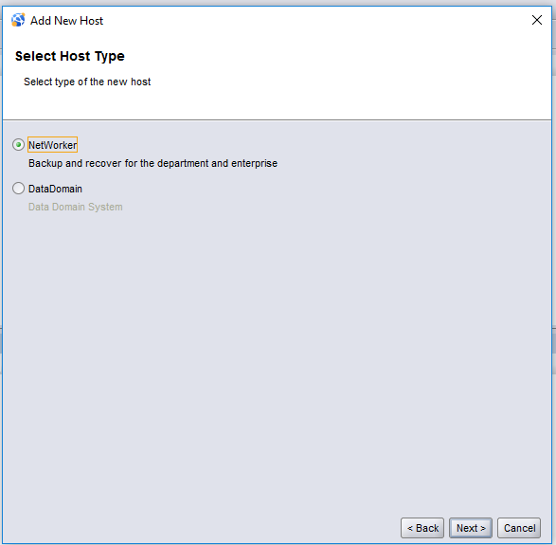
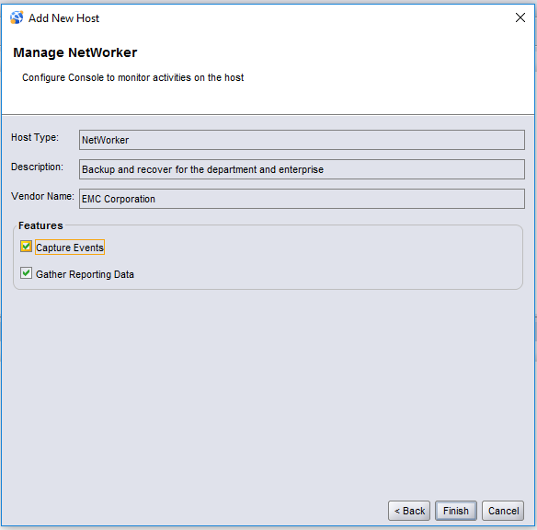

Click launch networker Administrator
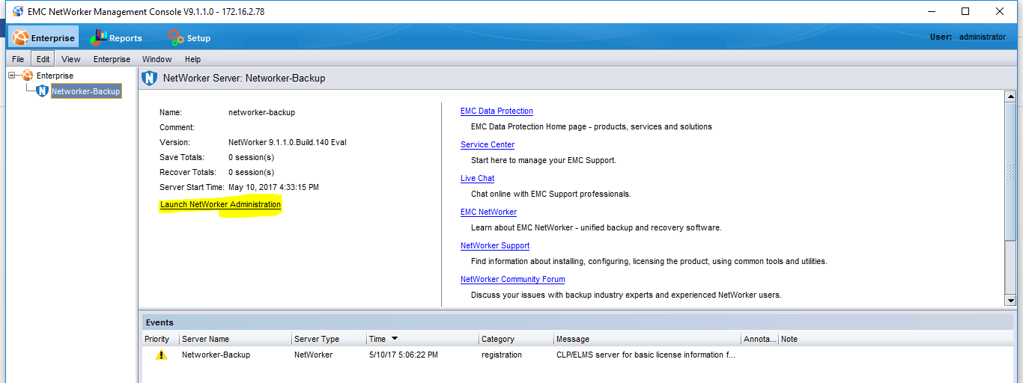

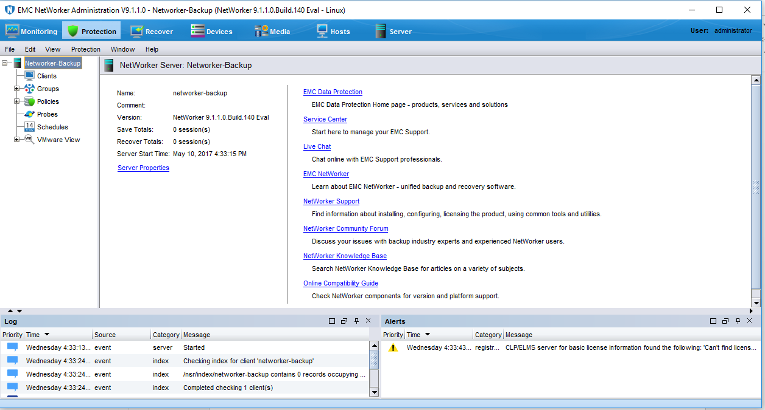

Agent installation on client
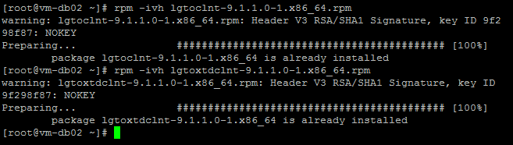

Creating media pool and policy

S.no | Policy Name | Media Pool | Storage device (Tape, SAN, Local Storage) | Backup Type | Backup window | Retention Period
1 | FS DB Policy | FS Pool | Local Storage | Daily Full (Sunday)  incremental (Mon-Sat) | Daily 09:00 PM | 1 month

Click media Tab => right click on Media pool
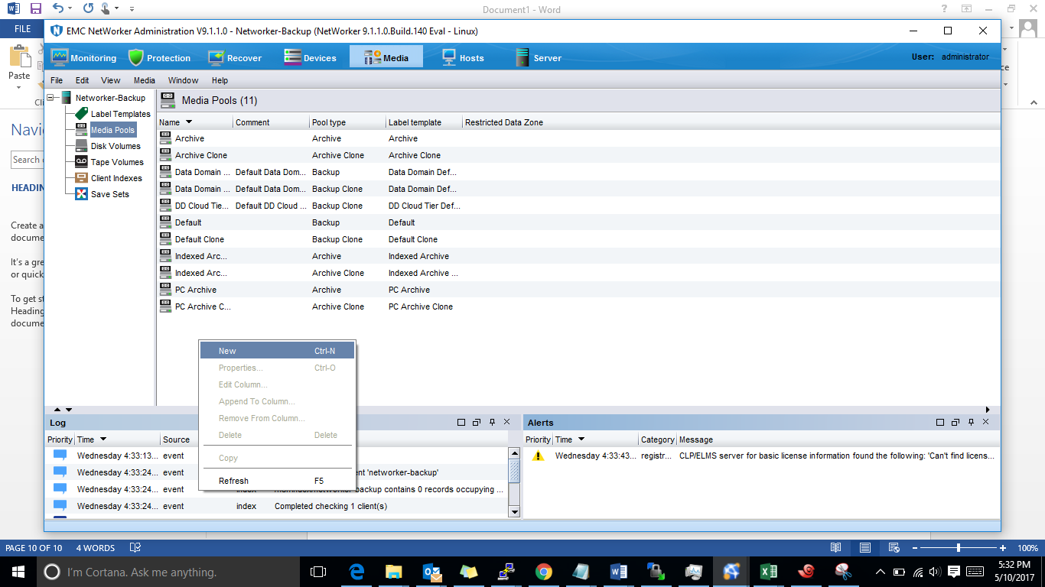

Provide pool name => check enable => pool type backup => OK

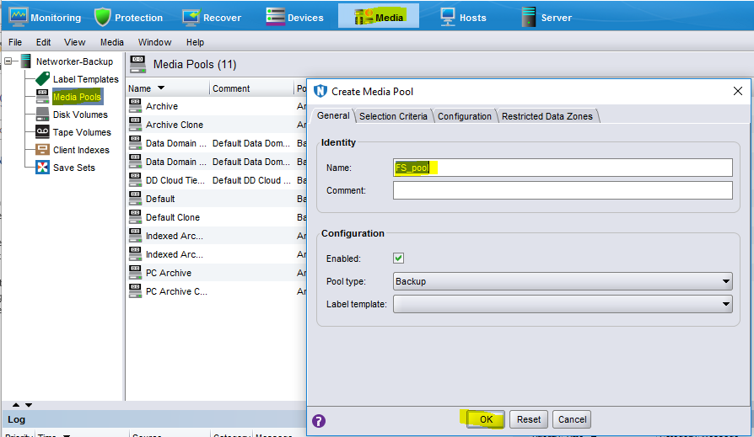

Create Policy.
Click protection Tab => right click on Policy > create new
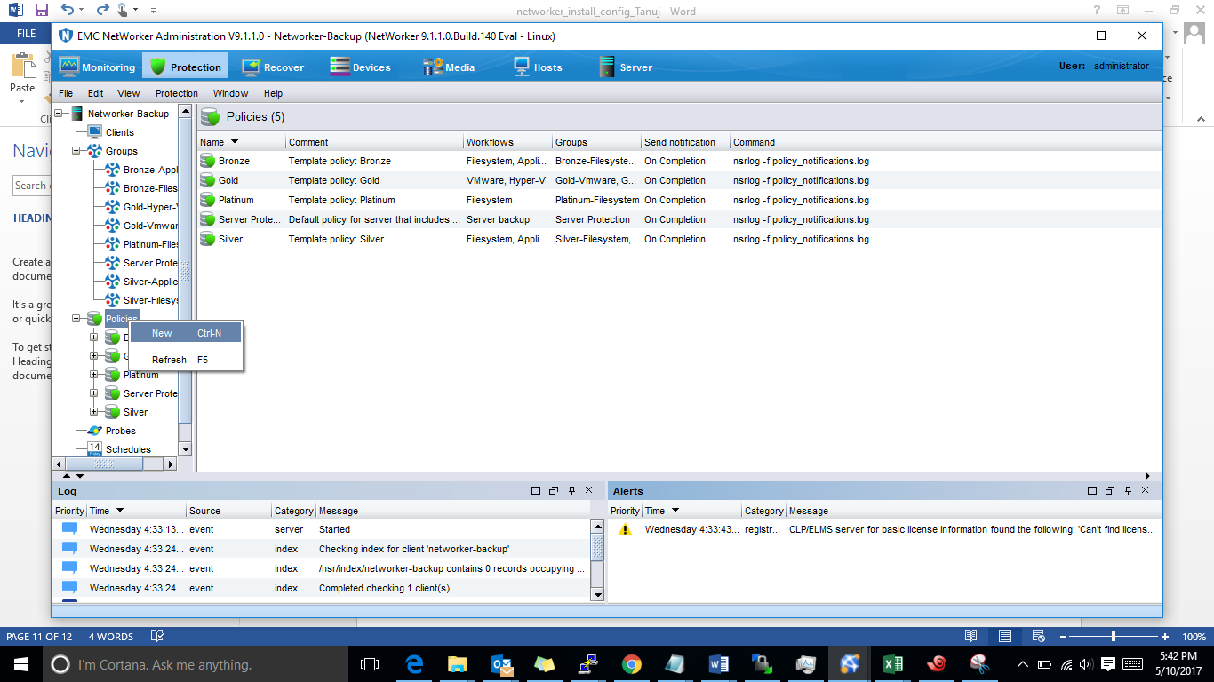
Provide policy name
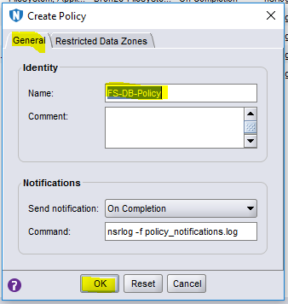

Backup & Retention Policy.

S.no | Policy Name | Media Pool | Storage device (Tape, SAN, Local Storage) | Backup Type | Backup window | Retention Period
1 | FS DB Policy | FS Pool | Local Storage | Daily Full (Sunday)  incremental (Mon-Sat) | Daily 09:00 PM | 1 month

Create workflow.
Right click created policy => click create a new workflow
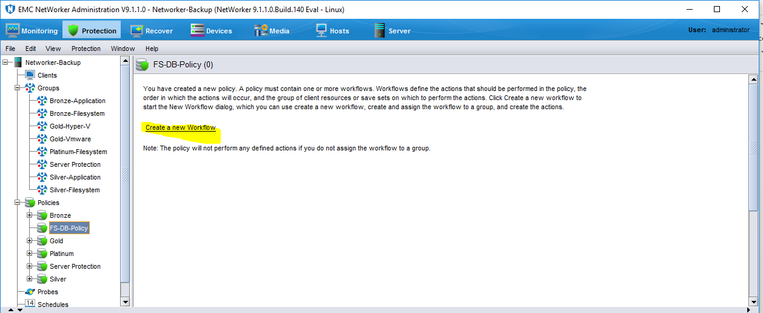

Provide Workflow name => give start time of backup = > add group => add
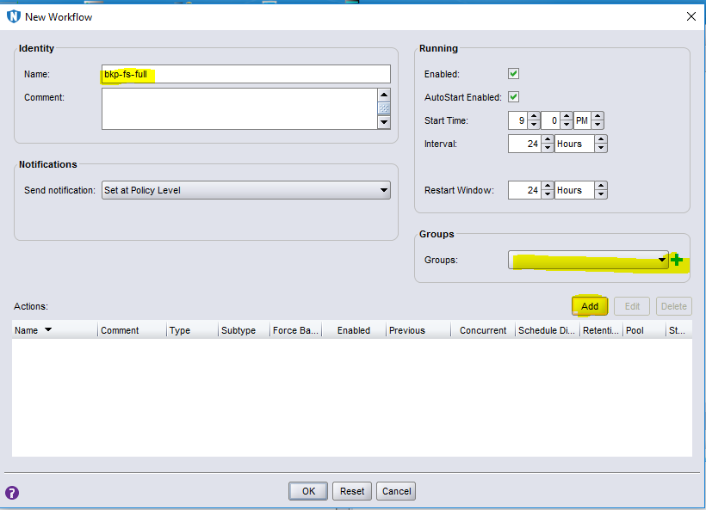
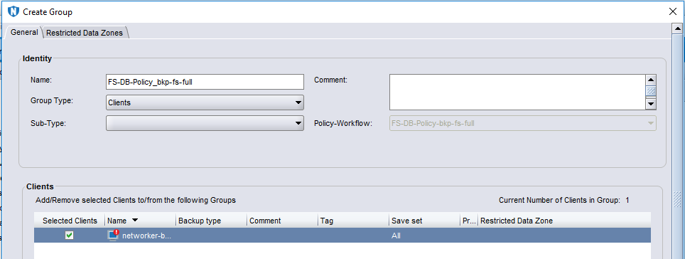
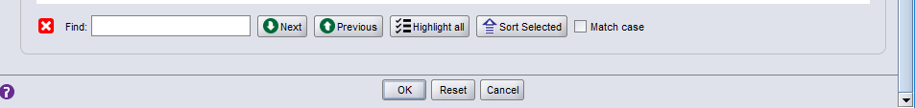

Create backup policy and provide days for full and incremental backup.
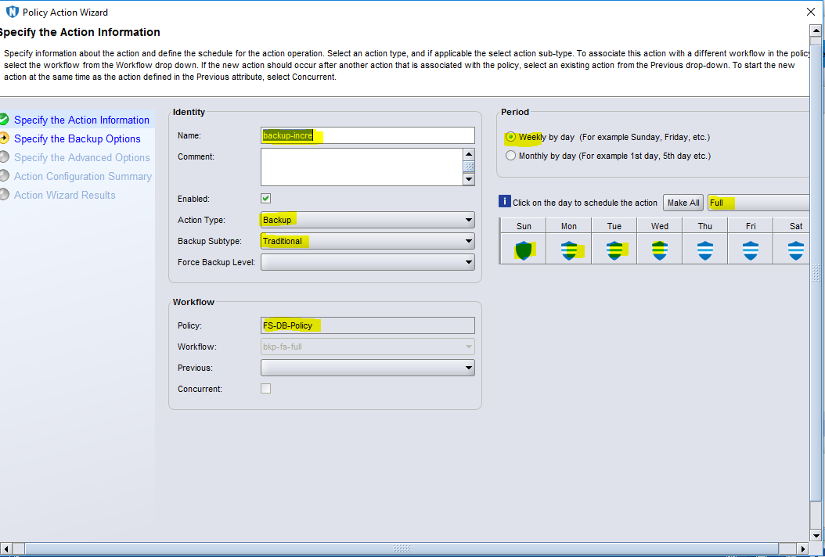

Click next => check on network server name => provide retention period and next.
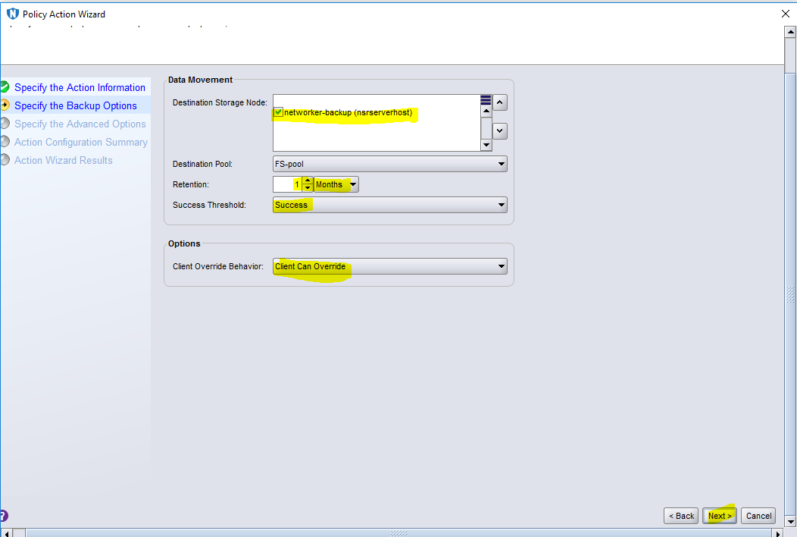
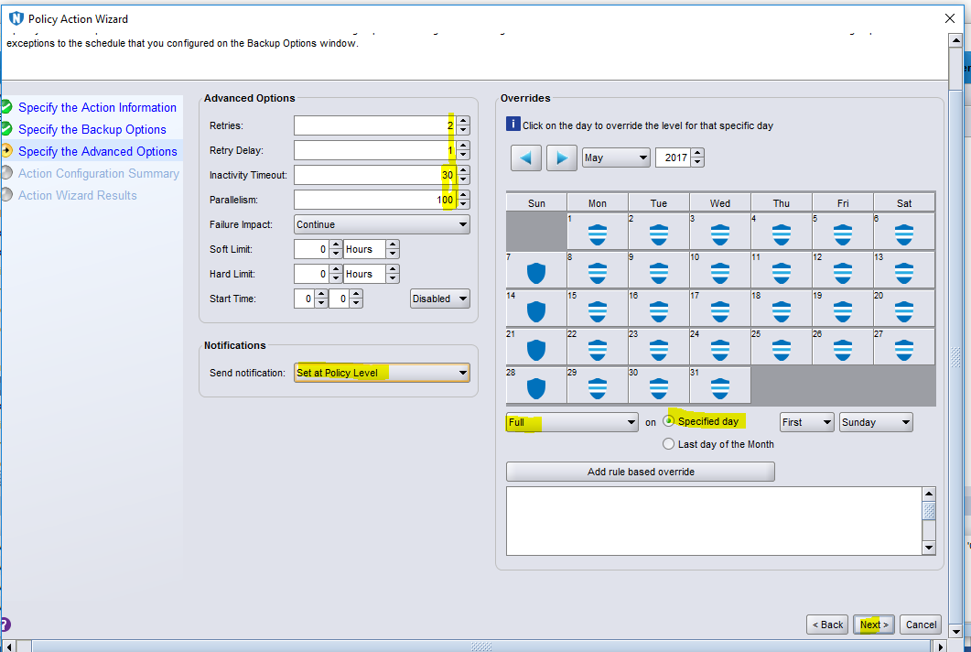
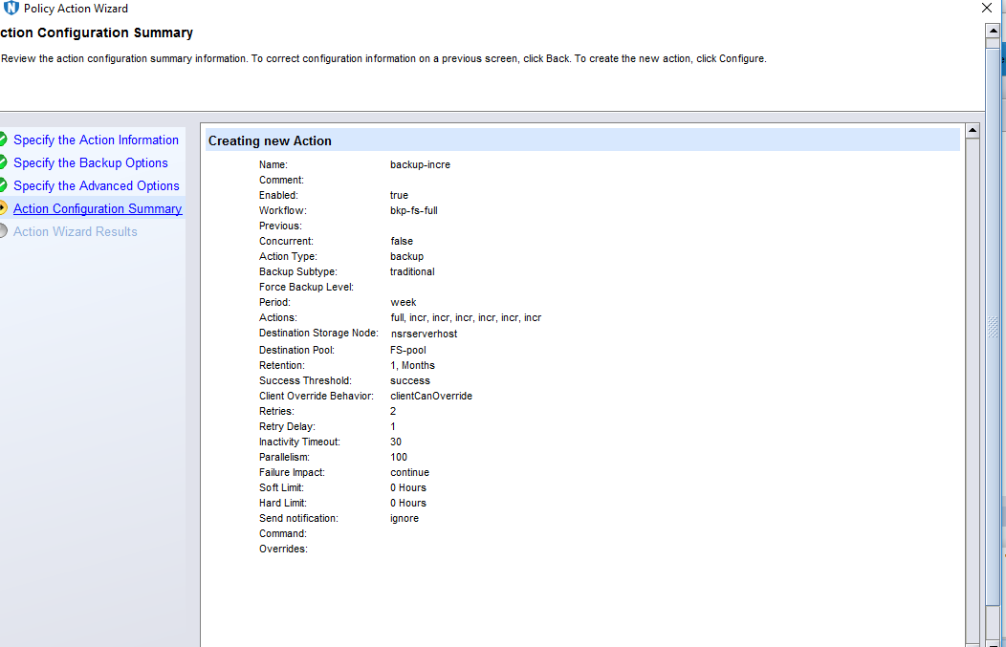
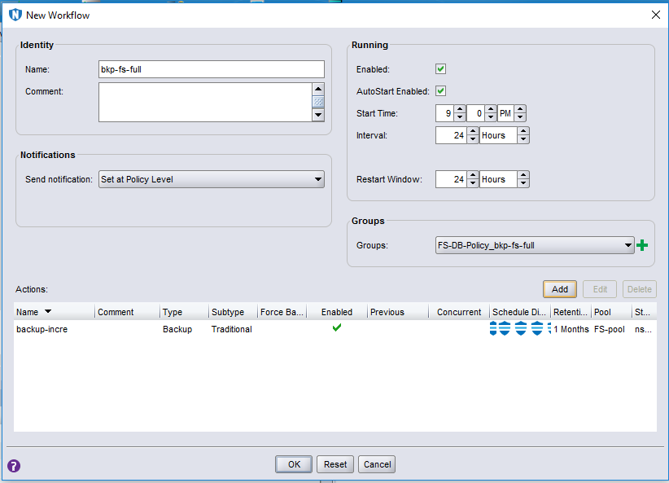
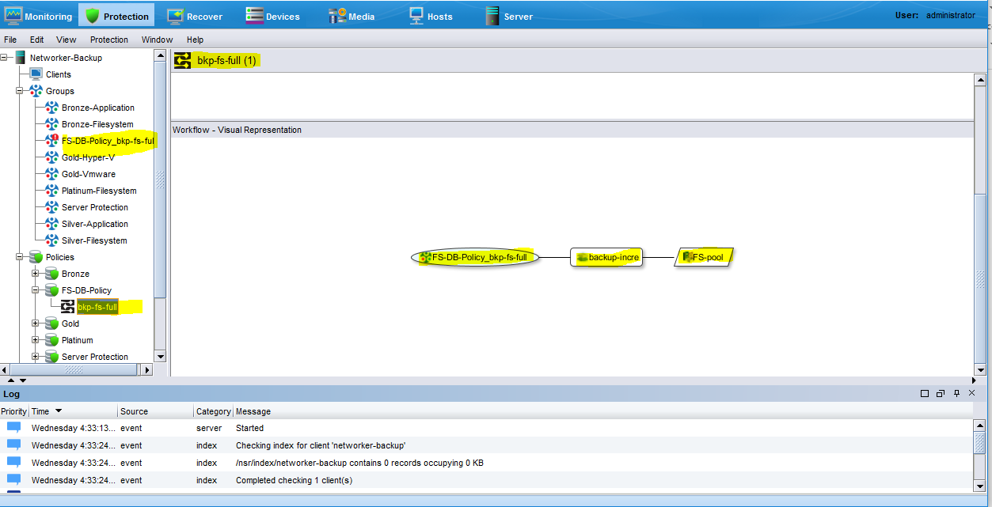

Add Storage Device for backup.
Click Devices Tab => right click on Device => New Device Wizard.
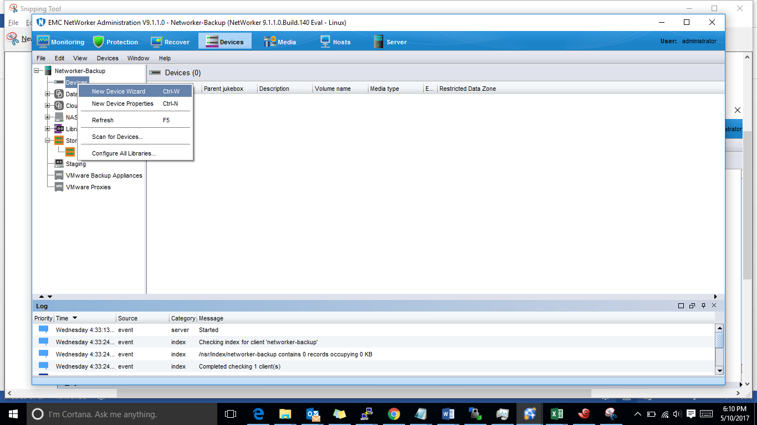
Click AFTD
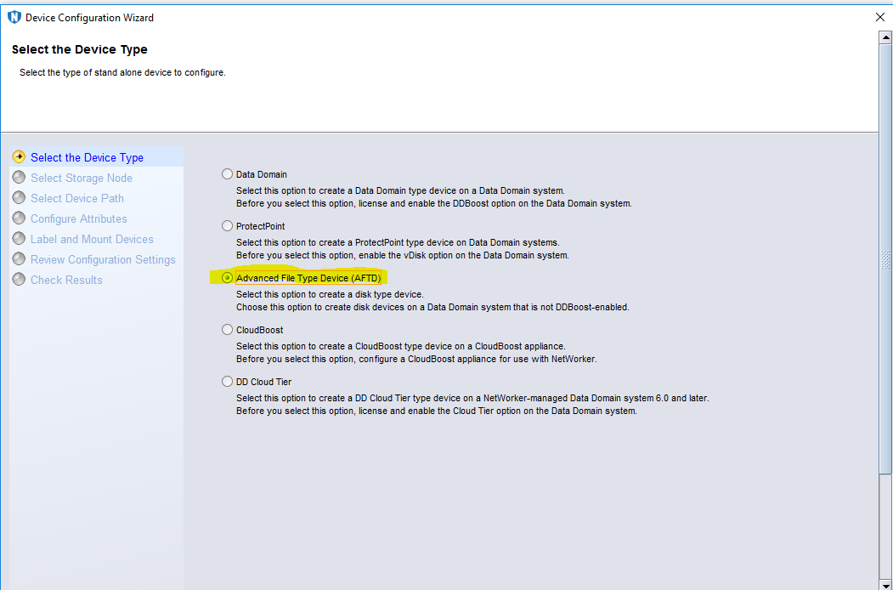

Select network server => provide backup path where backup will happen => give server credentials
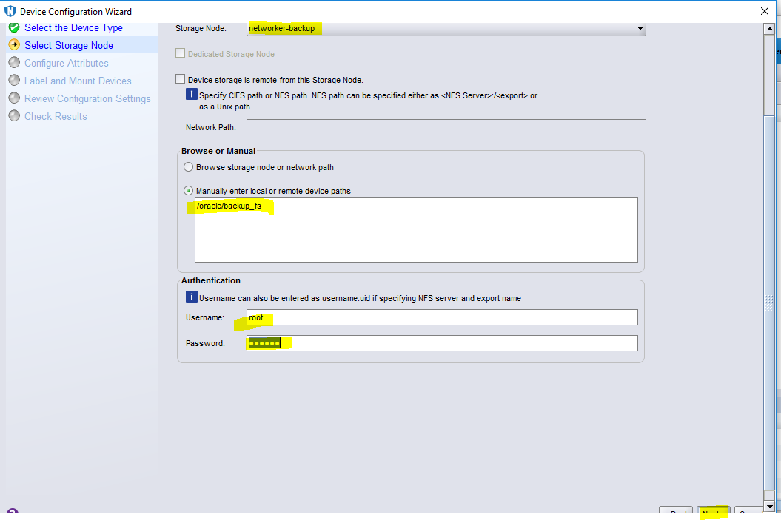

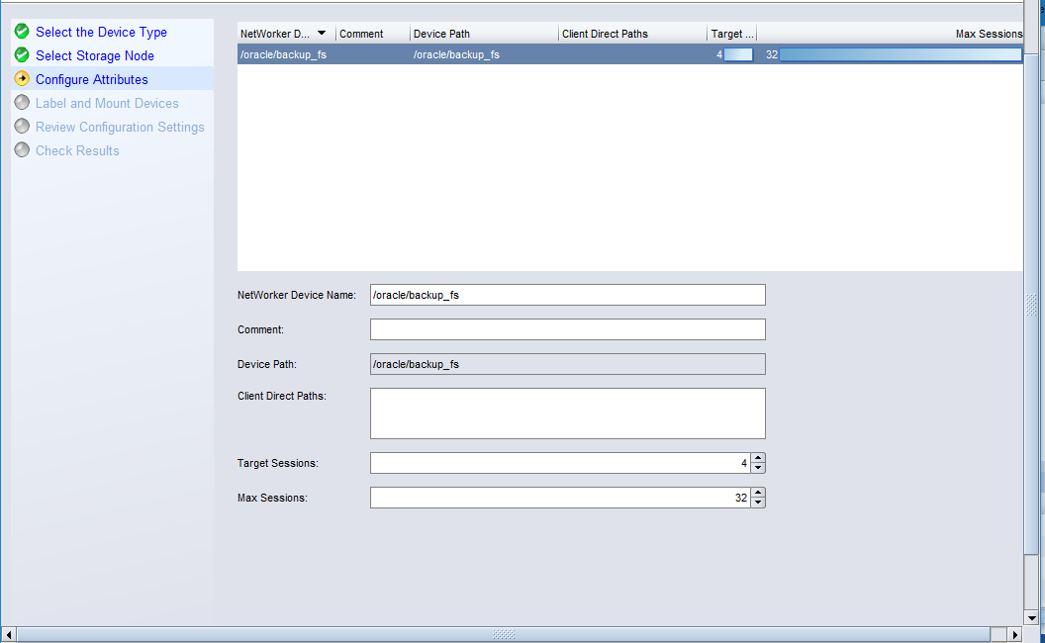

Select backup type => select pool => next
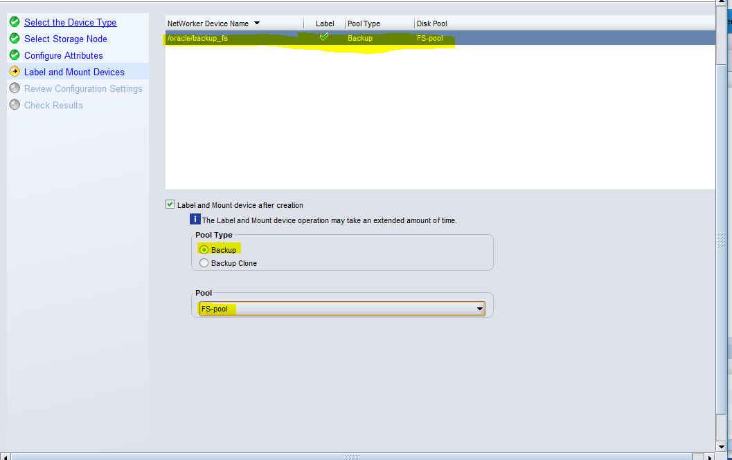
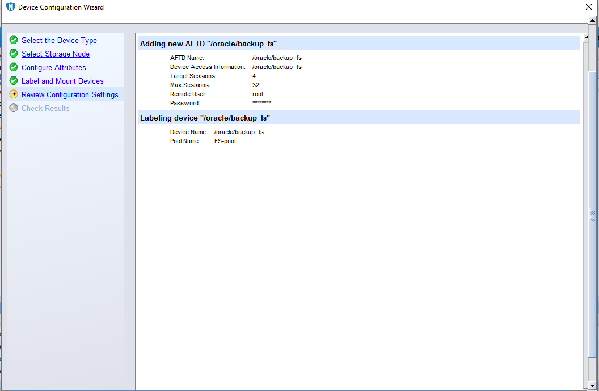
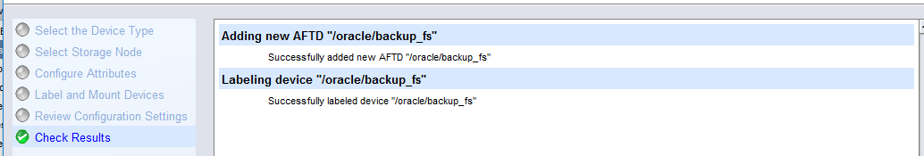

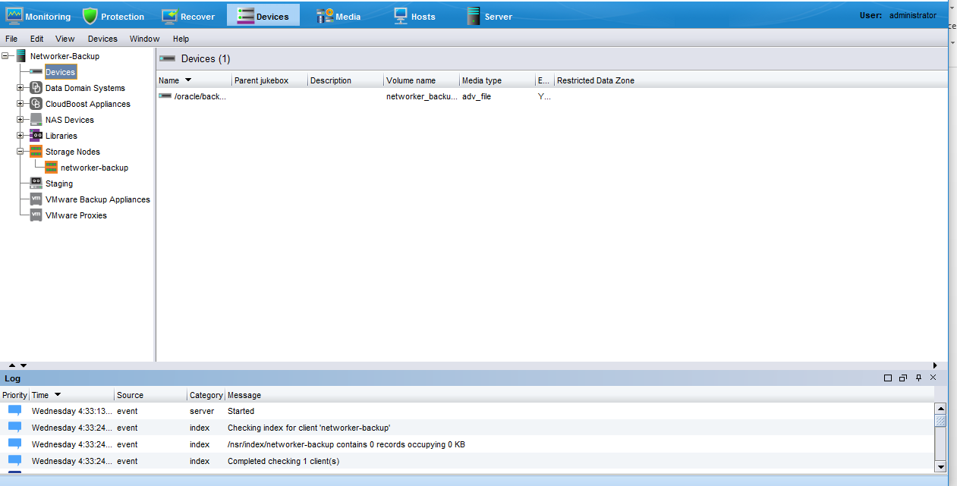
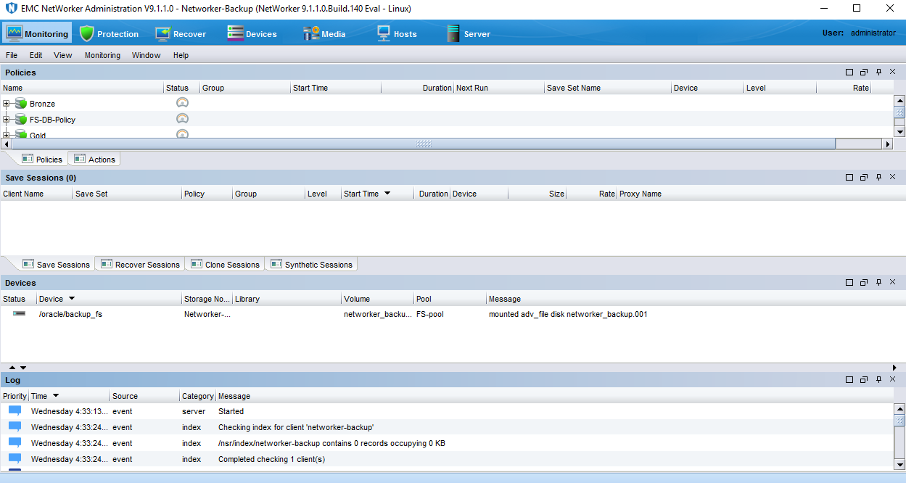

Add Client and select path for backup
Click Protections => right click on client = > new client wizard
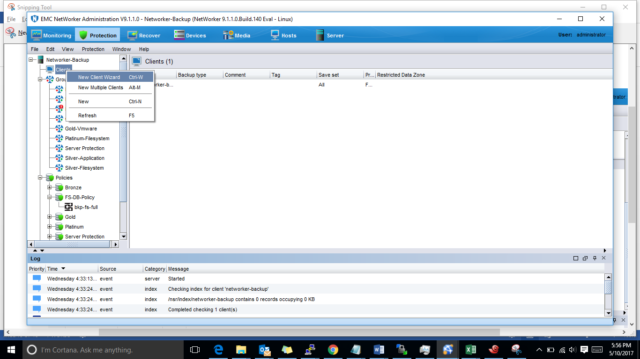
Provide Hostname or IP of client and click next.
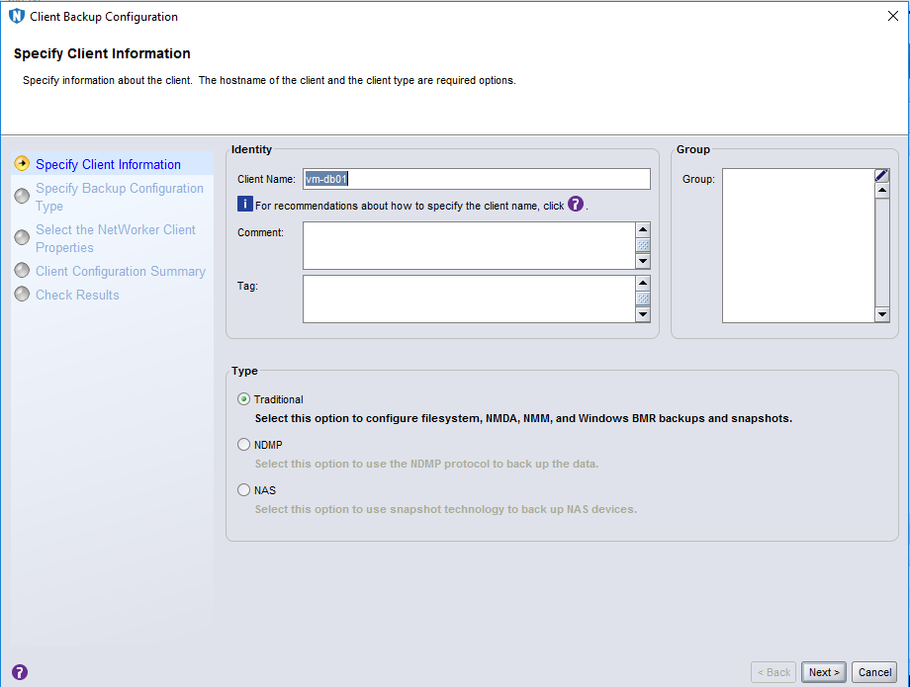
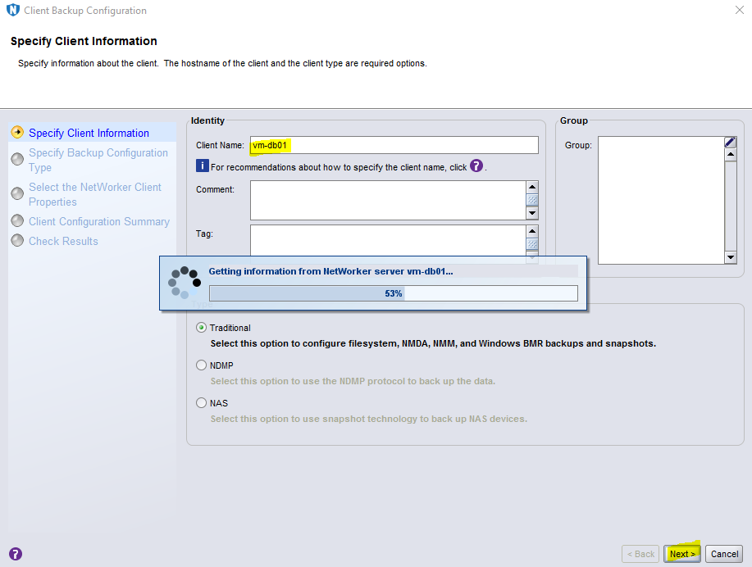
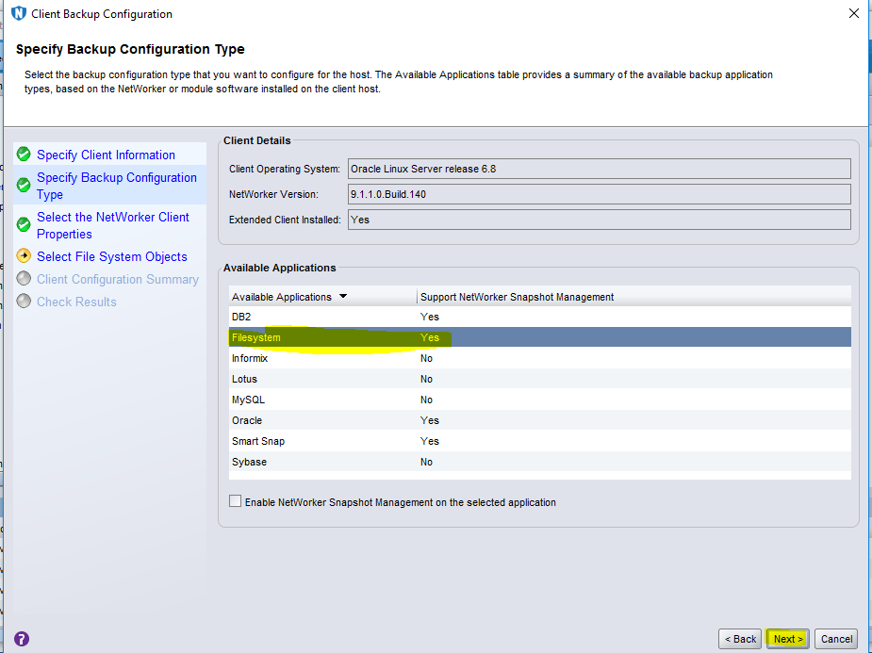
Add file system for backup.
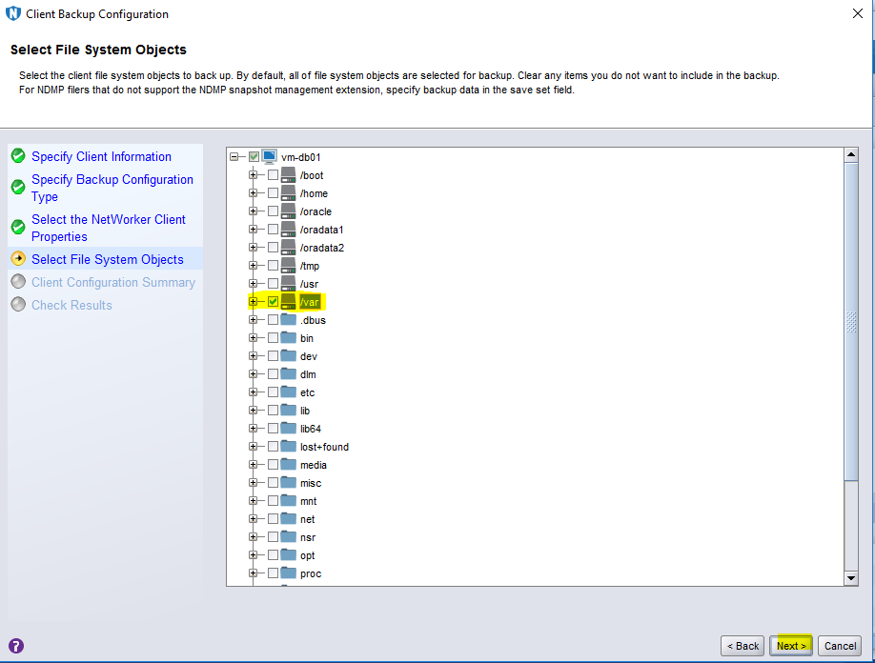
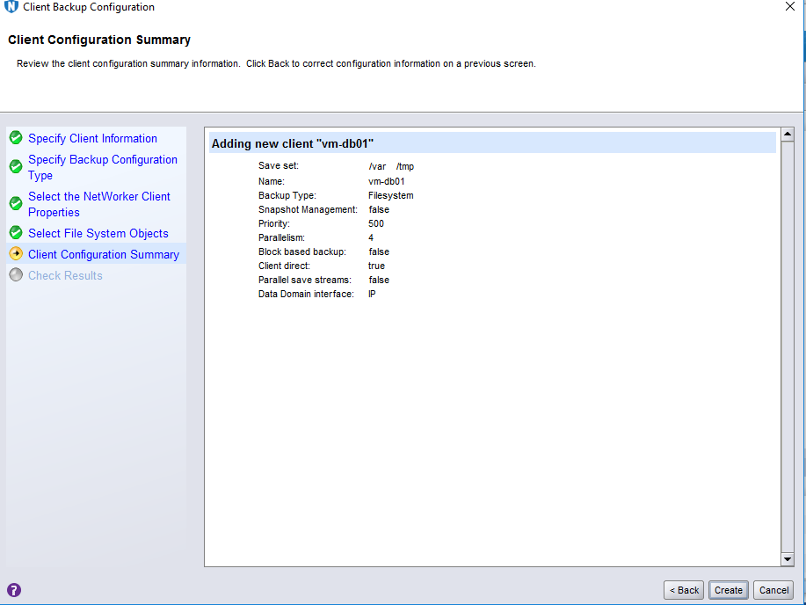
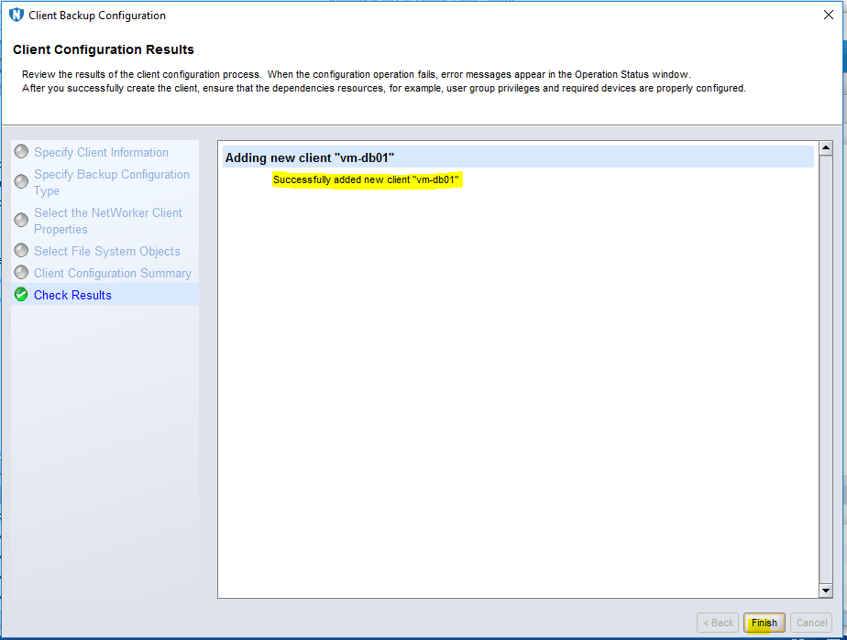

Test Case

Backup & Restoration
Start Backup
Select Monitoring Tab => select policy = > start
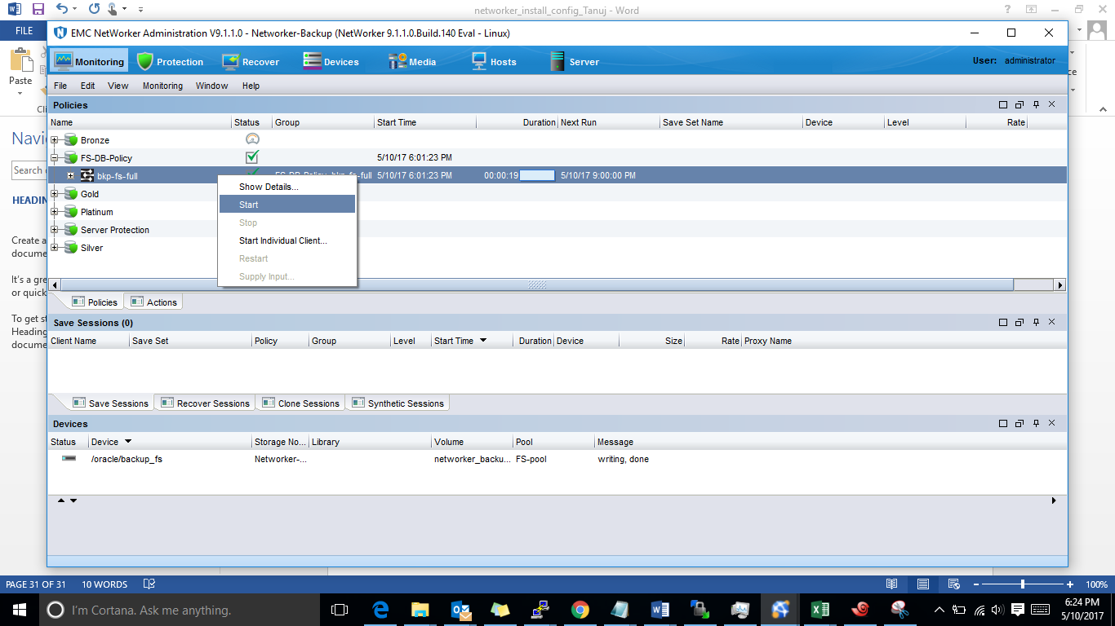
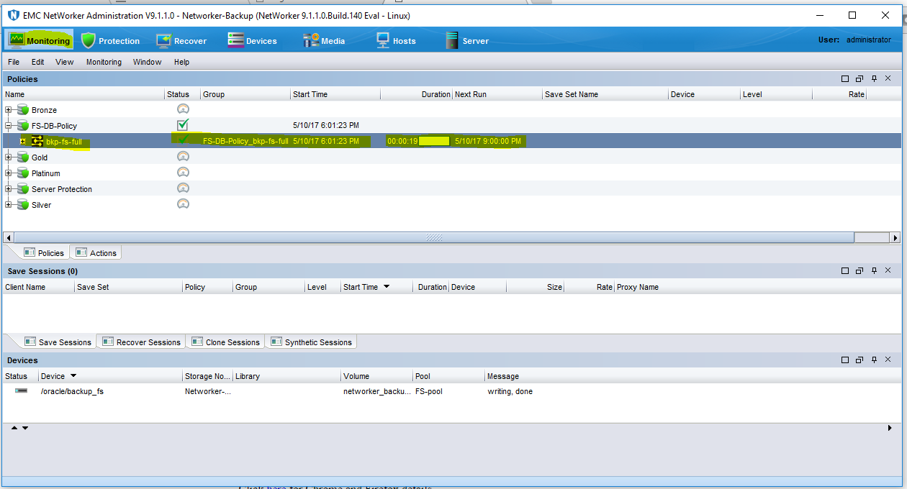
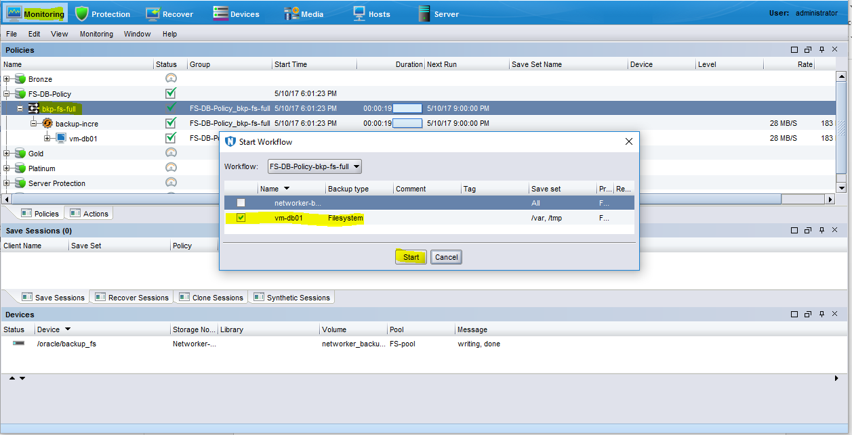
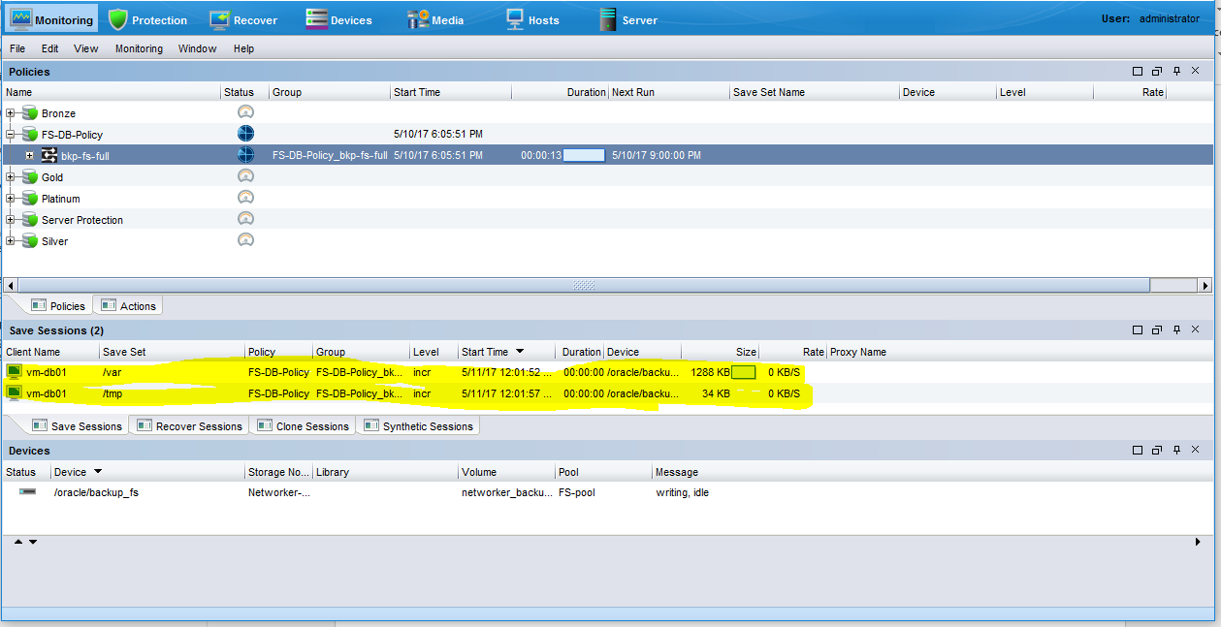

Start Recover.
Select Recover Tab = > Right click => click => new Recover
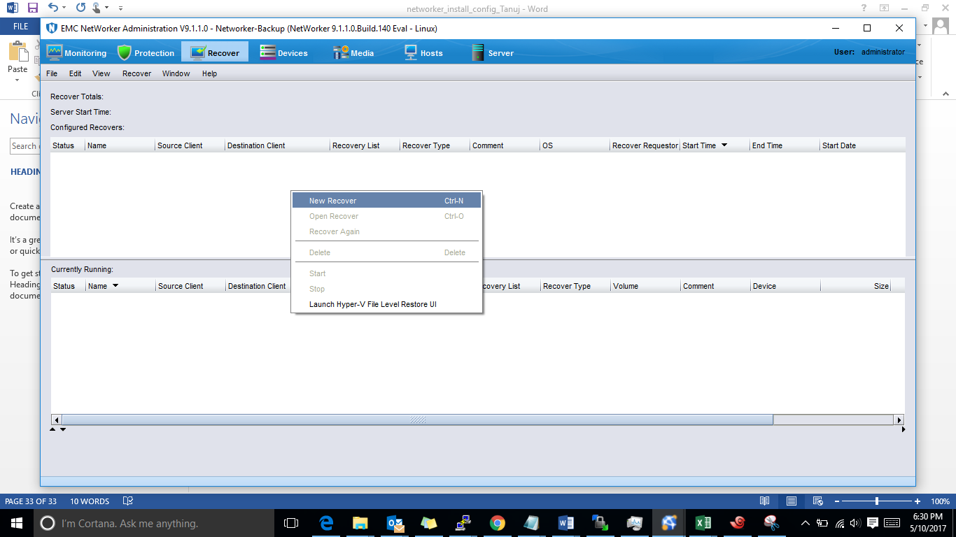
Select Traditional Networker client Recovery.
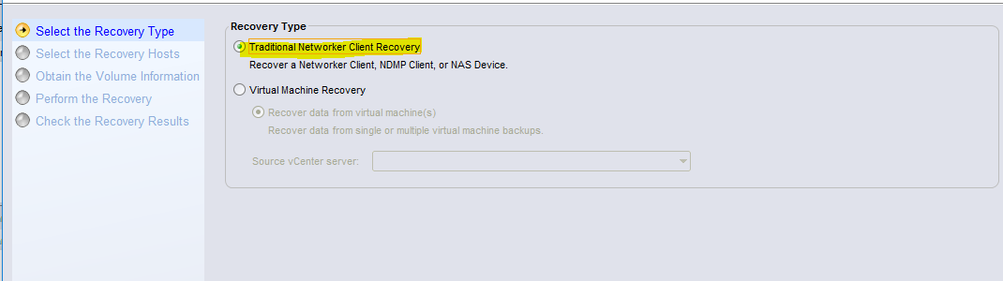

Provide source host and destination Host.
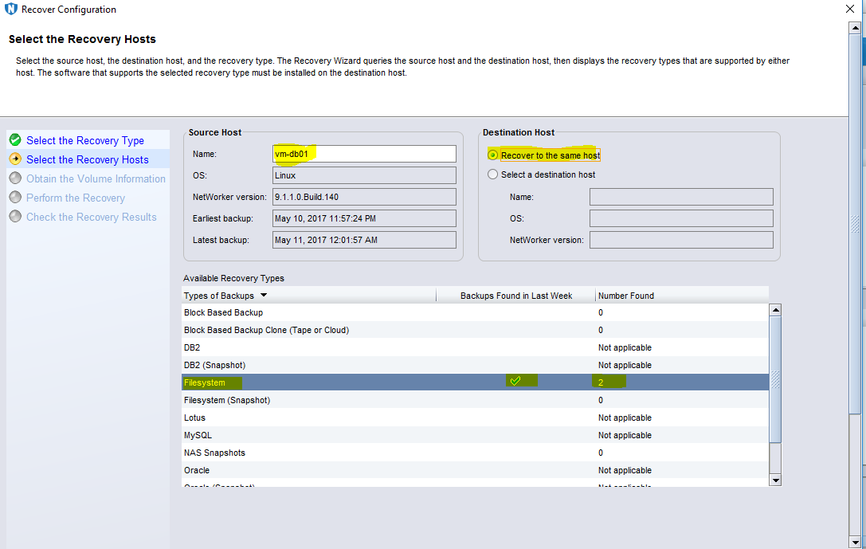
Select backup path.

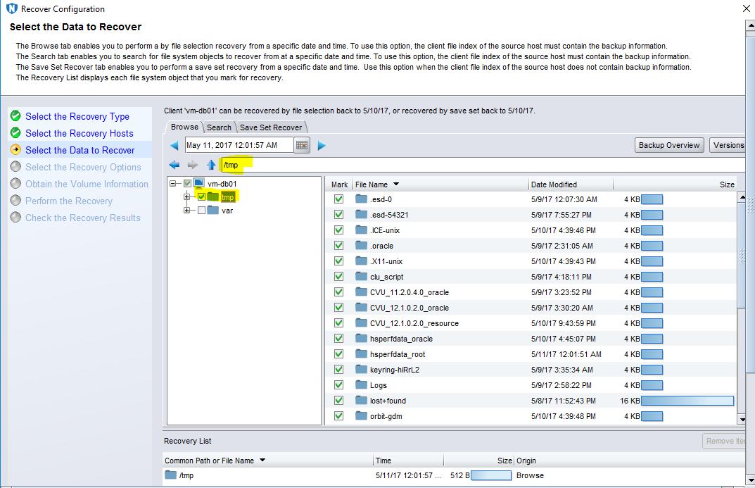
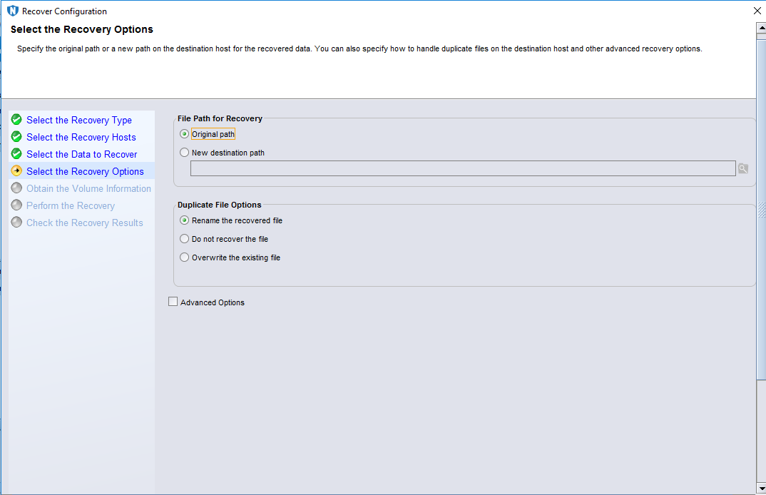
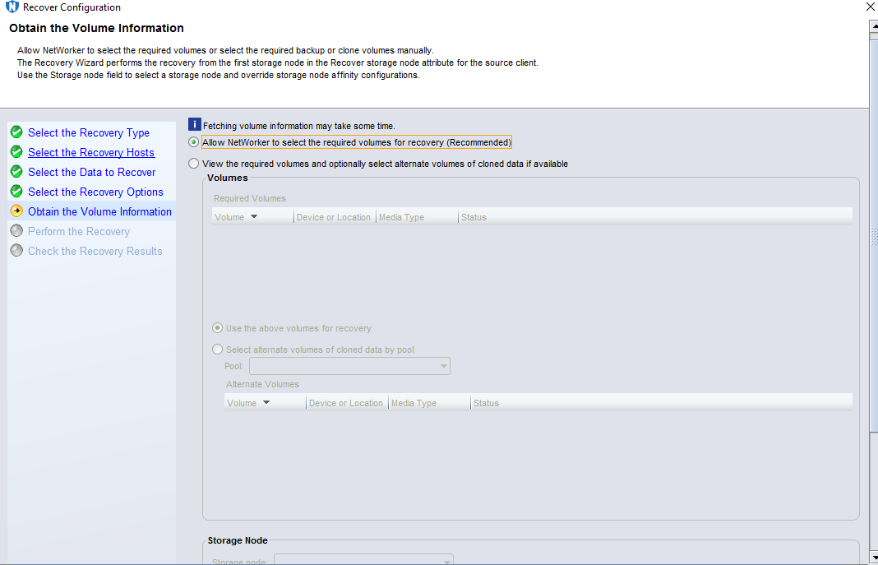
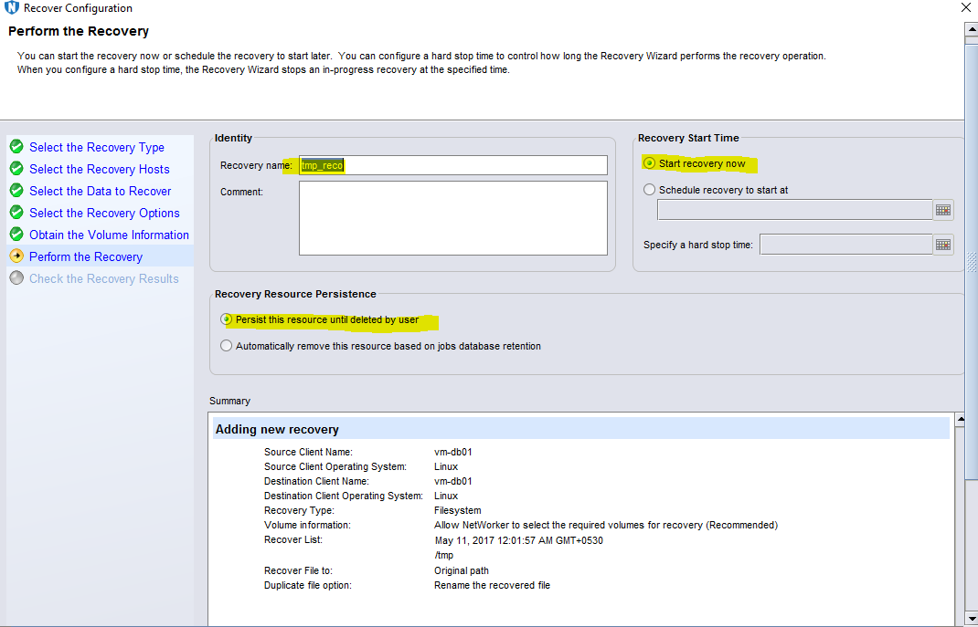
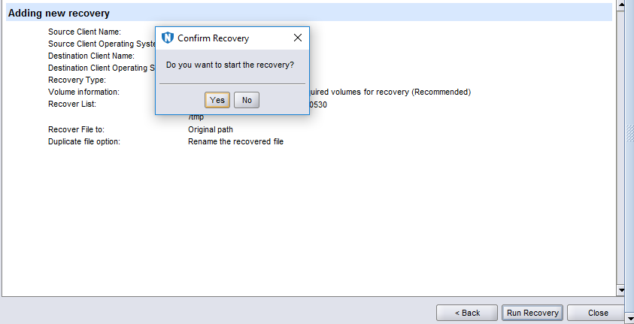
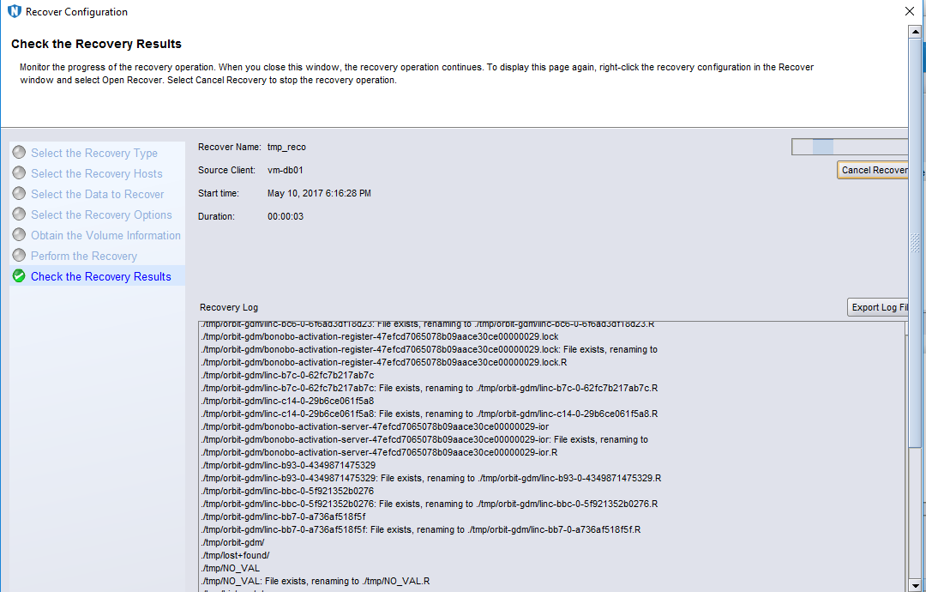
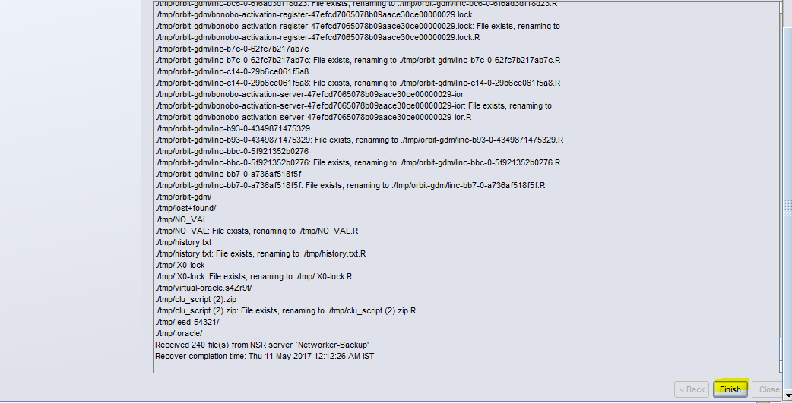

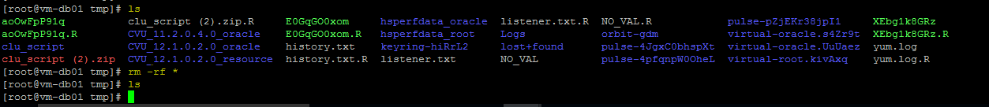
Check recoverd file or folder in client server.

