Simpana commvault Commvault Backup.

Table of Contents
1.1 Introduction III
1.2 CommVault backup software installation on Window Server. III
1.3 Simpana Quick Start Guide - Configure a Storage Device XVI
1.3.1 Option 1: Configuring a Disk Device XVI
1.3.2 Option 2: Configuring a Tape Device XVII
1.4 TAPE LIBRARY CONFIGURATION & No of Tape media Installed XVIII
1.5 Creating New media Group XVIII
Total no of tape library 1 & total no of Tape media Installed in tape library (23 media). XIX
1.6 Creating New Storage policy XXII
1.7 File systems backup policy XXVII
1.8 Test case XXXI
1.9 Backup & Retention Policy. XXXVI

Introduction

This document summarizes the configuration done for Backup.
In this document we will describe the CommVault backup Software details which include version, client, backup schedule, media agent, media details, etc. The main purpose of this document is to understand the brief overview & purpose of Backup software & backup details.

CommVault backup software installation on Window Server.

Interactive Installation – Standard
- Log on to the client computer as an Administrator or as a member of the Administrator group on that computer.
- Disable Anti-virus software on the computer.
- Run SetupAll.exe from the installation package that was created using the Download Manager.
The installation wizard is displayed.
- Click I accept the terms in the license agreement.
Click Next.

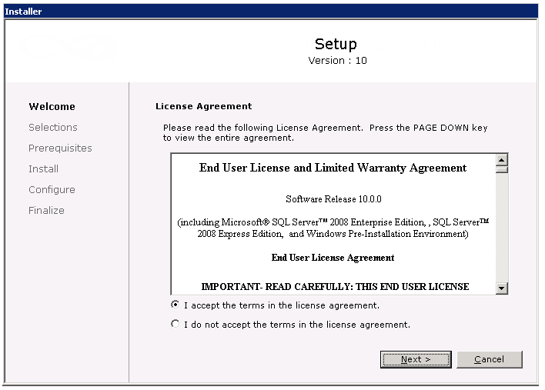

Click Standard.
Click Next.

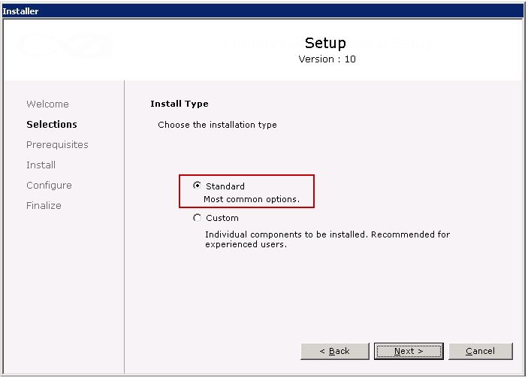
Click Create a New CommCell.
Click Next.

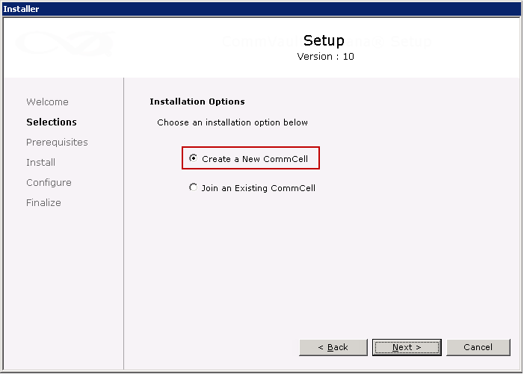

CommServe Modules is selected by default.

Click MediaAgent.

Click Next.

Windows File System iDataAgent will be automatically installed.

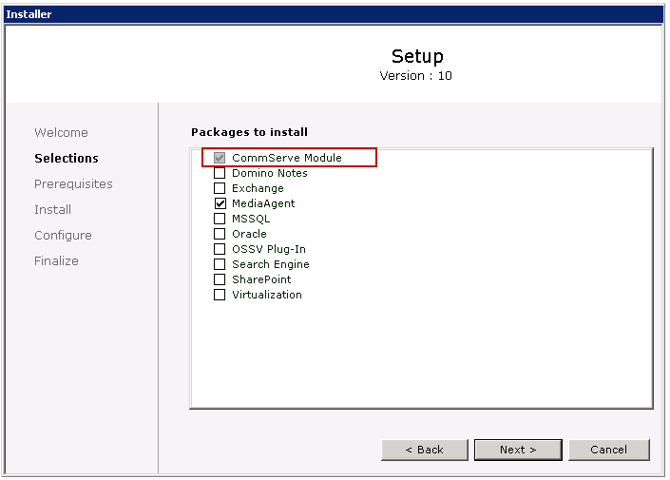

Verify the default location for software installation.
Click Next.
If necessary, click Browse... to change the default location.
- Do not install the software to a mapped network drive
- Do not use the following characters when specifying the destination path: / : * ? " < > | #
- It is recommended that you use alphanumeric characters only

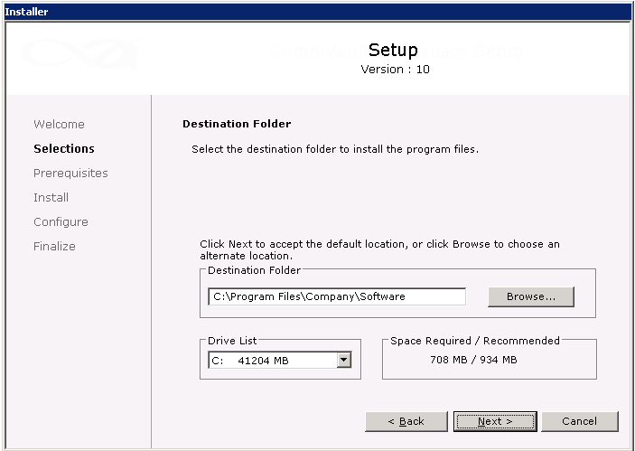

Click Install.
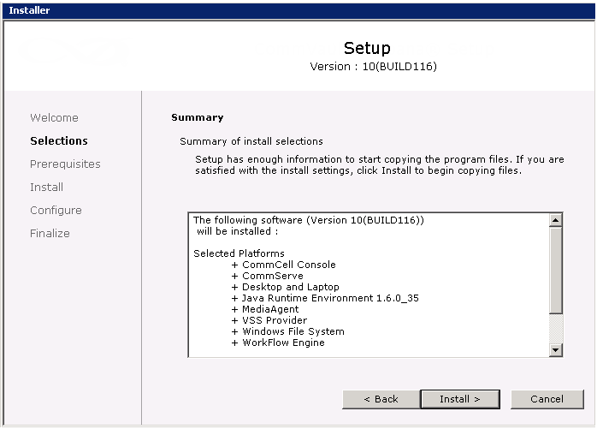
Click Yes.

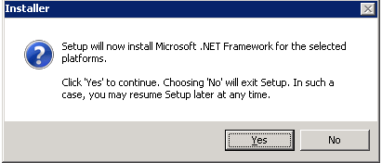

  - The computer may prompt for a reboot after installing the .Net Framework. In such a case, click Reboot Now to reboot the computer.
After the reboot, run SetupAll.exe from the installation package to resume the installation. The installer proceeds to copy the setup files, and then initiates the Microsoft SQL Server installation.
If the SQL Server is already installed on the computer, the installer skips the SQL Server installation.
By default, when the SQL Server is installed as part of the CommServe installation, the Simpana software automatically sets the system administrator (sa) password. If the 'sa' password of the preinstalled SQL Server does not match with the default password set by Simpana, the installer will prompt you for the password.
- Select one of the following options:
  - If you do not want to disable Windows Firewall, click Next.
  - If you want to disable Windows Firewall for all profiles, click Yes, disable Windows Firewall for all profiles and then click Next.

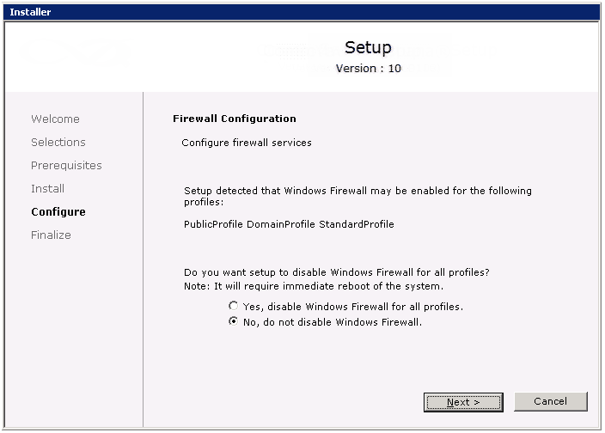

Verify the path to the SQL Server database files.
Click Browse to change the default location.
Click Next.
- Ensure that the drive has at least 1GB of free space.
- Do not specify a mapped network drive or a FAT drive.
- Do not save the database files to a compressed drive.
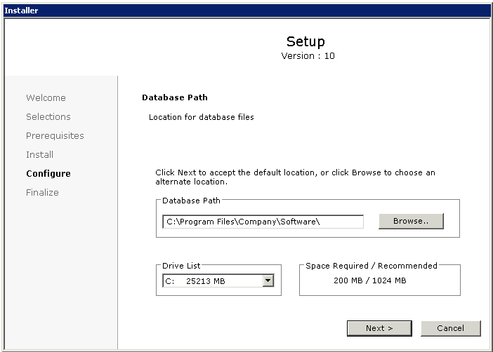

Select Create a New Database, and, then click Next.

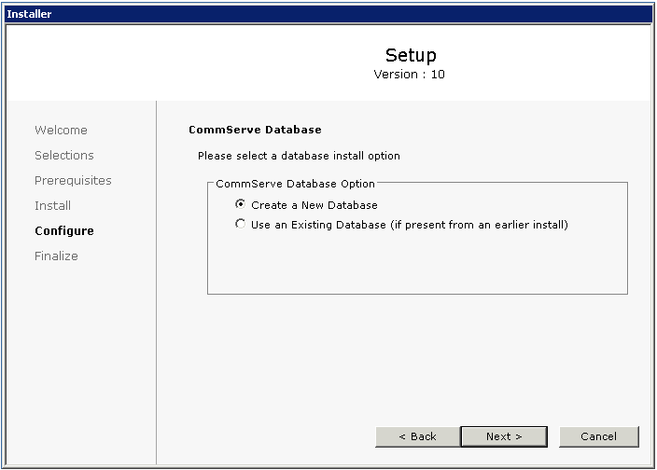
Enter the username and password for the CommCell Console administrator account.
Note down the username and password because you need it to access the CommCell Console.

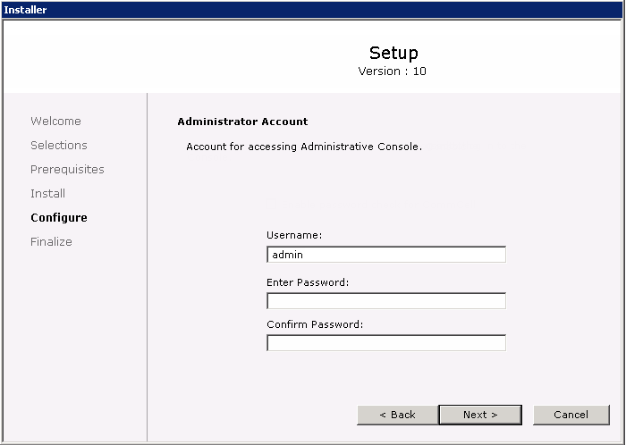

Click Next.

If you do not want to allow the CommServe to install software and updates to remote client computers, click to clear the Setup Software Cache check box and then click next.

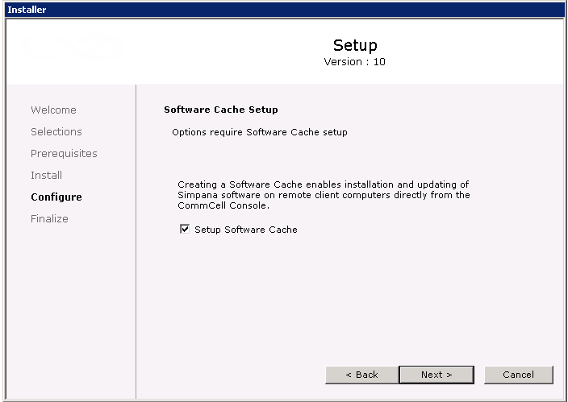

Click Yes to wait for the installer to copy the software packages required for the CommServe.
If you want to finish the installation, click No. The software packages will be copied in the background process.

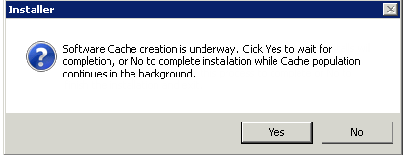

Click Finish.

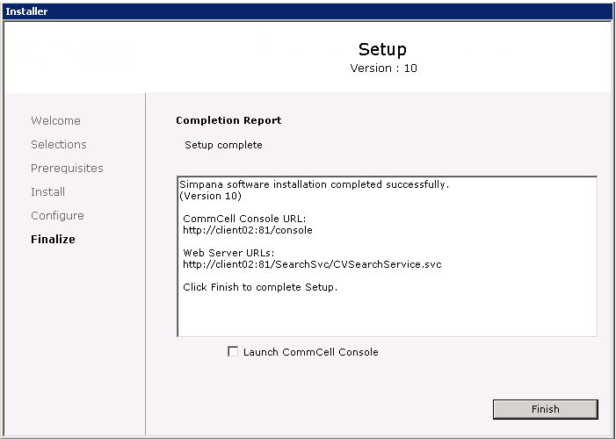

Procedure
- Open the CommCell Console, using one of the following methods based on your Windows operating system:
On Windows 8 and Windows Server 2012 computers
  - Click the Windows Start menu.
  - From the list of apps, under CommVault, click CommVault Administrative Console.
On computers older than Windows 8 and Windows Server 2012
  - From the Windows Start menu, click All Programs.
  - From the list of programs, click CommVault > CommVault Administrative Console.

- In the Connect to CommCell dialog box, enter the CommCell Console administrator account User Name and Password that you created during installation.

- Click OK.
  - If you have not activated the license yet, you receive a reminder.
  - Click OK.
When the CommCell Console opens, note the following components:
- CommServe
- MediaAgent
- Windows File System iDataAgent

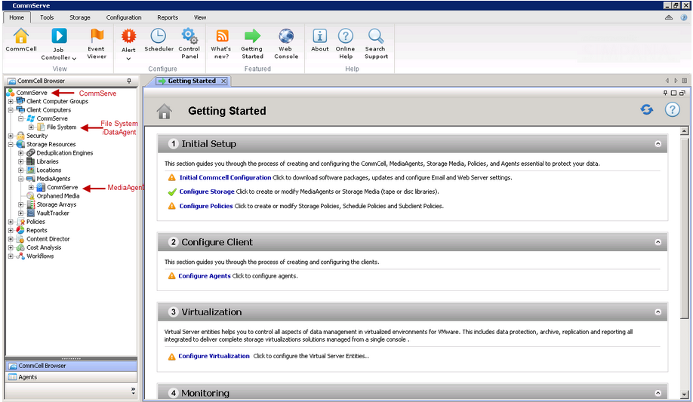

Simpana Quick Start Guide - Configure a Storage Device

After installing the software, and accessing the CommCell using the CommCell Console, configure a storage device (tape drive or disk device) attached to the MediaAgent to establish communications, and allow the storage device to be used to store backup data.
Depending on the type of storage devices that are attached to your MediaAgent, you can configure one or both of these devices:
- Option 1: Configuring a Disk Device
- Option 2: Configuring a Tape Device
If you have other types of storage devices, refer to the Configuration section in Media Management for information.

Option 1: Configuring a Disk Device
- From the CommCell Browser, expand to Storage Resources.
- Right-click Libraries, and the click Add | Disk Library.
The Add Disk Library dialog box appears.
- In the Name box, type the name for a disk library.
- Select the appropriate MediaAgent from the MediaAgent list.
- If the device is a direct-attached library such as SAS/FC/iSCSI for Windows or NFS for UNIX/Linux MediaAgents, define the mount path as a local path.
If the MediaAgent is a UNIX/Linux MediaAgent, then you must select the Local Path option. To access an NFS share, you must mount the share to your UNIX/Linux MediaAgent. Once the share is mounted, it appears as another local directory on the system. You can provide this directory location in the local path.

  - Select Local Path.
  - In the Disk Device box, enter the mount path location.
- If the device is on a network, define the mount path as a network path.
The Network Path option is available only for Windows MediaAgents that use CIFs shares.
  - Select Network Path.
  - In the Connect As box, type the user name.
  - In the Password and Verify Password box, type the password that is used by the backup software to access the network share.
  - In the Folder box, enter the mount path location.
- Click OK.
The new disk library appears in the CommCell Browser under Storage Resources | Libraries.

Option 2: Configuring a Tape Device
- From the CommCell Browser, expand to Storage Resources.
- Right-click Libraries, and then click Add | Tape Library.
The Add Tape Library dialog box appears.
- Select the appropriate MediaAgent from the MediaAgent list.
- Click Scan Hardware.
The tape library that is associated with the selected MediaAgent is detected. It appears in the Add Tape Library dialog box as Not configured.
- Right-click the detected library, and then click Configure.
A message appears that tells you that the library was configured successfully.
- Click OK.
The new tape library is now configured.
- Click OK.
The new tape library appears in the CommCell Browser under Storage Resources | Libraries.

TAPE LIBRARY CONFIGURATION & No of Tape media Installed

Creating New media Group

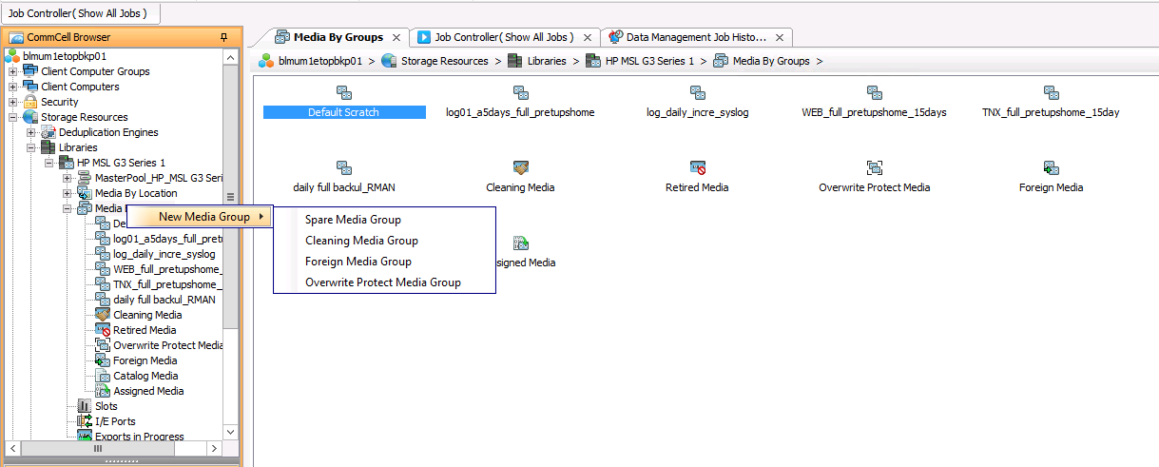

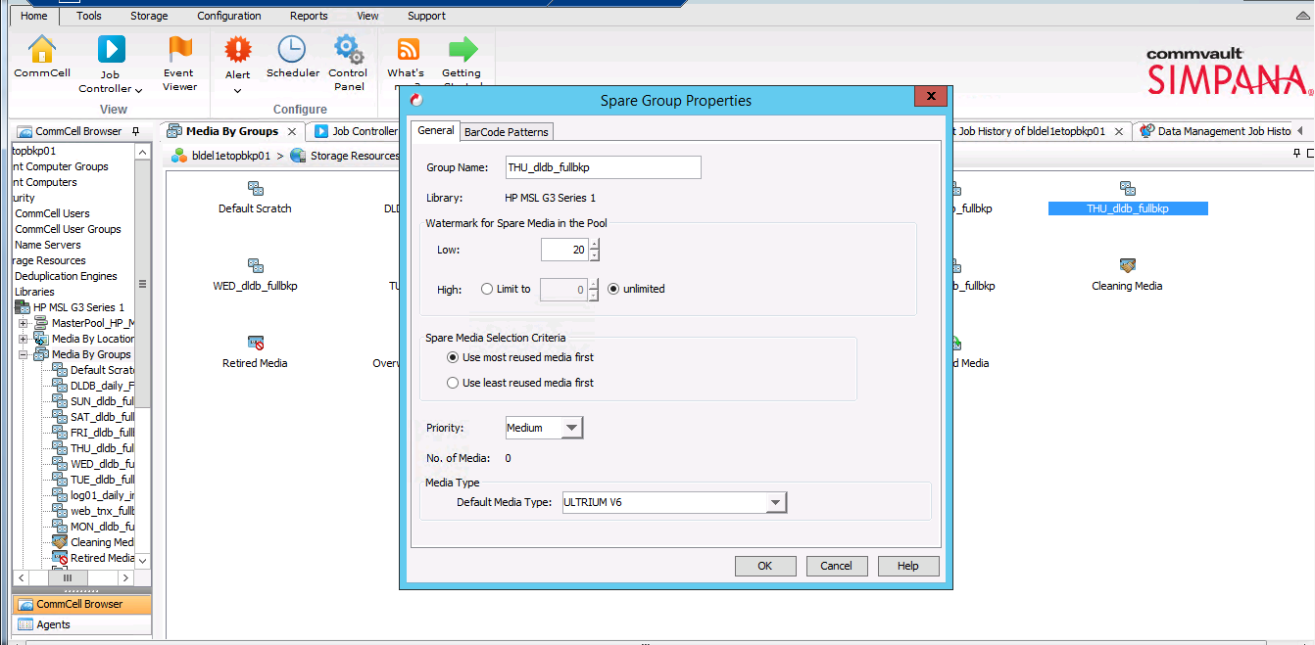

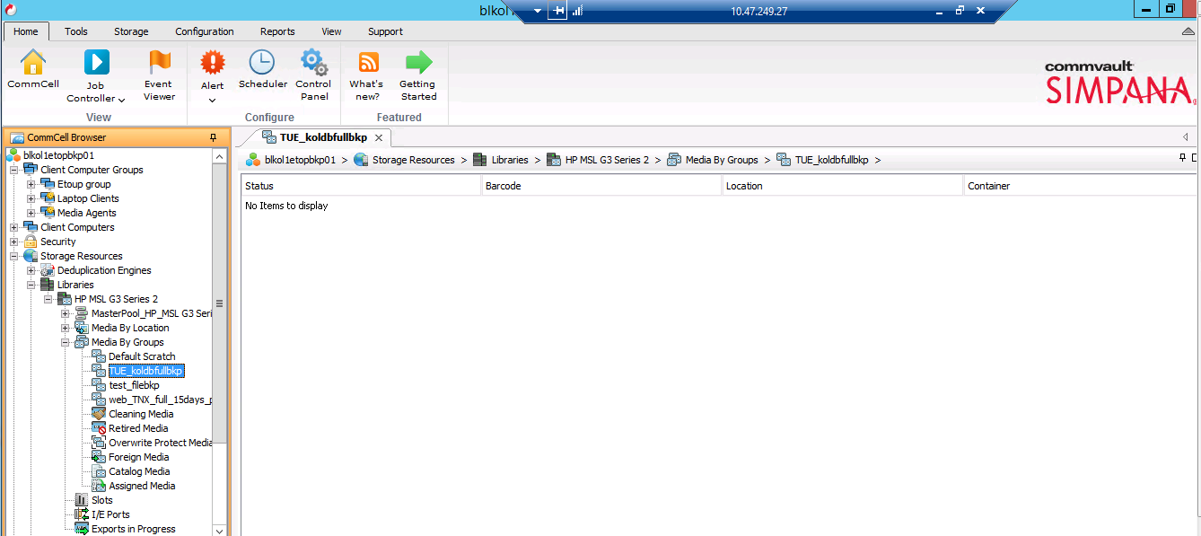

Total no of tape library 1 & total no of Tape media Installed in tape library (23 media).

There are total 23 tape media in tape library. Two pools have been created, one for DB backup and other for Application & Syslog backup. Each backup is being created in separate tape media. If tape media is full than it will use other media automatically. Also the backup data will be cleaned as per retention policy and then media will be re-used automatically.

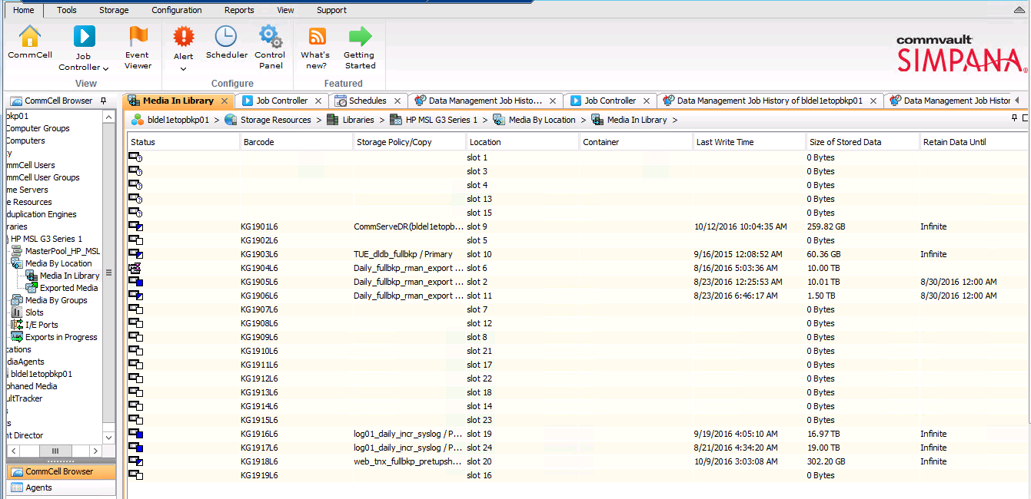

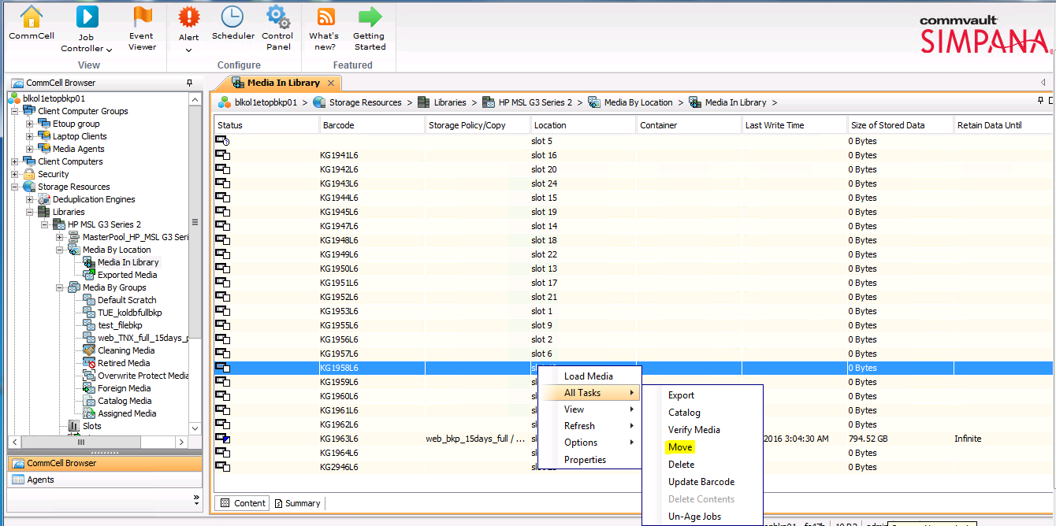

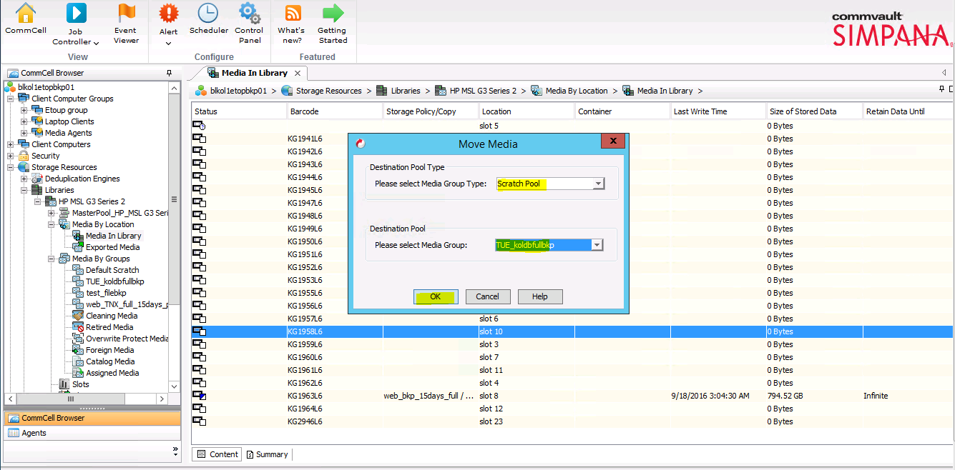

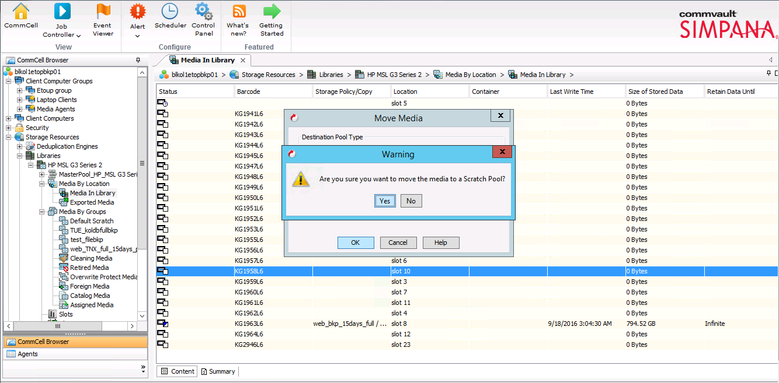

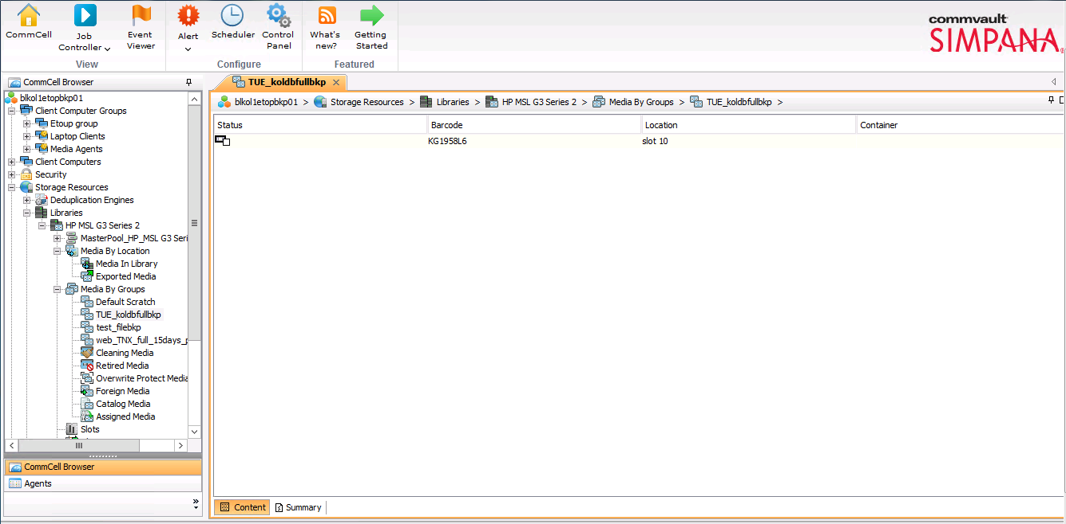

Creating New Storage policy

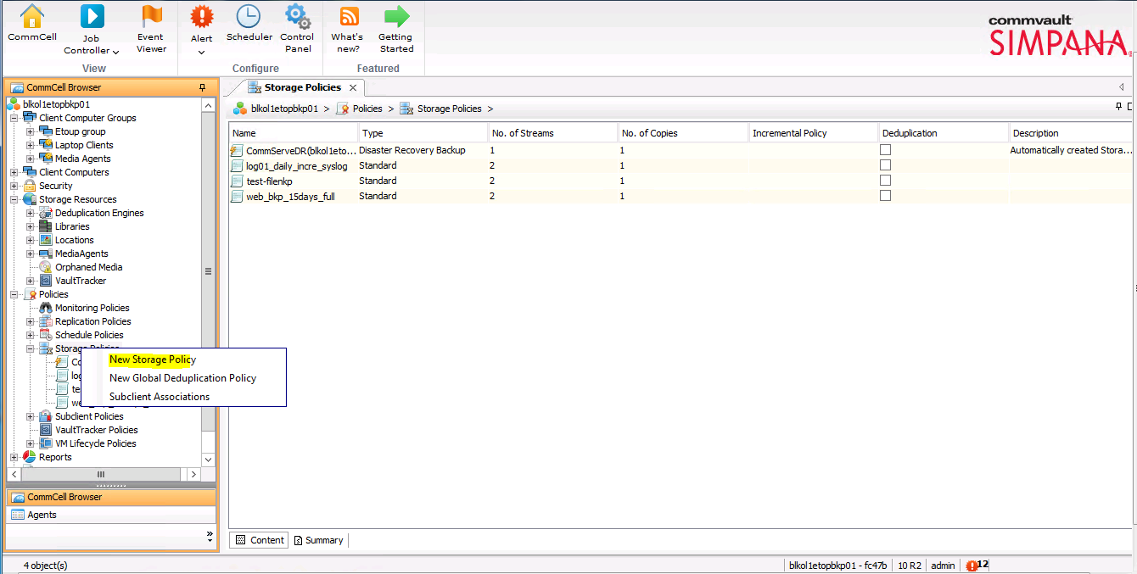

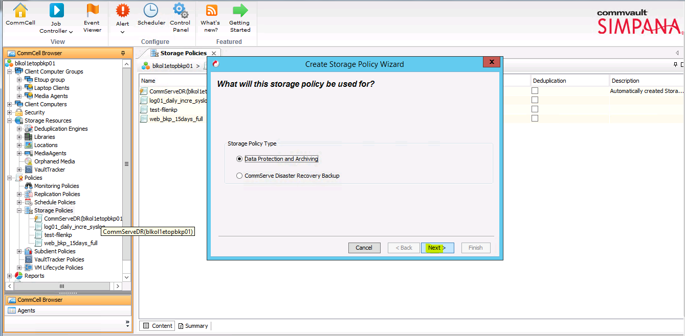

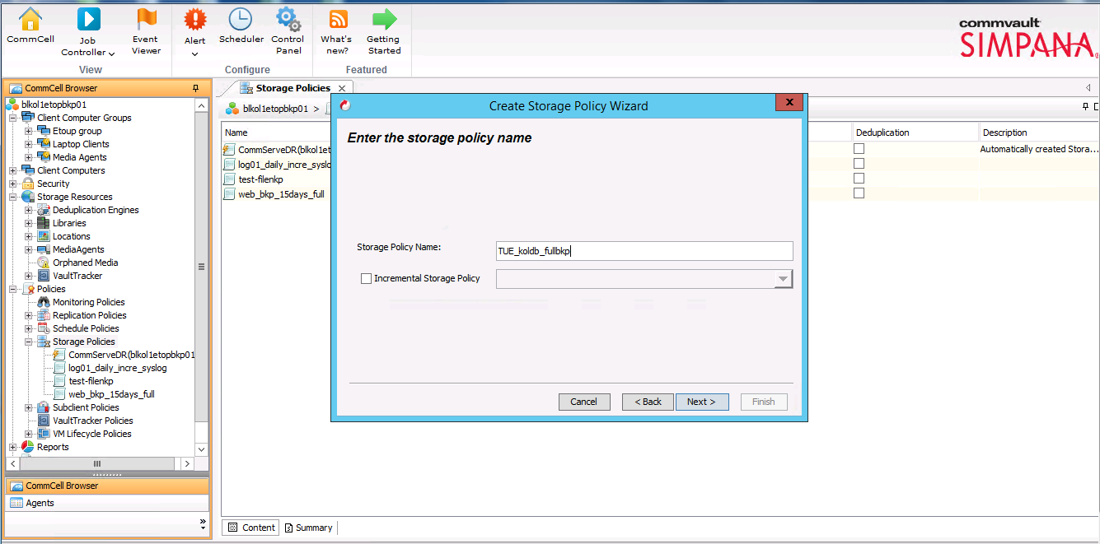

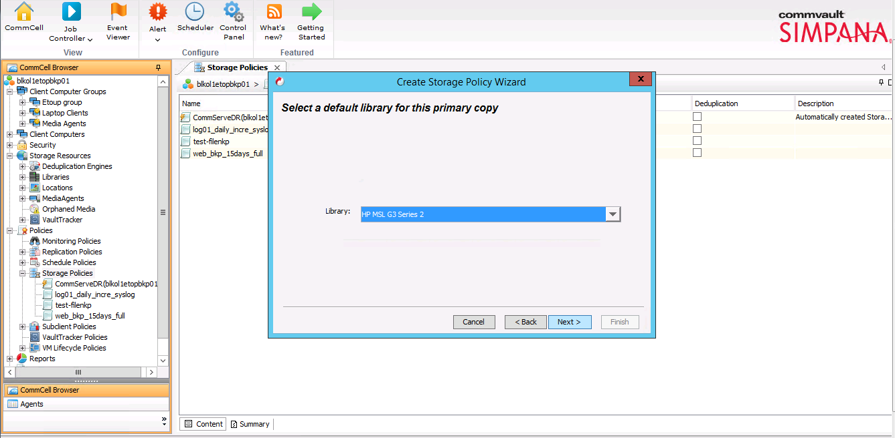

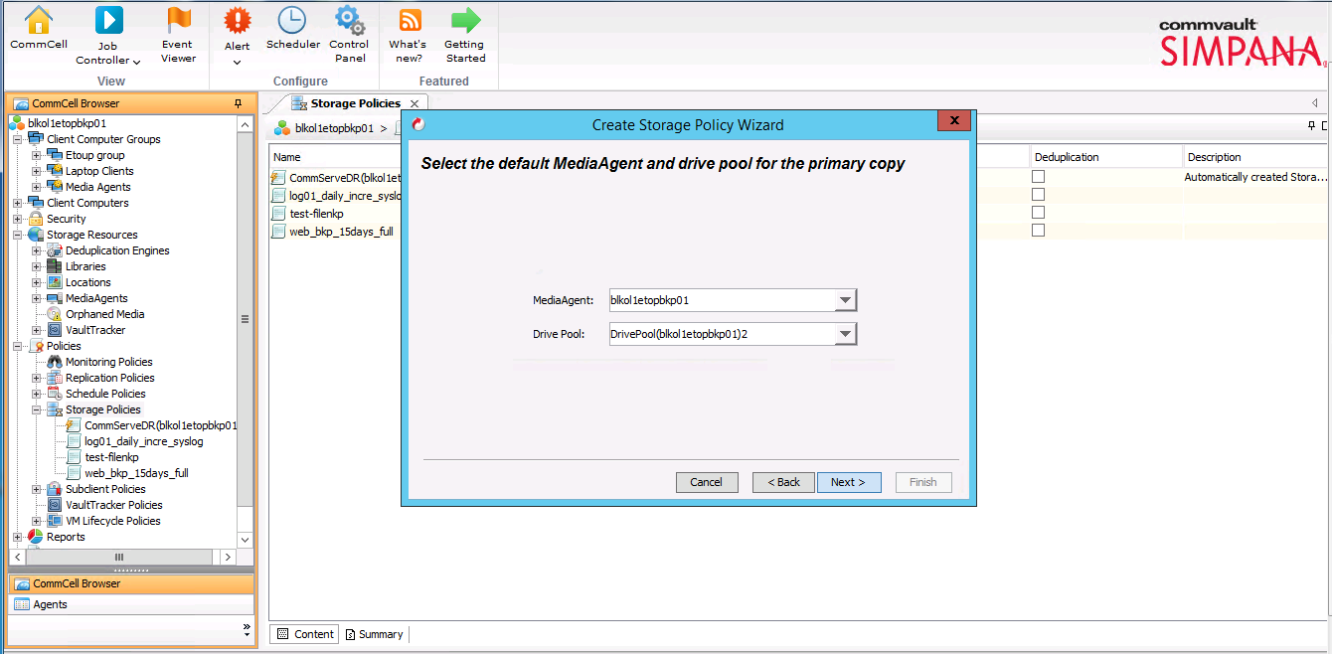

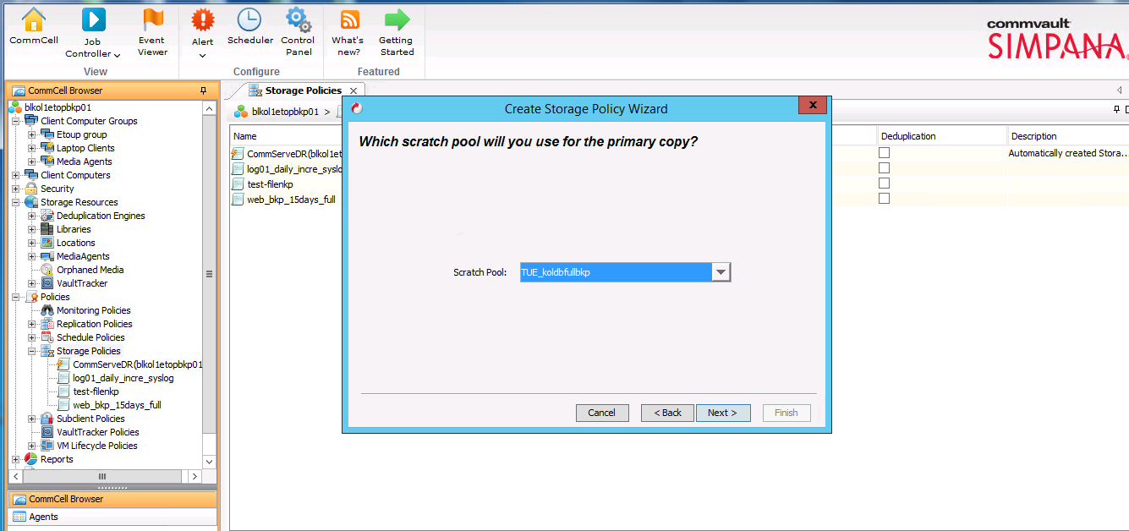

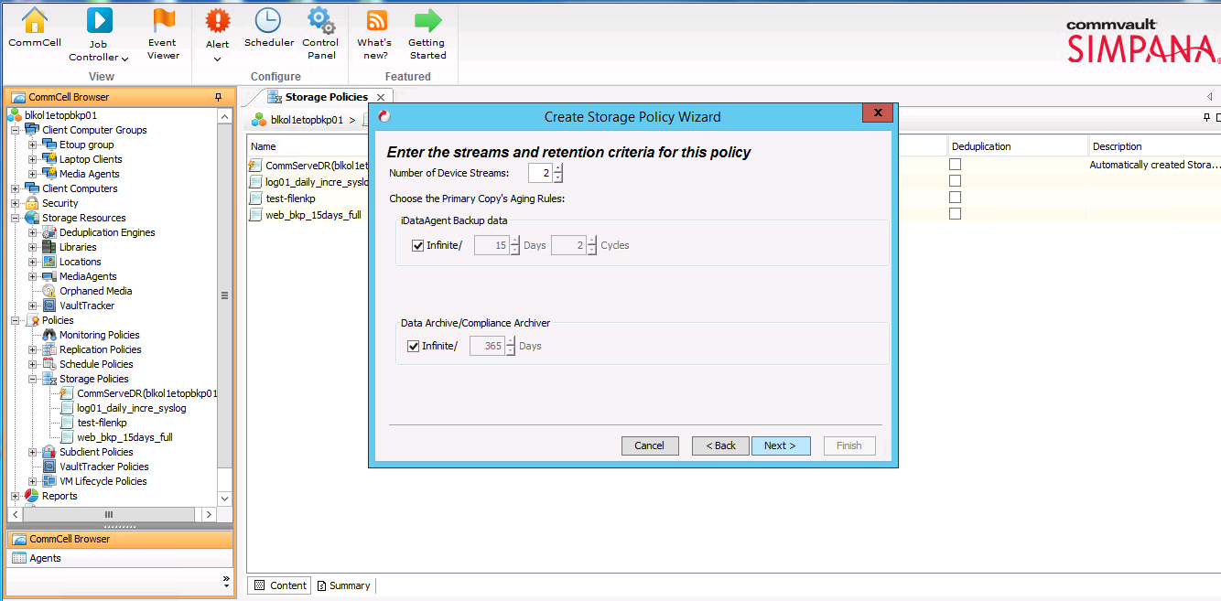

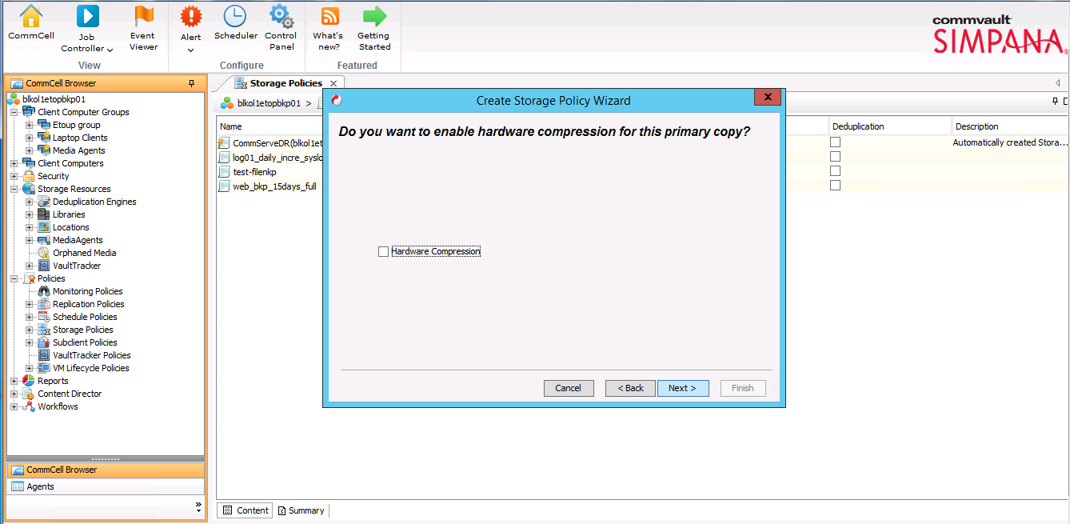

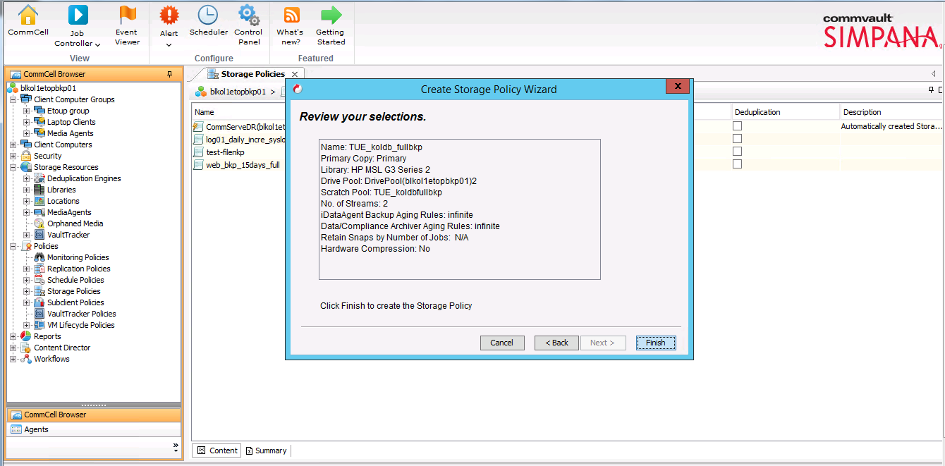

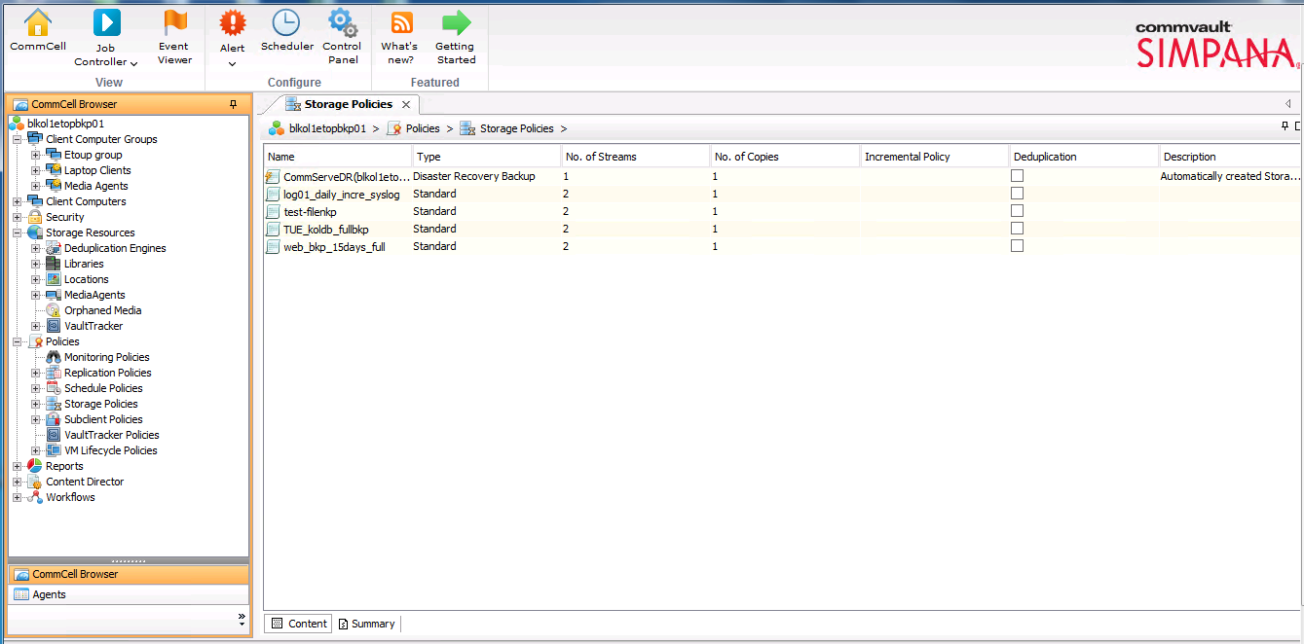

File systems backup policy
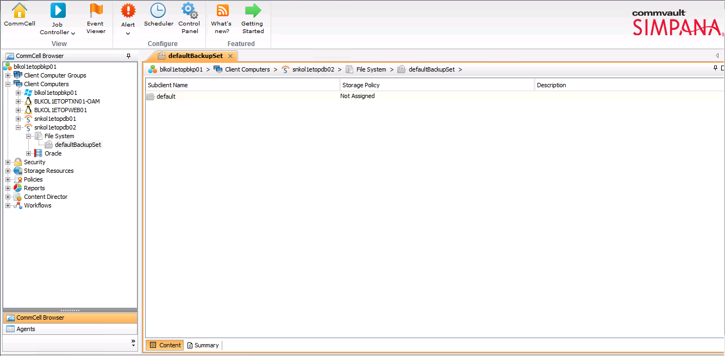

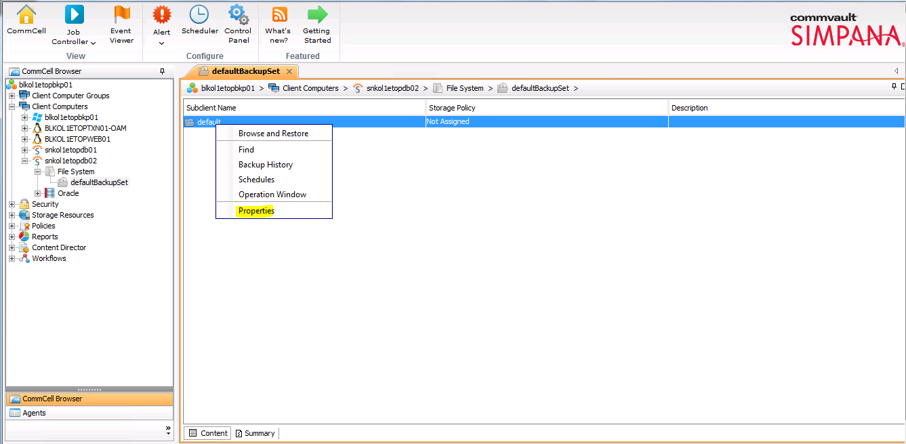

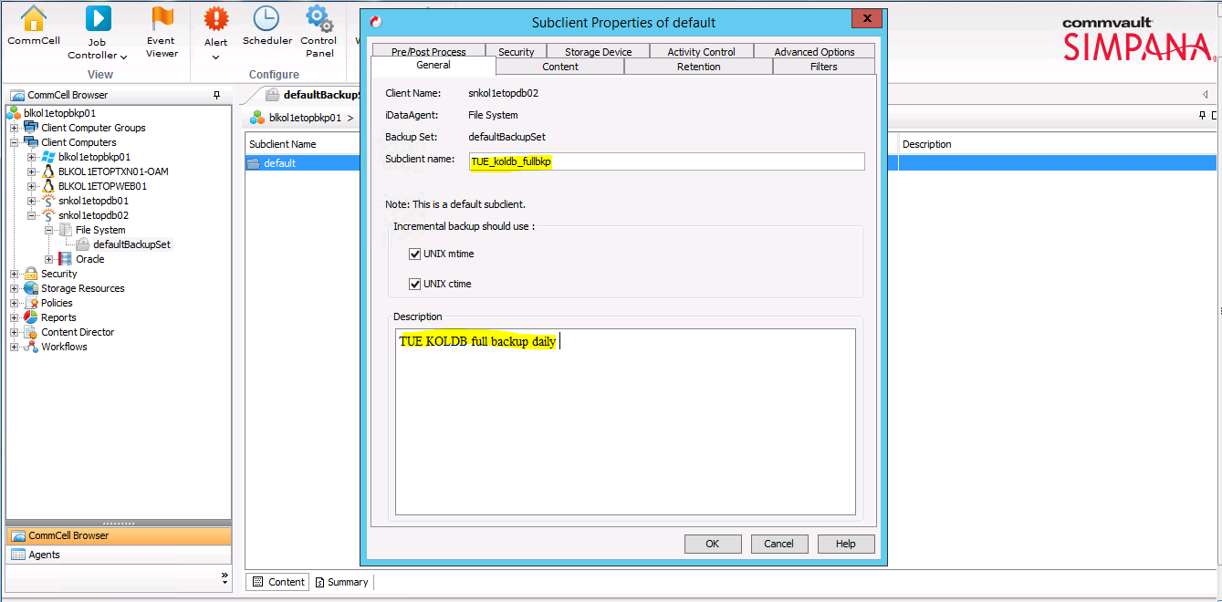

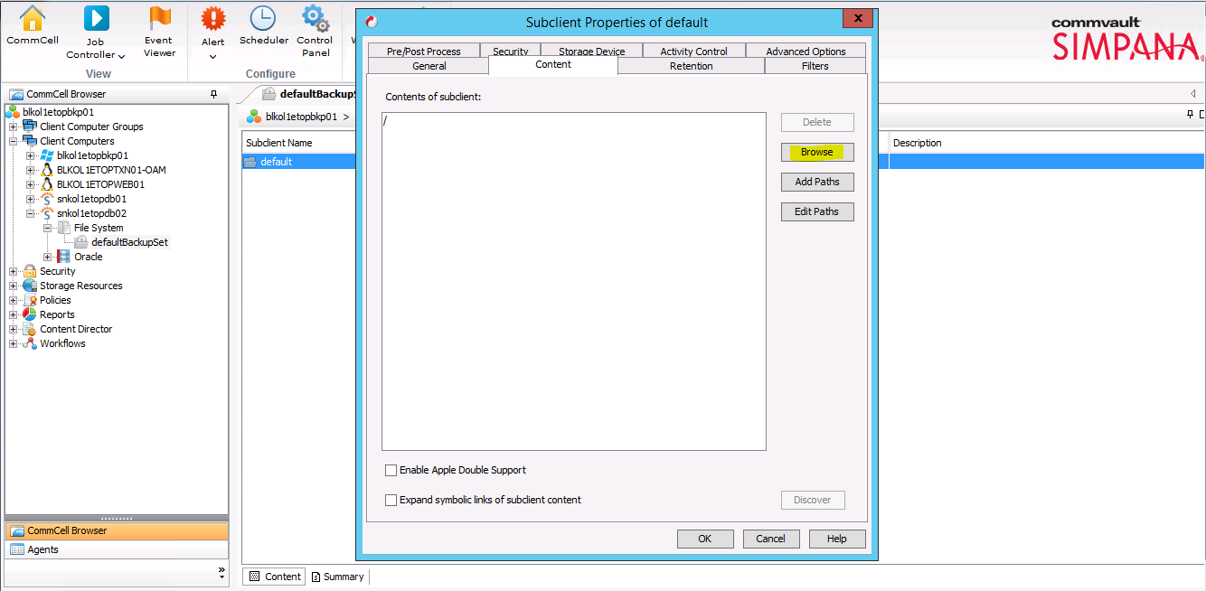

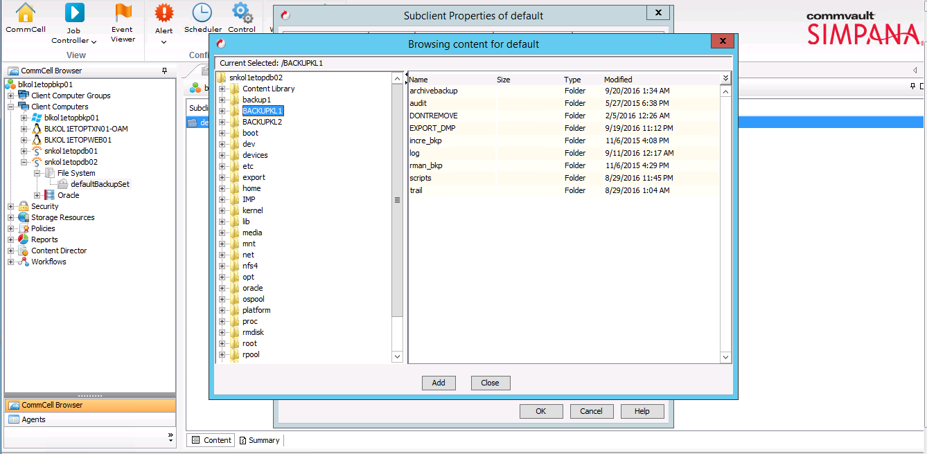

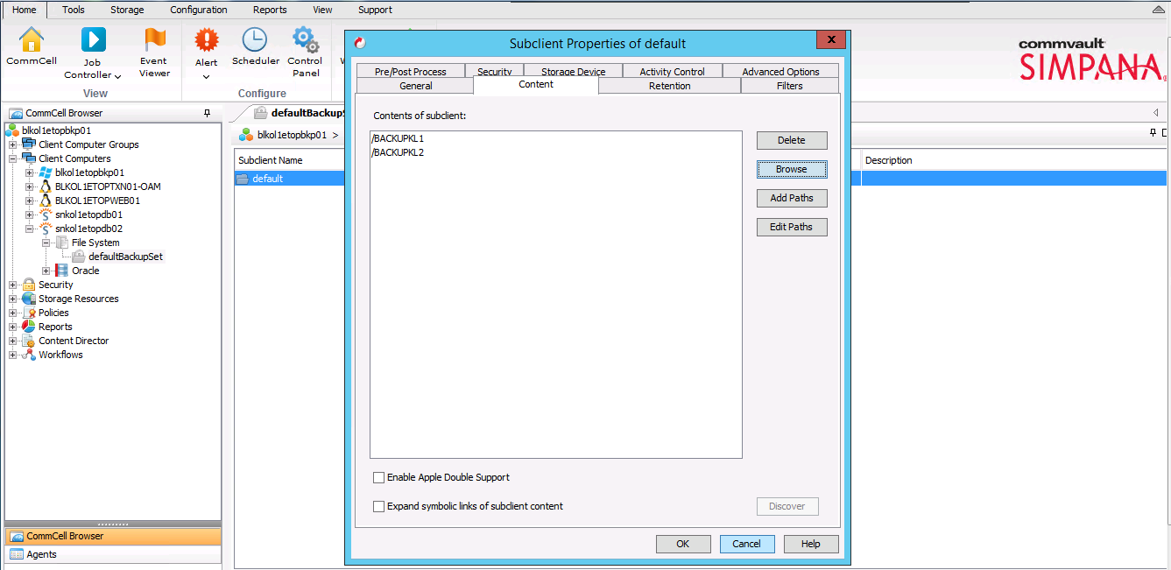

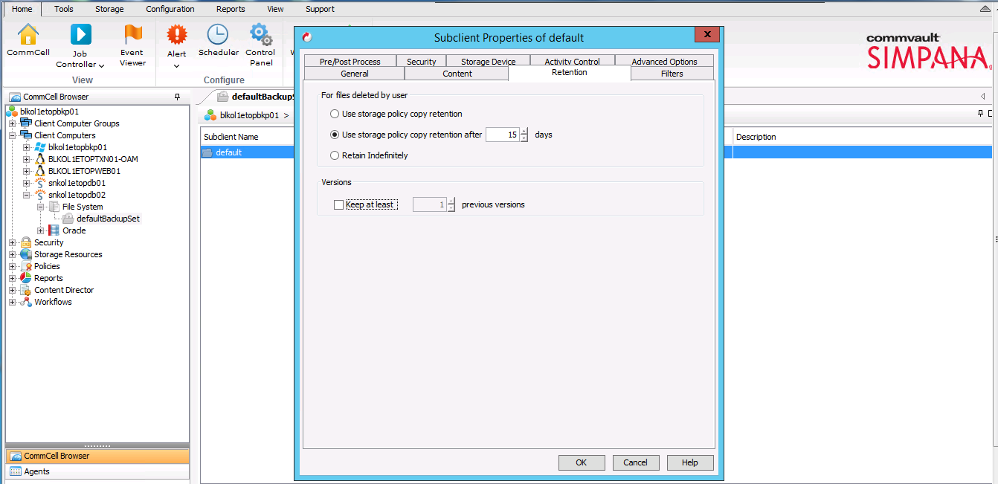

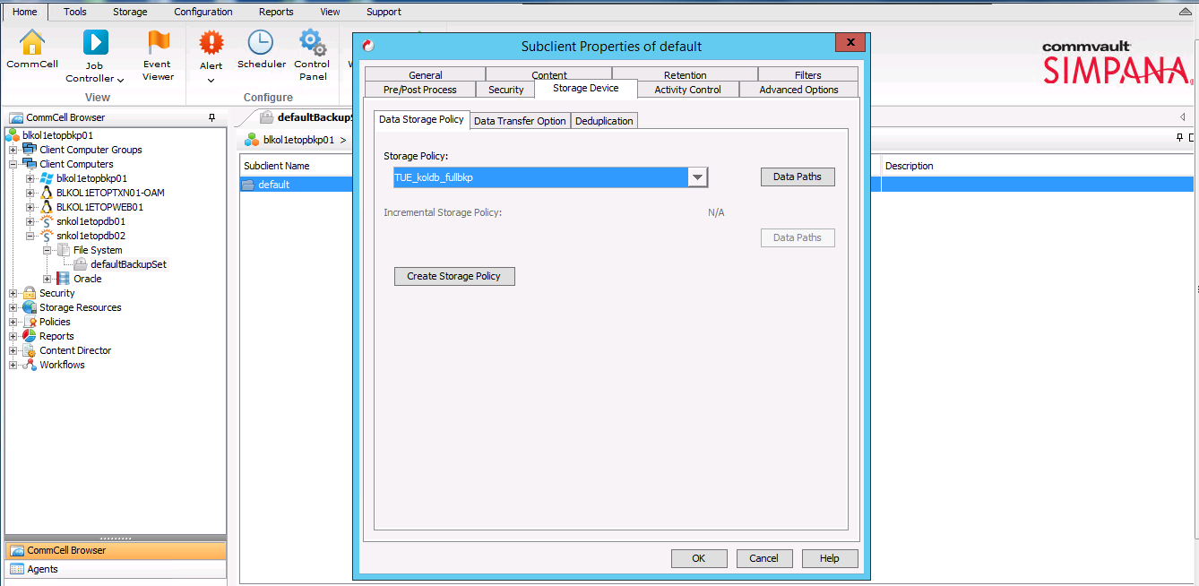

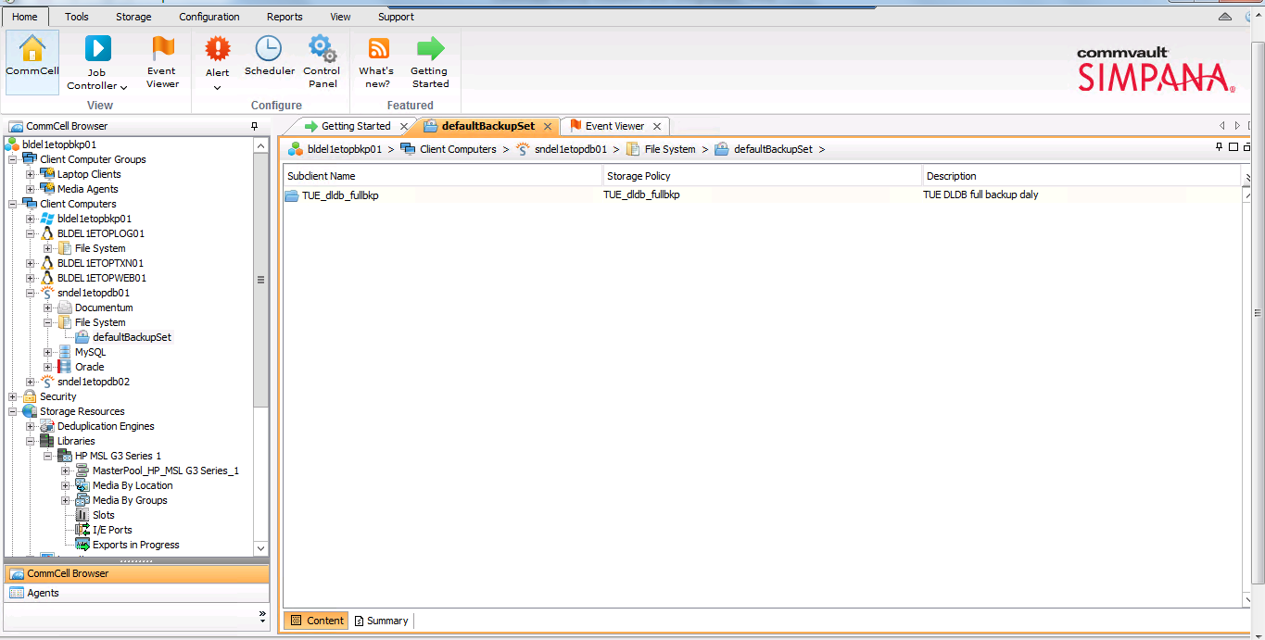

Test case
Scheduling Backup

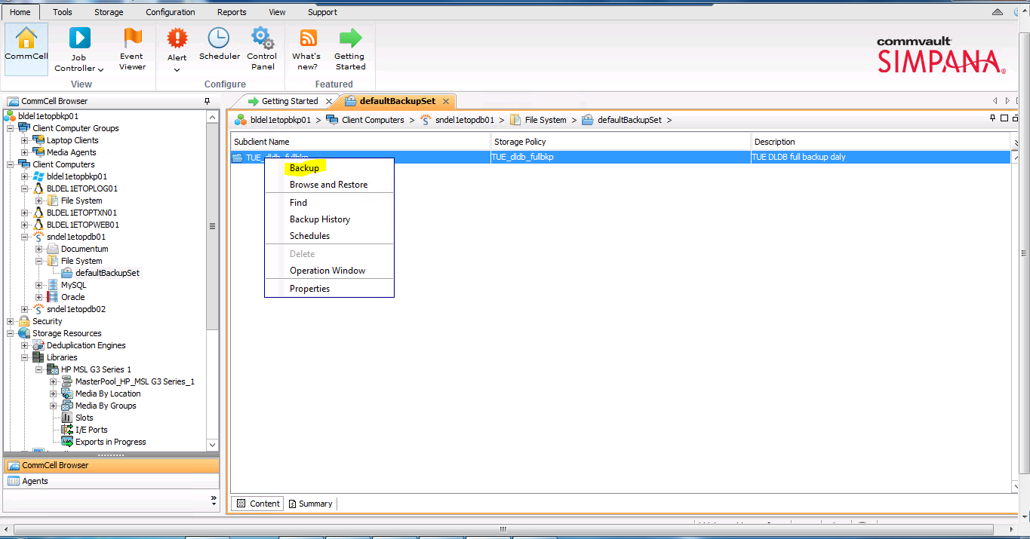

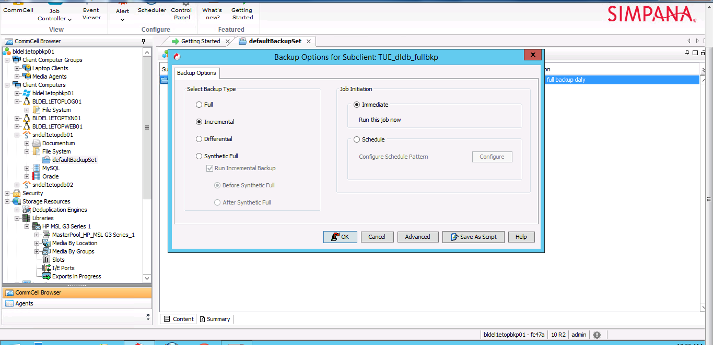
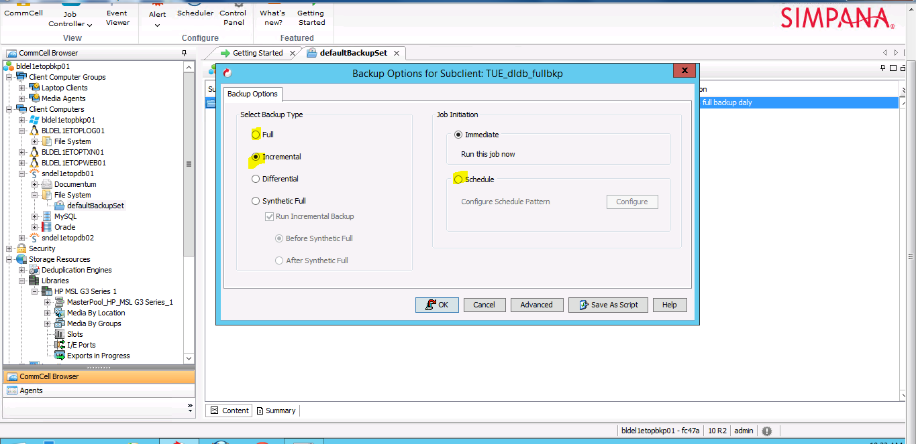

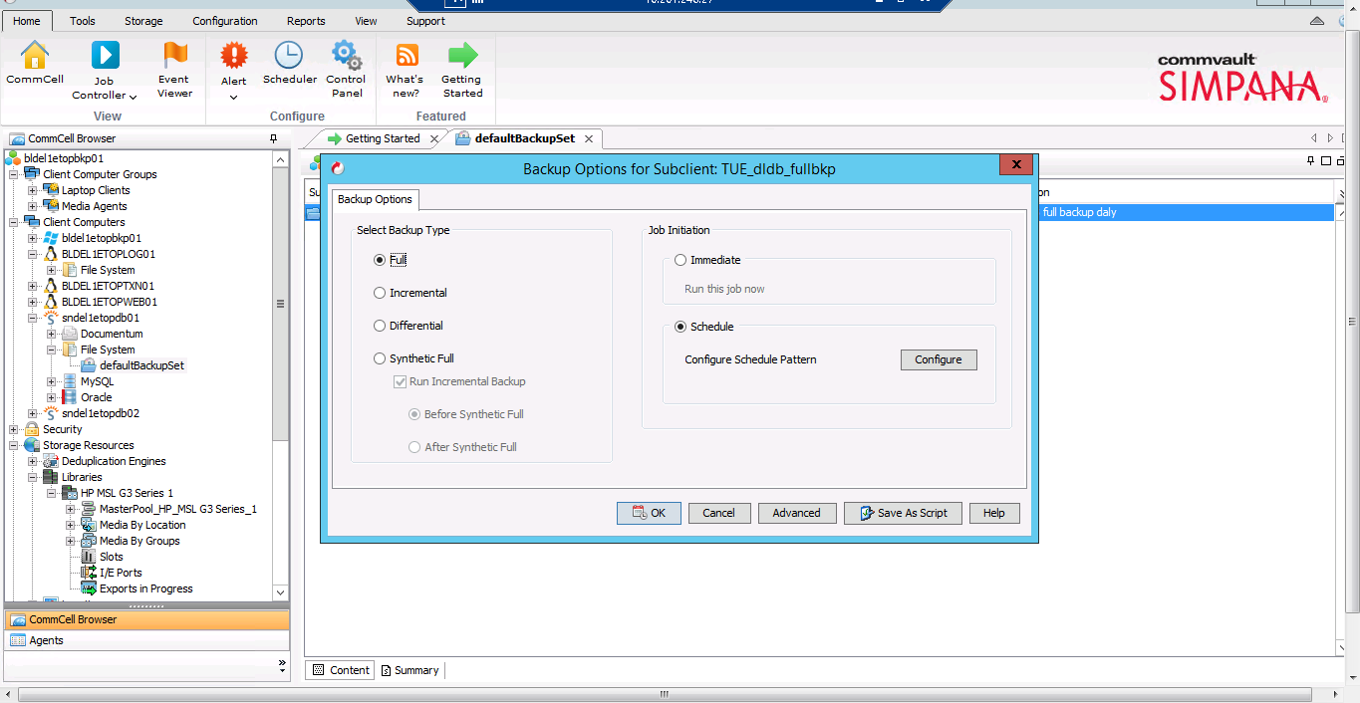

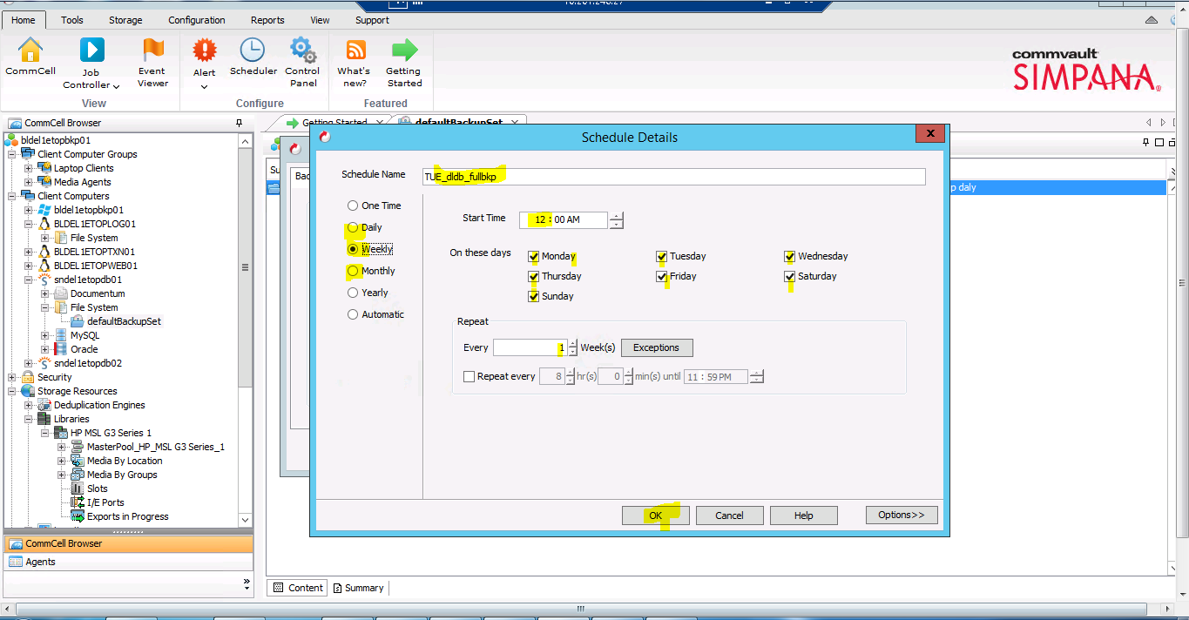

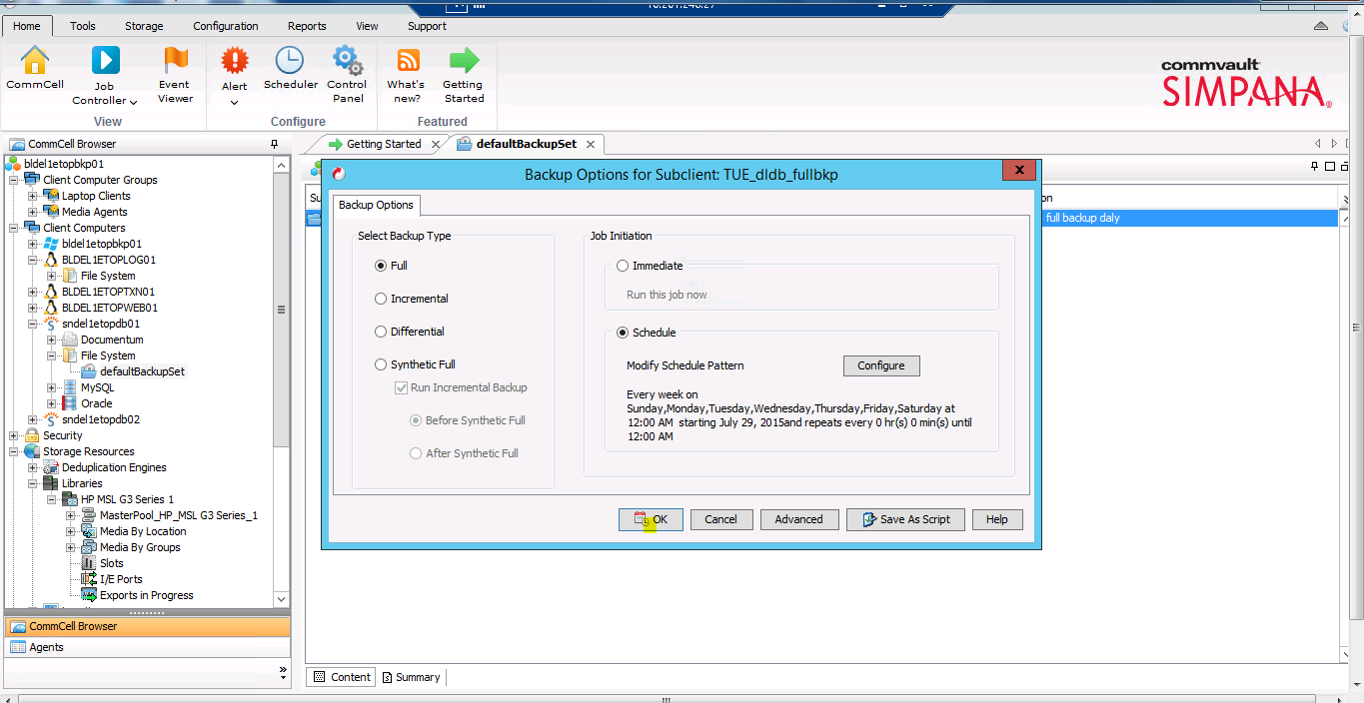

Running /Testing Backup
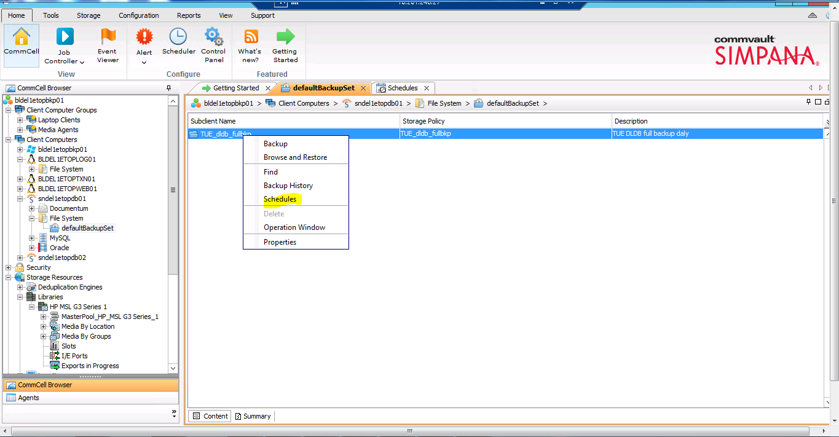
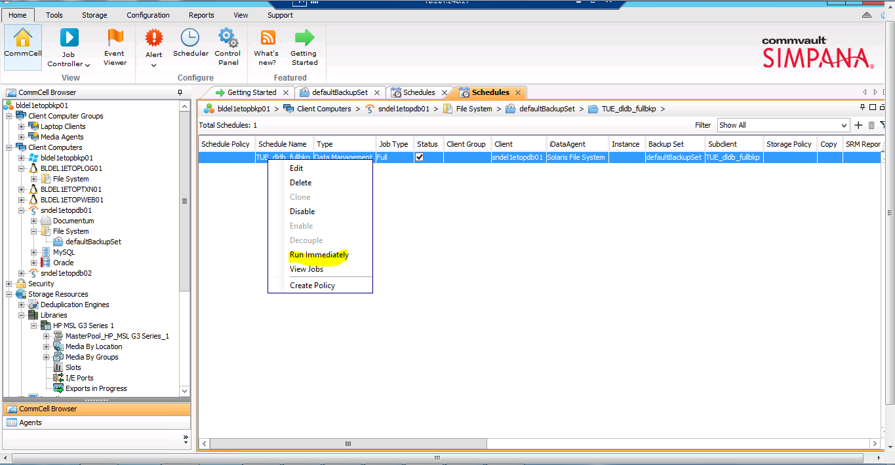

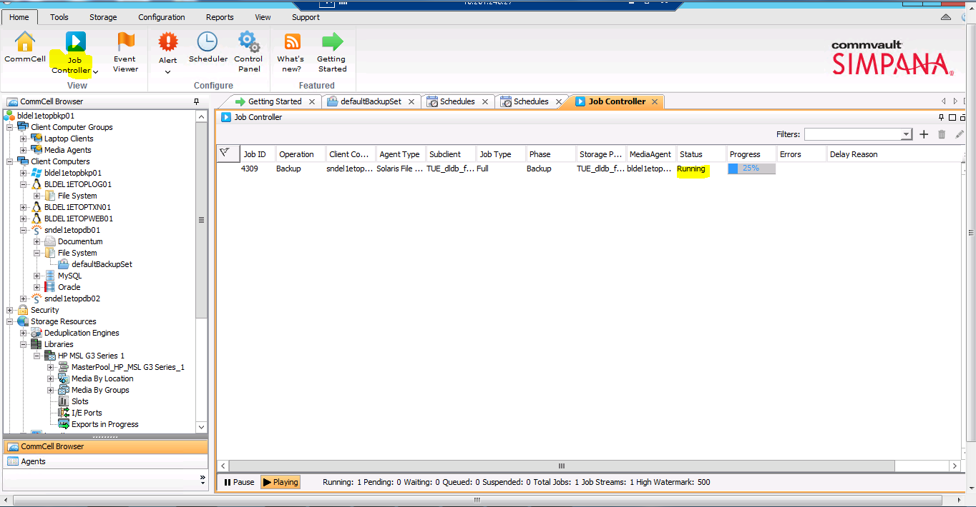

Backup & Retention Policy.
In attached sample excel sheet, we have mentioned the backup and retention policy which is configured. Also this sheet has the details of servers and their mount points.

There are total 23 tape media in tape library. Two pools have been created, one for DB backup and other for Application & Syslog backup. Each backup is being created in separate tape media. If tape media is full than it will use other media automatically. Also the backup data will be cleaned as per retention policy and then media will be re-used automatically.

Disclaimer
Copyright © 2013: Comviva Technologies Ltd, Registered Office at A-26, Info City, Sector 34, Gurgaon-122001, Haryana, India.

All rights about this document are reserved and shall not be , in whole or in part, copied, photocopied, reproduced, translated, or reduced to any manner including but not limited to electronic, mechanical, machine readable ,photographic, optic recording or otherwise without prior consent, in writing, of Comviva Technologies Ltd (the Company).
The information in this document is subject to changes without notice. This describes only the product defined in the introduction of this documentation. This document is intended for the use of prospective customers of the Company Products Solutions and or Services for the sole purpose of the transaction for which the document is submitted. No part of it may be reproduced or transmitted in any form or manner whatsoever without the prior written permission of the company. The Customer, who/which assumes full responsibility for using the document appropriately. The Company welcomes customer comments as part of the process of continuous development and improvement.
The Company, has made all reasonable efforts to ensure that the information contained in the document are adequate, sufficient and free of material errors and omissions. The Company will, if necessary, explain issues, which may not be covered by the document. However, the Company does not assume any liability of whatsoever nature , for any errors in the document except the responsibility to provide correct information when any such error is brought to company’s knowledge. The Company will not be responsible, in any event, for errors in this document or for any damages, incidental or consequential, including monetary losses that might arise from the use of this document or of the information contained in it.
This document and the Products, Solutions and Services it describes are intellectual property of the Company and/or of the respective owners thereof, whether such IPR is registered, registrable, pending for registration, applied for registration or not.
The only warranties for the Company Products, Solutions and Services are set forth in the express warranty statements accompanying its products and services. Nothing herein should be construed as constituting an additional warranty. The Company shall not be liable for technical or editorial errors or omissions contained herein.

The Company logo is a trademark of the Company. Other products, names, logos mentioned in this document , if any , may be trademarks of their respective owners.

Copyright © 2013: Comviva Technologies Limited. All rights reserved.

Thank You
Visit us at www.mahindracomviva.com

