Scope of Work Document
Integrated Messaging (SMSC & SMS-GW)
Unixplus
Version 1.0

Contents
Contents 3
1 Introduction 6
1.1 Purpose 6
1.2 Scope 6
1.3 Definitions, Acronyms, Abbreviations 6
1.4 Audience 6
2 Product Overview 7
2.1 Product Description 7
2.2 Philosophy of Messaging Solution 7
2.2.1 Multiple Delivery Channels 7
2.2.2 Simpler Management 8
2.2.3 Enhanced Value 8
2.2.4 Power and Space Savings 8
2.3 Delivery Channels Offered to Unixplus 9
2.3.1 SMS Channel 9
2.3.2 USSD Channel 10
2.3.3 A2P Manager (SMS-GW) 11
2.4 Benefits 12
2.5 Architecture 13
2.6 SMS Call flows 17
2.7 Features and Functionalities 17
2.7.1 Traffic Management 18
2.7.2 Congestion Management 20
2.7.3 CP/ESME Management 23
2.7.4 General features 25
2.7.5 Ecosystem Management 26
2.7.6 Configuration and Service Management 26
2.7.7 SMS Management and Control 28
2.7.8 Fraud Control Management 30
2.7.9 USSD Management 31
2.7.10 System Backup 31
2.7.11 Housekeeping 32
2.7.12 Extensive Logging 32
2.8 Regulatory and Standards Compliance 33
3 Unixplus’s Technical Solution (Scope of Work) 34
3.1 Solution Overview 34
3.1.1 Software Deliverables 34
3.1.2 Capacity Dimensioning 34
3.1.3 MDA Definition and Licensing 34
3.1.4 Hardware Specs 35
3.2 Deployment Specifications 36
3.2.1 Feature list 36
3.2.2 Deployment Architecture 36
3.2.3 Solution Redundancy Description 36
3.2.4 System Integration Scope 37
3.2.5 Operations, Maintenance and Administration 37
3.3 Project Specific Scope 41
3.3.1 RJio Specific requirements and customizations 41
3.3.2 Applications (USSD) 41
3.3.3 Migration Scope 41
3.3.4 DND functionalities 42
3.3.5 Charging and Billing 43
3.3.6 Reports and Statistics 43
3.3.7 Logs and CDRs 45
3.3.8 KPI Requirements 46
3.3.9 Security Requirements 46
3.3.10 Data Retention, Archiving and Cleanup 47
3.3.11 Backup and Restore 47
3.3.12 Implementation and Services 47
3.3.13 SLA 48
3.3.14 Training 48
3.3.15 Documentation 48
3.4 Testing and Acceptance 48
3.4.1 System Integration Testing 48
3.4.2 User Acceptance Procedure 49
3.5 Assumptions, Pre-requisites and Dependencies 49
3.5.1 Major Assumptions and Constraints 49
3.5.2 Pre-requisites & Dependencies 51
3.6 Risks, Impact and Mitigation 53
3.7 Responsibility Matrix 53
3.8 Out of Scope 54
4 Document Change History 56

Introduction

Purpose
The purpose of this document is to provide solution details of Mahindra Unixplus’s Integrated Messaging (enabled with SMS and USSD bearers/channels) and SMS-GW to Unixplus India.

Scope
The scope of this document is to provide the overview of Mahindra Unixplus’s Integrated Messaging (enabled with SMS and USSD bearers/channels) and SMS-GW to Unixplus India and provide the features that will be provided as part of the solution. USSD shall be deployed when RJio is ready to launch the USSD based services.

Definitions, Acronyms, Abbreviations
Acronyms | Full Form
CDR | Call Data Record
GSM | Global System for Mobile Communication
GSMSCF | GSM Service Control Function
HLR | Home Location Register
IMSI | International Mobile Subscriber Identity
IP | Internet Protocol
LME | Layer Management Entity
MAP | Mobile Application Part
MDA | Message Delivery Attempt
MMI | Man Machine Interface
MS | Mobile Station
MSC | Mobile Switching Center
MSISDN | Mobile Station International ISDN Number
PLMN | Public Land Mobile Network
PSSR | Process Unstructured Supplementary Service Request
PSSD | Process Unstructured Supplementary Service Data
SME | System Management Entity
SMPP | Short Message Peer to Peer
SMS | Short Message Service
SS7 | Signaling System No. 7
TCP | Transmission Control Protocol
SCCP | Signaling Connection Control Part
TCAP | Transaction Capabilities Application Part
USSD | Unstructured Supplementary Service Data
USSN | Unstructured Supplementary Service Notification
USSR | Unstructured Supplementary Service Response
VLR | Visitor Location Register
VPLMN | Visited Public Land Mobile Network
USSN | Unstructured Supplementary Service Notification

Audience
This document is intended for the technical group of Unixplus India and Mahindra Unixplus.

Product Overview

Product Description
Mahindra Unixplus’s Integrated Messaging and SMS-GW platform offered to Unixplus is a highly scalable, cloud-ready and consolidated messaging infrastructure platform. It enables the operator to efficiently and cost-effectively manage a range of messaging related services by consolidating all of the key messaging delivery channels required by them.
It simplifies management of the complete messaging lifecycle – from service creation and deployment to service management & maintenance – the Integrated Messaging and SMS-GW Solution places greater control in the hands of the mobile operator, faster service launch, and implementation of enhanced operational efficiencies from a common OAM and Reporting GUI.
Taking an open-standards approach to enable greater flexibility, the solution seamlessly handles third-party components, ensuring new services can be launched rapidly and at a small incremental cost. The platform further optimizes outlays by being architected to ensure that each module scales independently.
Platform enables operators to have better message management and control by offering single reporting tool which provides end-to-end visibility of all transactions, capacity utilization, and subscriber activity across channels.

Philosophy of Messaging Solution
Unixplus’s integrated messaging platform is built on the philosophy of offering a single platform to mobile operators for fulfilling all their messaging needs and at the same time providing business benefits such as bringing down the overall TCO and improving customer experience/ satisfaction. Following are some advantages of Unixplus’s integrated messaging platform.

Multiple Delivery Channels
Unixplus’s integrated messaging platform gives access to multiple messaging delivery channels from a single place, enabling the management and delivery of multi-channel content from a centralized repository. In addition, the solution has a Common Reporting engine for all channels with associated features such as Common Transaction ID for easy end-to-end tracing of messages across channels and applications. Following are the different messaging delivery channels supported by the platform:
Table 1: Delivery channels
Delivery Channels Type | Brief Description | Offered/Not Offered
SMS | SMS channel is available as part of our integrated messaging platform for sending and receiving of SMS messages between the network and the user. | Offered
USSD | USSD channel is available as part of our integrated messaging platform for sending and receiving of session-oriented USSD messages between the network and the user. Both push and pull based services are supported. | Offered
Source: Unixplus

- **Only USSD and SMSC channels are part of the proposed solution. Any requirement to enable any other channels (enablers) in the future shall have commercial implications as applicable and defined in the Integrated Messaging commercial proposal submitted to Unixplus India.

Simpler Management
Integrated messaging platform offers centralized control for managing all third party application interfaces across multiple channels through a Single, Web-based GUI. It provides superior usability and user-experience to mobile operators via easy-to-use point and click tabs in a single web interface enabling end-to-end management of all applications across the channels. Automated backend integration reduces effort associated with configuration of keywords, short codes, subscription process, provisioning, etc…for all channels.

Enhanced Value
Unixplus’s integrated messaging solution provides some enhanced features to improvise customer experience by addressing the specific needs of the consumer and at the same time offering a unique value proposition in terms of new business models and alternative revenue streams for mobile operators to increase their falling ARPU levels.

Power and Space Savings
Significant amount of power and space saving can be achieved by replacing aging inefficient servers with up-to-date, more powerful, and energy efficient blade servers and unified storage. Improve power and cooling efficiency in every aspect of mobile operator’s data-centre operations.

Delivery Channels Offered to Unixplus

SMS Channel
Representing an evolution in intelligent message delivery, Mahindra Unixplus's SMSC is designed to deliver SMS according to the priority of the message itself. High priority messages, representing 80% of the messaging load, can be delivered via first delivery attempt (FDA), while the non-critical messages can be delivered in a store and forward manner. This helps optimize message delivery, even during peak hours.
SMSC is widely deployed across multiple operators to power personal (P2P) text SMS, diversified application SMS, and m-commerce/m-payment-related alerts and notifications. Operators also use SMSC to support mobile advertising and other binary messages, including ringtones, vcard, picture message, and operator's logo.

Business Need
Death of the SMS? Not quite
Some in the industry have been predicting the 'death of the SMS' for some time now, calling to light the fact that SMS is slowly being replaced by mobile internet and social-media based messaging apps. While many have suggested that operator SMS revenues are declining, data suggests that this may not be the case.
Analysts have estimated that global SMS traffic in Q2, 2012, was 2.2 trillion messages, up from 2.1 trillion in Q2 2011. Others have estimated increases in SMS revenues from 2012 to 2016, delivering a cumulative 1 trillion in operator revenue during that five-year period.
Diversified Applications
More interesting is increased recognition of the fact that the service lends itself to a host of use cases, resulting in significant expansions in the applications of SMS.
Businesses use SMS for marketing, advertising, vouchers, promotions, and competitions. Transportation and related organizations use it for ticketing and messaging customers. Banks and financial services have found the SMS useful for transactions, notifications, and security.
In all these situations and more, the value of the SMS comes from its cost-effectiveness, reliability, and availability. The SMS' omnipresence, across devices, is something that neither OTT, nor rival messaging, nor related apps, can hope to replace in its entirety.
The Need of the Hour
Operators are facing steady pressure on their SMS revenues and are faced with the need to find new ways to revitalize the SMS side of their business. Critical at the moment is the handling or large, complex traffic flows, while maintaining—and potentially exceeding—overall quality of service. Traditional SMS infrastructures are slowly becoming obsolete, for a variety of reasons, among which are congestion, delays in message delivery, load repartitioning issues, lack of routing, and lack of flexibility.
The need of the hour is a reliable messaging platform that allows operators to maximize their SMS revenue while ensuring subscriber loyalty and satisfaction.

Key Features
Mahindra Unixplus's SMS Platform extends the capacity in the current network by optimally distributing network load and traffic flows, or by introducing message controller elements that can generate significant traffic offloads. This introduces traffic management controls, while consolidating network access and enabling services integration.
The SMS Platform offers a range of traffic handling options, tailored to the operator's messaging needs, to improve transaction performance on the network, and significantly reduce SMS infrastructure costs.
Mahindra Unixplus's transformative approach assesses current SMS network architecture, analyzes the characteristics and the flow of messaging traffic patterns, anticipates growth trends and then brings together a relevant set of technologies, approaches and capabilities to optimize the operator's SMS infrastructure.
The SMS Platform portfolio includes:
- SMSC
Powers smooth delivery of the rapidly growing volumes of A2P and P2P messages
- AppSMSC
Provides seamless support of mass application based traffic to free-up expensive P2P messaging capacity
- SMS Router
Ensures efficient delivery of increasing volumes of SMS, without requiring high levels of network investment

USSD Channel
Service innovation is vital to maintain strong growth and counter intense competition in any telecom market. The ability to continuously provide compelling content and engaging services and applications to subscribers is a key growth driver for operators. These offerings, or Value Added Services (VAS), can enable operators to retain subscribers on their network, develop alternative revenue streams and create differentiation.
Mahindra Unixplus's Integrated Messaging containing USSD channel is an end-to-end solution that sets new standards for user experience, interactivity, usability and mobile content consumption.

Business Need
The Need for Innovation
With strong competition from OTT providers which offer free services, operators need to match their investment in data, with a similar investment in innovation and core communication services. For operators, service innovation is about significantly more than developing incremental revenue streams.
Operators are in a unique position to capture a larger portion of the subscriber base, since they own the network the subscribers use. Leveraging either internal development teams or partnering with smaller technology providers that focus on disruptive technologies can result in the launch of operator branded innovative apps in the market.
Recapturing the Marketing with New Technologies
One example of innovative technologies is cloud-based messaging apps built and delivered by operators.
Verizon Messages was launched in early 2013, and received the "Best of Show" award at CITA 2013, in the emerging technologies category. 90 days of messages are synced between all devices that the user has the app on; it is fully compatible with both local and international text messaging; in addition to the traditional features of multimedia messaging, the app also offers collage, captioning, and sketching capabilities.
Other apps, such as Tu Go and Messaging Plus, also include audio and video capabilities, location sharing, and address book integration, along with multi-device support and file sharing.
With these apps being increasingly preloaded on mobile handsets today, and users showing clear interest in them, operators are working to find ways to develop their platform beyond the more traditional messaging and communications solutions.

Key Features
Mahindra Unixplus's USSD suite has immense potential to enhance operators' service offerings, create better visibility and improve end-user experience. The suite provides the operator a faster way to interact with its subscriber base whilst at the same time enabling the creation and launch of new services in just a few minutes.
It also empowers the operator to leverage the vast number of 'ready to launch' applications available with Mahindra Unixplus or just make use of the application platform where operators have the flexibility to customize applications as per their requirements.
- USSD Channel
The USSD channel delivers high-speed interactive content to mobile subscribers, linking content providers to end users and maintaining real-time interaction, without consuming large amounts of bandwidth.
- USSD Service Creation Environment
USSD FLARES (Framework to Launch Applications and Rapidly Evolve Services) or USSD Service Creation Environment provides a service creation environment on a single platform, enabling management of all internal and external applications involved in delivering value added services to the mobile user.

A2P Manager (SMS-GW)
Mahindra Unixplus A2P Manager, earlier known as the Short Messaging Gateway (SMS-GW) is a convergent solution, providing a single platform that facilitates content provider - operator collaboration. A2P Manager speeds service creation, improves service control and enables timely service delivery over multiple bearers, whilst offering enterprise customers an efficient route to effective message delivery. Key Features of Unixplus A2P Manager are:
- Content providers upload content and applications to A2P Manager over SMPP interface, defining relevant delivery specifications.
- A2P MANAGER provides an easy plug-in interface allowing third-party content-providers to upload content quickly and seamlessly, regardless of the underlying protocols; A2P MANAGER supports HTTP, HTTPS, CIMD, SMPP, FTP, WEB and PI protocol interfaces. But only SMPP, FTP and HTTP are part of proposed solution.
- Complete Access and Control for Operator over the content and applications
- Scheduled Delivery, Message Prioritization for Content Providers and Operators
- Load Distribution ensures smooth delivery of messages; Easy Integration with Network Elements; A2P MANAGER delivers comprehensive reports on usage characteristics for submitted messages, such as application access during a month, day or hour, or number of requests served successfully

Benefits
Unixplus’s proposed Integrated Messaging solution as Integrated Messaging offers a wide array of benefits to operators and consumers alike:
Smooth Message Delivery:
Modular in approach, network independent and able to seamlessly scale to handle growing and diverse A2P and P2A messaging streams, Unixplus SMSC is a proven carrier-grade solution that meets stringent operator requirements for an advanced traffic control and message delivery engine.
Scalable Message Throughput:
Unixplus SMSC is able to scale rapidly to handle growing messaging needs and incorporates advanced load balancing features
Time to Market:
New value added services and third party applications can be integrated with the SMSC with minimal time to market
Service Differentiation:
Integration of the SMSC core platform with Unixplus Intelligent Messaging Suite ensures operators have access to network capacity whenever and wherever required
One Stop Shop:
Unixplus has a large portfolio of messaging products and can cater to all the needs of operator. Unixplus has deployed its messaging solutions for a large number of operators and is capable of delivering customized solution to handle both small and large subscriber base.
Creates New Customer Segments:
Delivering Enhanced content, applications in multiple formats helps target new consumer segments as well as grow existing consumer ARPU. Enhanced Service Experience creates satisfaction and Loyalty amongst subscribers
Enhanced Brand Image:
Single Platform drives content provider collaboration, creating an extensive suite of content applications and enhancing the brand image
Drives Revenues:
Cost-effective platform with Enhanced suite of applications drives top line
Reliability:
Unixplus integrated messaging solution is a reliable service that ensures subscribers receive messages promptly, ensuring highest quality standards.

Architecture
Unixplus proposes its Integrated Messaging to enable the Integrated Messaging Platform which comprises of
- SMS Platform
- A2P MANAGER
- USSD
- Charging Module
The network architectures, stated below, detail out the scalability and availability of the proposed solution. The following diagram depicts the solution architecture of Unixplus Integrated Messaging Solution at Unixplus India network premises.
Solution Architecture
Unixplus Unified integrated messaging platform is capable of configuring the complete platform access, configurations & management using a single GUI. Any component in this platform can be operated from this login interface based on user privileges. Logical representation of Unixplus messaging components proposed in this solution is depicted as below.
Integrated Messaging Platform Architecture

Below section provides the details of software modules available in the proposed integrated messaging platform.
Integrated Messaging Platform Modules
S. No. | Module Name | Description | Offered/ Not Offered
1. | Messaging | Messaging is a module that forms the basis of the integrated messaging platform. It comprises standard functionality that is common to all service modules and applications.  All MO or MT messages across channels will be routed through the messaging core layer. Any application module can call the core messaging layer by using the specific APIs.  This architecture allows not only existing service modules to use the core functionality but also enables third party application providers to built new applications or service modules on top of it.  It is designed for performance, reliability, availability, and scalability. | Offered
2. | Traffic Management | It is a management responsible for traffic routing, distribution, load balancing and control of messages between mobile users, network, and content providers. Besides that it also takes care of the management of application interfaces, push and pull services, charging definition for each service, pre-paid and post-paid account management. | Offered
3. | Service Management | Unixplus’s FLARES is a Service Creation Environment framework which acts as a single platform for managing all internal and external applications that provides value added services (Pull services) to the end user using mobile messaging.  FLARES deliver an extensive range of features to manage the subscriber’s profile, the application profile, and for device management, session management and content management. For the service provider, FLARES enables the analysis of the traffic and system level reports. | Offered
4. | Policy Manager | Unixplus’s content provider and application interface is based on many open wireless standards specified by 3GPP, OMA. It enables mobile service providers to manage push and pull based services with multiple forms of content from multiple content providers more efficiently and effectively.  The system is built with a framework wherein different messaging platforms and interfaces can be easily plugged into the system without disturbing the current functionalities. | Offered
5. | Partner Management module | This module will help in managing the content providers and partner organization’s applications. Each organization will have a single admin to which all permissions and privileges are assigned. Admin can create different users within the organization and has the power to allocate different privileges to each user.
6. | KPIs | Unixplus’s integrated messaging platform will have common OAM module for all delivery channels.  The Operations and Maintenance module is a powerful 24/7 back-office surveillance mechanism that closely monitors the integrated messaging platform, measures process efficiency, and schedules tasks for the systems and manages process workflow. Equipped with a user-friendly graphic interface, the O&M module provides an extensive set of front-end administrative options that help mobile operators map platform performance metrics and undertake immediate corrective measures when necessary. | Offered
7. | Reports and Statistics | Unixplus’s integrated messaging platform has a powerful inbuilt engine to produce reports and is able to track message trends over time and aid mobile operators in plotting resource utilization, analyse message capacity and strategize service planning.  This gives information on various traffic segments, usage pattern, trends, etc… | Offered
8. | Charging | Integrated messaging platform supports billing for text and data messages handled in the platform. It can support billing in two different modes as explained below:  FTP support for CDR’s:  System supports FTP interface to interact with third party billing system. Either billing system pulls the CDR’s from Unixplus platform or CDR’s shall be pushed to billing system.  Once the CDR is transferred successfully the files will be deleted. Billing system should provide the FTP access for the same.  Duration or the periodicity for pushing the CDR’s is configurable.  System supports only FTP access for collecting the CDR’s by the billing system. Hence on failure billing system has to retry.  Billing Module:  For pre-paid subscribers, integrated messaging platform can interact with 3rd party billing gateways or directly to operator’s IN servers over following interfaces:  - UCIP 3.0/3.1  - Diameter SCAP v1  - MML  - Diameter Ro Interface | Offered
Unixplus’s integrated messaging platform gives access to multiple messaging delivery channels from a single place, enabling the management and delivery of multi-channel content from a centralized repository. Also, it has a Common Reporting engine for all channels with associated features like Common Transaction ID for easy end-to-end tracing of messages across channels and applications.

SMS Call flows
SMS Call flows are described in the document attached below.

Assumptions and Notes on the Call Flows:
  - A-party MNP is required for circle identification.
  - A-party and B-party number in Cloudmark requests will be sent prefixed with LRN, so A-party and B-party MNP dip shall be done before Antispam.
  - SMS-GW (A2P Manager) shall maintain local DND-DB and DND data will be synched from RJio’s DND DB on periodic basis.

Features and Functionalities
Unixplus’s Integrated Messaging platform to Unixplus enables operators to shape traffic and effectively utilize resources to realize optimum cost efficiencies. Unixplus’s solution provides a range of features that enable operators to effectively handle increased messaging loads without requiring a linear progression in upgrades. Below are the features offered to Unixplus:
- Traffic Management
- Congestion Management
- Application Message/ CP Management
- Ecosystem Management
- Configuration and Service Management
- SMS Management and Control
- USSD Management
Details of these features are provided in the tables below. Features and functionalities mentioned in the below tables are part of the scope. Any deviation or changes or new additional features required in the future shall be taken as customization, which may have commercial implications.

Traffic Management
The following table outlines Integrated Messaging (IM) Platform’s traffic management features.
Traffic Management Features
S. No. | Traffic Management Feature | Description | Business Potential | Offered/Not Offered
1. | Dynamic rule configuration | Unixplus IM supports rules which can be easily configured by the admin using GUI. The rules are broadly classified as redirection and restriction rules | Enables configuration of rules with various combinations in order to support operators traffic shaping requirements | Offered
2. | Time/Day based traffic management | Capability to flexibly route messages to other nodes during a particular Day of year / Time of day. | Enables improved management of SMS traffic based on day to day expected SMS traffic patterns | Offered
3. | MSC based Routing | Messages can be distributed across connected Mobile Switching Centers (MSC) | Operators can define an alternate routing policy if the primary route is congested | Offered
4. | Error based redirection | Messages which failed to get delivered on account of error can be redirected to the fallback SMS/ MMS Platform based on the type of temporary error codes | Enables improved messaging traffic management by defining suitable actions to be performed on error based messages | Offered
5. | Alpha Numeric Sender Id Redirection | These rules are used to bar CP accounts with specific system IDs | If the MO traffic is very high at any time, IM Platform uses this rule to temporarily bar AO messages. | Offered
6. | CP delivery mechanism | Messages can be directly delivered or stored and delivered at a later period of time | Operators can choose from the delivery mechanism and route message as per priority. | Offered
7. | MO Forwarding | MO forwarding is used when SMS Platform relays the SMS to the fall back SMSC | This is applicable when SMS Platform distributes SMS traffic to the configured SMSC in order to achieve load balancing. | Offered
8. | Country Code Prefixing | Ensures that destination mobile numbers earmarked for message delivery by client applications are in the valid GSM format | Correct destination address ensures successful delivery of messages | Offered
9. | Address Translation | SMSP supports a wide range of address translation that can be applied to Destination MSISDN | Enables configuration of a flexible routing policy as per requirements | Offered
10. | Virtual Service Center Support | Refers to an SMS Platform, which acts as a virtual SMSC by providing SMS services to subscribers of other PLMNs | Serves the purpose of multiple SMSCs using only 1 SMSC | Offered
11. | Multiple SC address support | Multiple service centers from different networks can connect to the same IM Platform. | Supports centralized deployment to meet the messaging needs of various networks | Offered

Congestion Management
The following table outlines IM Platform’s congestion management features.
Congestion Management
S. No. | Congestion Management Feature | Description | Business Potential | Offered/Not Offered
1. | Intelligent Load-balancing | Rules such as priority based message routing, Round robin, Percentage based message distribution can be configured to achieve load balancing | Facilitates control of network congestion by intelligent routing of m traffic | Offered
2. | Throttling control for CP accounts | CP account-based throughput regulation | Operators can regulate application-originated message flows on the network by assigning per second, per minute, per hour and per day messaging limits on CP accounts. | Offered
3. | Congestion Notification | SMS Platform receives an alert from the MAP Stack and it reduces the number of message transmissions per second | Enables closer monitoring of network congestion | Offered
4. | Large message buffer pool | Even if there are minor problems in operator network in delivering messages, the system buffers incoming messages for further delivery. | This prevents queue build up and prevents system logjam. | Offered
5. | First retry from the system | In case of SMS Platform performing FDA (First Delivery Attempt), the routing engine does not store the message in any of the secondary storage mechanisms and performs first retry. | Reduces SMS traffic on the fallback SMSC as 90% of the SMS is delivered with FDA and 1st retry | Offered
6. | Intelligent Retry Schedules | The retry policy governs the number of attempts at message delivery within a pre-defined timeframe. | Facilitates congestion management | Offered
7. | Auto Reply | Platform allows configuration of an auto reply (standard) for each service number/s against any CP account. | Helps avoid the user sending further request/s thus enhancing the user’s experience | Offered
8. | Priority Delivery | Priority values ranging between 0 and 3 where 3 is the highest priority level) can be assigned to application-originated messages. | Allows SMS Platform to continuously process traffic without wasting critical resources on low-priority application traffic | Offered
9. | Priority SRI | SMS Platform supports Send Routing Information (SRI) request s to the HLR with High Priority. | Any message qualifying for this rule will query the HLR for SRI with high priority. This will increase the probability of successful delivery of messages from VIP/VVIP subscribers in the absence of an Alert SC. | Offered
10. | Session Deactivation | Disable application sessions from an operator’s GUI | Disables non-critical application sessions and reduce SMS traffic congestion | Offered
11. | Message Expiration | Supports enabling/disabling SMS validity period | To maintain the relevance of the messages that subscribers receive, SMS Platform discards messages whose validity period has expired | Offered
12. | Alert Notifications | SMS Platform buffers messages that remain undelivered on account of temporary transmission errors until it receives alerts from the HLR indicating that a mobile station is available. | Helps to schedule new delivery attempts in accordance with predefined retry parameters | Offered
13. | Message Throttling | Provides an effective SMS flow control mechanism by placing a cap on the higher limit up to which SMS can be pushed | Enables handling of increased traffic loads without degrading the overall system performance  License modules manage system level throughput control, based on transactions processed per second | Offered
14. | Disable Delivery Reports | Enable/disable delivery reports | At peak periods, along with the rise of SMS, there is a relative rise in the number of delivery reports. This may cause congestion in the operator’s SMS nodes. | Offered
15. | Failure reply configuration | Administrator can configure failure replies for each service through the web GUI provided for CP management. | Reduces unnecessary bursts in SMS traffic. | Offered

CP/ESME Management
The IM Admin has provision to create and defined rights for multiple Content Partners e.g. the IM admin of an operator can assign the rights of creating CP/ESME users and assigning capacity to VAS team. Utilization and monitoring rights can be assigned to the Network team. The following privileges can be controlled to the second level administrator.
- Region management
- Partner Management: Content Partner Lifecycle
- CP/ESME Creation
- Authentication and authorization
- Privileges and Quota Allocation
- Assigning Service and Short code
- Delete or Expire Account
- CP/ESME Account creation/view/ termination/suspension
- CP/ESME User creation/view/ termination/suspension
- CP/ESME Admin creation/view/ termination/suspension
- Reports download/view permission
- Charging definition
- Server configurations and monitoring
- Comprehensive Web Based Portal for Customer Care
CP Mangement
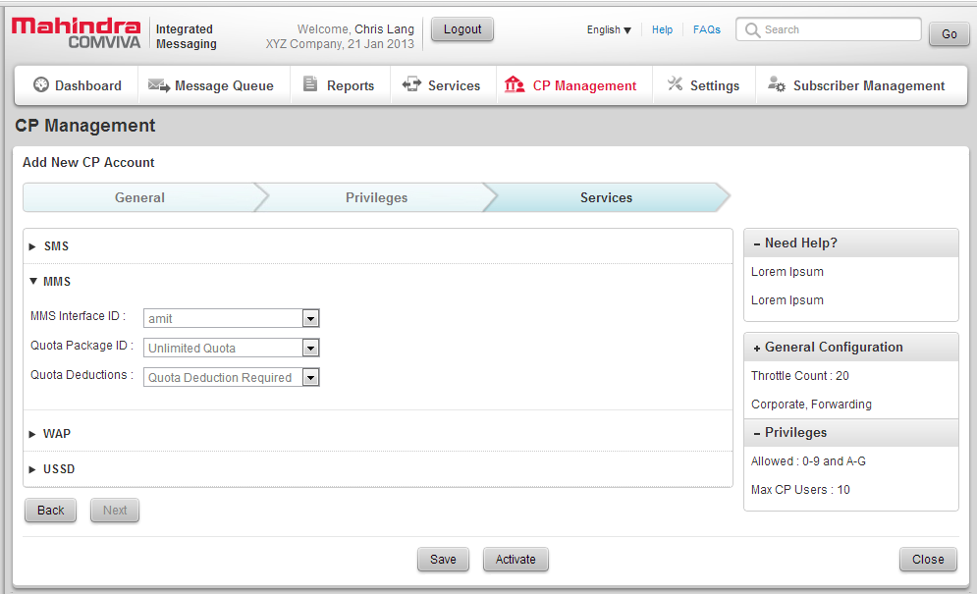
The following table outlines IM Platform’s message management features for CP’s.
CP Management Features
S. No. | Application Message Management Feature | Description | Business Potential | Offered/Not Offered
1. | Multi Session Large Account support | Allows CP’s to have multiple sessions with SMS Platform | Enhances CP throughput requirements simply by initiating another session | Offered
2. | Multiple service number CP mapping | Allows the operator to associate multiple service numbers with an CP account. | Using different service numbers, users can access the same application. | Offered
3. | Short Message Delivery Policies for AO Traffic | Offers a wide range of message servicing options to SMPP/UCP applications. | Conforms to standard messaging policy. | Offered
4. | Special Message Indication | Supports special message indication in GSM networks for different types of message. | Provides a platform for third-party value added services or voice mail systems to indicate that a subscriber has outstanding messages. | Offered
5. | CP Account based retry configurations | Retry rules can be defined, based on the application. | Improves management of SMS traffic. | Offered
6. | Account based traffic details | Provides detailed messaging counts for all CP accounts configured on the system. | Account based statistics facilitate analysis of SMS messaging trends. | Offered
7. | Range based CP provisioning | Supports range based service number provisioning | Enables the operator to configure a large number of service numbers with less effort using length qualifier. | Offered
8. | Alert SC forwarding to SMPP CP’s | This feature enables CP’s to receive alert notifications from SMS Platform | Facilitates immediate sending of SMS when the mobile becomes reachable or is ready to receive messages. | Offered
9. | CLI Masking for CP Accounts | This feature allows operators to mask or hide the actual sender IDs for messages sent to a configured number series with the preferred sender IDs | By using masked send IDs, operators are able to penetrate networks that do not allow alphanumeric sender IDs from Application-Originated messages. | Offered
10. | Sender Id Prefixing for CP Accounts | Able to prefix the configured text to messages originating from CP accounts with alphanumeric sender id. | Facilitates identification of the account from which a message has originated. | Offered
11. | Message truncation/rejection | Messages transmitted by an External Short Message Entity that exceed predefined lengths are either rejected by SMS Platform or auto-truncated (to a predefined message length) or split and delivered. | Enables implementation of flexible message policies. | Offered
12. | SMPP Outbind | Allows SMS Platform to signal a CP to originate a bind_receiver request to SMS Platform. | Facilitates extending a session for cases where message delivery may be delayed due to a delay in processing. | Offered
13. | Submit Multi Support | Used to submit an SMPP message for delivery to recipients. | Helps to support delivery of messages to multiple recipients. | Offered

General features
The following table outlines SMS module’s general features which are considered as optional features in this proposal.
General Features
S. No. | Optional Features | Description | Business Potential | Offered / Not Offered
1. | Charging | Supports both prepaid and postpaid billing and enables each application to be configured with different charging configurations |  | Offered
2. | MNP Support | Instead of the MSISDN, all SMS will be routed based on the IMSI of the source and destination mobile terminal. | The subscriber keeps the same MSISDN number even after switching operator. | Offered
3. | Lawful interception of messages | Able to intercept copy and log messages that received or sent to suspected MSISDN. | Supports regulatory norms. | Offered

- **MNP feature is supported based on ENUM request towards Unixplus MNP-DB; subscriber LRN shall be retrieved and details shall be retrieved from HLR by SRI_SM request on LRN number. If any changes to approach in future shall be taken as customization which may have commercial implications.

Ecosystem Management
- A graphical rule-based service creation environment enables rapid on-boarding of 3rd party application developers, including content providers, enterprises, social networking, and IM applications.
- Provides SDKs that rationalize services development time by 72%.

Configuration and Service Management
- One view of all settings, including stack and core platform settings and 3rd party app configurations.
- Consolidated management of signalling interfaces, content providers and apps speeds content on-boarding, whilst automation of backend configurations reduces overall maintenance efforts.

Service Management
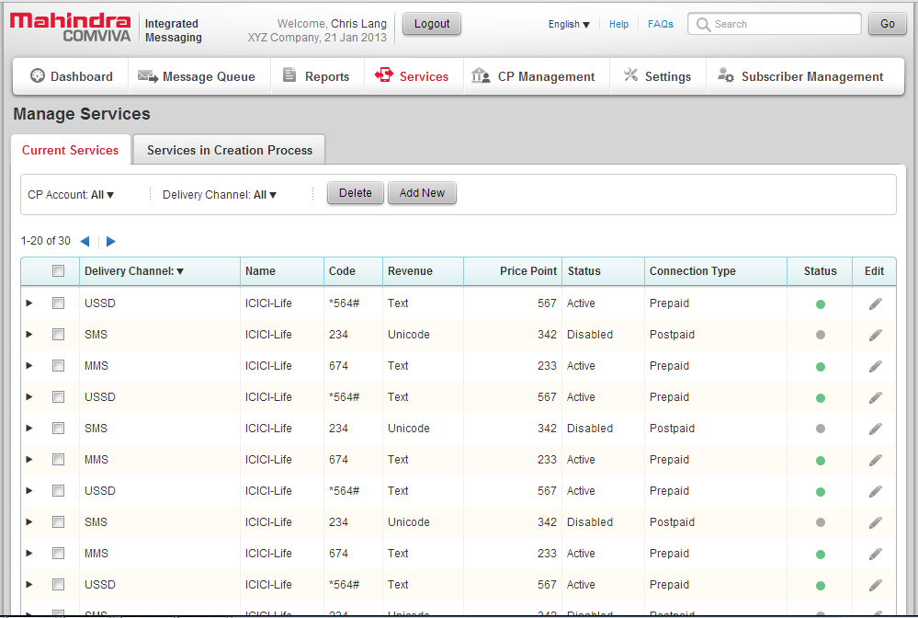
- GUI-based service wizards facilitate service lifecycle management from launch to retirement.
- Common GUI to create and manage all VAS simplifies service management and reduces related opex.
Configuration and Service Management Features
S. No. | Configuration Management Feature | Description | Business Potential | Offered / Not Offered
1. | SMPP account configuration | SMPP account configuration via GUI | Enables configuration of a new account using the UI | Offered
2. | Service code configuration | Service code configuration via GUI | Enables configuration of a new service code using the UI | Offered
3. | MSISDN group configuration | MSISDN group configuration via GUI | Enables configuration of a new MSISDN group using the UI | Offered
4. | VLR Group configuration | VLR Group configuration via GUI | Enables configuration of a new VLR group using the UI | Offered
5. | User management configuration | User management configuration via GUI | - Enables management (add/delete/edit) of configurations using the UI  - Enables the operator to distinguish users/operations personnel by their roles and provide access accordingly | Offered
6. | Reports | Reports | Generation of reports based on traffic, performance among others | Offered

SMS Management and Control
- Enables dynamically allocation of messaging capacity across channels to optimize and increase utilization.
- Single reporting tool provides end-to-end visibility of all transactions, channels, capacity and subscriber activity, enabling improved service management.
Message Management Features
S. No. | Message Management Feature | Description | Business Potential | Offered / Not Offered
1. | Deferred Delivery | Messages are buffered in the database and delivery will be attempted at a deferred time. | Enables creation of a pre-configure schedule for deferred delivery of SMS. | Offered
2. | Message Querying/Interception | Post-submission and prior to delivery, an CP can query for SMS related information | Operators can also view the textual contents of a short message, identify the CP from which the message originated and its intended destination | Offered
3. | Message Replacement | SMS Platform can replace the contents of a message before final delivery to the designated destination. | Helps the operator monitor and check message content. | Offered
4. | Message Cancellation | SMS Platform supports cancellation or deletion (through CP applications) the short messages that are stored in the database. | Supports greater flexibility in message management. | Offered
5. | Override reply via same service centre | SMS Platform supports masking of replies via the same service center parameter for mobile terminated messages. | This feature ensures that messages originating from the operator’s network will be handled by the operator’s SMS Platform and not any other SMSC. | Offered
6. | Multipart messages | If the message length is longer than 160 characters, SMS Platform splits the message into several parts and delivers it. | Ensures that the full SMS is delivered even if it is more than 160 characters. | Offered
7. | Multiple recipient distribution list | Messages can be sent to multiple recipients | Supports greater flexibility in message management | Offered
8. | Canned Text Messaging | Provides up to 254 canned messages for delivery through SMS Platform | Supports greater flexibility in message management | Offered
9. | Binary data support | SMS Platform supports the processing of binary data, ASCII, and double byte (UCS2) short messages enabling applications to send and receive short messages | Besides text SMS, other types of messages such as the operator’s logo and ring tones are supported for promotional or related activities. | Offered
10. | Unicode character set supports | Universal Character Set (UCS-2) format is a character string where each character is represented by 2 bytes. | Helps to send SMS in various languages including. | Offered
11. | Message Validity Period | SMS Platform appends a default validity period to messages transmitted by an application or a mobile station that contain no validity period. | Supports greater flexibility in message management | Offered
12. | Delivery Notifications | Notification on success/failure of delivery of SMS | Helps to track success or failure of the delivery of SMS | Offered

Fraud Control Management
The following table outlines IM Platform’s SMS fraud control features. As per discussion with Jio and Cloudmark team on 19th March 2015, all Antispam (Fraud Control & Content Filtering) features and rules need to be disabled in Unixplus IM (SMSC) solution as all Antispam features and rules will be handled by Cloudmark solution.

Fraud Control Features
S. No. | Fraud Control Feature | Description | Business Potential | Offered / Not Offered
1. | Spam Control | SMS Platform intercepts SMS and segregates all spam and drop them while normal SMS are delivered to the destination | This helps the operator to keep their network clean from unwanted messages, reduce congestion and improve end user satisfaction | Offered
2. | Spoof Control | SMS Platform detects any spoofer who uses an engine to simulate mobile devices and uses a home/foreign SMSC to deliver messages. | This helps the operator to keep their network clean from unwanted messages, reduce congestion and improve end user satisfaction | Offered
3. | Anti-Flooding | Detects sudden increases in SMS traffic from the same originator(s). | Prevents over-flooding of the network form a particular source | Offered
4. | Pattern Detection | It detects messages which are (very) similar to a relatively large number of recent messages. | Helps to identify unwanted SMS | Offered

USSD Management
USSD shall be deployed when RJio is ready to launch the USSD based services. USSD feature shall be discussed and agreed later during USSD deployment.

System Backup
- Daily backups of DB – The data is backed up on a daily basis. This is an automatic process.
- Weekly/Fortnightly backups – This is a cold backup where the complete data is backed up.
- If the current data is corrupted or the data is inaccessible, the recent full backup with the incremental backups available before the failure occurred will be used to restore the data and bring the service back alive.
- Backups are done on media such as tape or disks, depending on the requirement.
- Separate media is used for each day’s incremental backup. For example, each incremental backup is made on a separate individual tape or disk.
- Data backed up in any of the media will be verified at least once a month, in order to check the restore backup capacity.
- Date and time stamps will be tagged to the backed up data for easy tracking and restoration of the latest data.

Housekeeping
Housekeeping is the process of maintaining process logs. Housekeeping is performed automatically using scripts that can be scheduled to execute at any time, as per the requirement.
- Log Deletion Scripts: Used for the periodic auto cleanup of logs and temporary files to free disk space.
- Reporting Server: This generates different scripts to monitor the utilization of the system.
- SMS Alert Script: In the event of any problem, alarms are generated and sent via an SMS to a configured set of mobile numbers.

Extensive Logging
IM has the functionality to generate logs for all the modules on a configurable path.
The modules for which logging is done are mentioned below
- Charging and Provisioning
- Messaging Core
- OAM Module
- Reporting Module
The system performs logs according to the specified format in the configuration file.
- The logging supports various levels, including fatal, warning, Info and debug levels, which are configurable.
- Logging can be restricted by specifying the log-level.
Log Rotation/Deletion
All the logs are automatically rotated over night. The log rotation rules can be set in the configuration file for each task as follows.
- Time wise: To rotate the file at regular intervals. The interval could be daily or weekly. The time of rotation can also be recommended by configuration.
- Size wise: To rotate the file according to the maximum file size specified in the configuration file to the corresponding task

Regulatory and Standards Compliance
Unixplus’s Integrated Messaging platform is compliant to below standards.

Unixplus’s Technical Solution (Scope of Work)

Solution Overview
The following sections outline the details on the proposed solution.

Software Deliverables
Below is the list of services/software’s which will be delivered as part of the solution
No | Software | Version
1 | SMSC | v2.1.0
2 | SMS-GW | v4.3.1
3 | Operating System | RHEL 6.x
4 | Database | Oracle 12.c with columnar DB
5 | MySql | v5.x
6 | Health Monitoring | OAM 4.x
7 | SNMP | SNMP v2.0

Capacity Dimensioning
The MDA and subscriber base is considered as given below.

MDA Definition and Licensing
Transaction: One MDA (Message Delivery Attempt) means 1 incoming/ outgoing message from/ towards the network. This message can be initiated either as a response from the mobile handset (USSD/SMS Pull) or simply as an application generation message from the operator infrastructure (USSD/SMS Push).
MDA (IM): Number of Delivery Attempts performed during the time period of 1 second.
Example: Consider a data sample over ten consecutive seconds. In first second there are 250 requests, in the next second there are 300 requests and so on. The number of requests in each second is considered as MDA (Message Delivery Attempt). Meaning:
1st Second – 250 MDA
2nd Second – 300 MDA
And so on...
Unixplus Integrated Messaging (IM) solution is capable of handling requests from various External systems. Each request type served by IM is considered as a separate MDA. Below is the mapping of IM MDA with various channel,
1 SMS MDA = 1 IM MDA
1 USSD transaction = 1 IM MDA
For details on the type of MDA in IM, please refer to IM TPS definition document

Hardware Specs
The document attached below describes the BoQ of the proposed solution.

Assumptions on proposed hardware
-> | Summary and the Assumptions
1 | Application servers for all the applications are given in N+1 redundant mode
2 | Oracle would be running on DB servers and common DB servers for only Mumbai solution
3 | AC power supply is considered.
4 | Network type is considered as SIGTRAN.
5 | All antispam features shall be part of Cloudmark solution only.
6 | No. of days to keep data in DB is 7 days for SMSC and SMS-GW
7 | No. of days to store raw EDR is 7 days and compressed EDR is 0 days.
8 | No. of days to store logs is 3 days in uncompressed and 4 days in compressed format, only for FTP towards Rjio centralise storage.
9 | Uncompressed EDRs, Logs and CDRs storage is not considered as per the input from Rjio on 24th April 2015
10 | All Logs, EDRs and CDRs of previous days shall be pushed to Rjio central storage every night.
11 | 100% of MO traffic is considered for charging
12 | AO traffic charging is out of scope.
13 | 5 VLANs are considered - 2 for SIGTRAN (SIGTRAN-A & SIGTRAN-B), 2 for Traffic+management (1 for Internal traffic & 1 for External traffic) and 1 for OAM
14 | Maximum 3 seconds delay from Application for FLARES.
15 | Assumed 70% of requests for internal Menu Management and 30% for external system
16 | N+1 server redundancy is proposed for within the site.
17 | N+1 redundancy is proposed for site level redundancy
18 | 16 blade chassis is considered.
19 | DB and Reporting servers are Rack based servers.
20 | Additional enclosures required for storage are based on the OEM vender
21 | For SMS-Gw deployment, only configurations will be replicated between Primary and DR sites.
22 | For SMS-Gw deployment, detailed reports like transactions based will be available only at the site where the request is processed.
23 | DND is proposed only for SMS-GW and A2P SMS will not perform any DND check. DND Check is required only for ESME(External) who pushes promotional notifications.
24 | DND check is not required for services related notifications and ESME(Services CP) will directly connect to A2P SMSC.
25 | No DR for Bulk push, and 15% of DR is considered for Non Bulk push
26 | Storage required are mentioned in Usable space under RAID 1+0 and IOPS required on the storage for the proposed solution.
27 | Storage as required for the given data (Usable space and IOPS) need to procured by Unixplus.
28 | SMS-GW with dedicated SMSC is proposed only in 4 sites (Mumbai, Delhi, Bangalore and Kolkata)
29 | Mumbai and Delhi are pair, Bangalore and Kolkata are pair for SMS-GW DR switch over
30 | In previous proposal, signalling servers were dimensioned considering server utilization @50%. Server utilization is increased from 50% to 70%
31 | Backup & restore hardware is not part of the proposed Unixplus solution and shall not take backup & restoration of CDRs, logs, application binaries and DB data. It is Rjio, which will take the backup & restore functionality from the centralised backup solution.
32 | Rjio team shall backup of required CDRs, logs and data for audit purpose.
33 | Common Reporting servers proposed for P2P, P2A, A2P (internal) and A2P (external).

Deployment Specifications

Feature list
The sheet attached below describes the features of SMSC and SMS-GW.

Deployment Architecture
The deployment architecture is captured as part of the HLD document. Kindly refer “Unixplus_IM_HLD_Reliance-Jio India v1.2.1” document for more details.

Solution Redundancy Description
The solution redundancy is captured as part of the HLD document. Kindly refer “Unixplus_IM_HLD_Reliance-Jio India v1.2.1” document for more details.

System Integration Scope
Following network components shall be integrated from this proposed platform over the interfaces mentioned.
S. No | From | To | Interface | Descripiton
1 | IM | HLR/MSC | SIGTRAN | MAP version 2.0 and MAP version 3.0 to interact with the GSM network.
2 | IM | IP-SM-GW | SIGTRAN | MAP version 2.0 and MAP version 3.0 to interact with the IP-SM-GW.
3 | IM | CloudMark | DIAMETER | Integration with CloudMark over DIAMATER for SMS Firewall functionality..
4 | IM | LAN/WAN | Ethernet | Ethernet to interact with LAN/WAN
5 | IM | Web interface | Web/ HTPP/ HTTPS | Protocols supported towards web interface
6 | IM | Towards billing interface & IN | DIAMETER Ro | Integration with billing system or IN
7 | IM | Towards NMS | SNMP | Connectivity towards the NMS system
8 | IM | CP/External applications | SMPP v 3.3 and v 3.4, HTTP, HTTPS, FTP | Integration with 3rd party ESME/CP

- Integration with external elements or network nodes shall be done with the external element’s or network node’s version mentioned in above table, any changes or upgrades of these elements and nodes in future shall impact the proposed solution and the same shall require re-dimension of hardware, software & customization and/or upgrade of the proposed solution may required to support the same. And this may involve commercial implications.
- The above protocols and APIs are supported as per the Protocol Conformance document published by Mahindra Unixplus. Any variation from the conformance shall be a customization with commercial impacts.

Operations, Maintenance and Administration
The OAM module is a comprehensive module that handles the operation, maintenance, alarms and report generation for Unixplus’s Integrated Messaging (CIM). The CIM OMS tool brings following benefits to the solution
- Unified OAM
- Enhanced presentation
- Holistic monitoring
- Simplified configuration
- Application Controls
Sample OAM snap shots are given below.
OAM Home Page
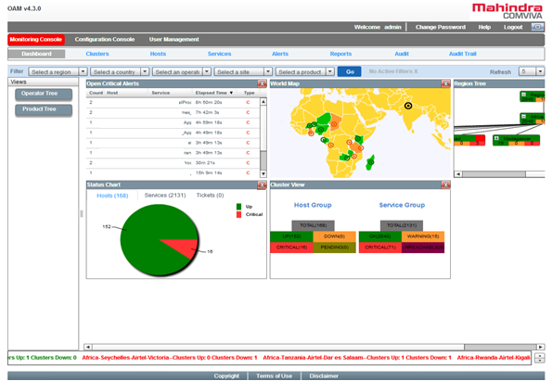
The OAM module monitors CIM nodes, modules and processes. It keeps a continuous check on the status of applications and ensures round-the-clock availability of all the applications. In the event of any of the CIM components failing, the OAM module sends an alarm to the specified list of users and also takes corrective action with respect to that specific component.
System Monitoring and Detection
OAM monitors the system level resources such as CPU, memory and disk and raises an alarm whenever configured thresholds are exceeded.
- Process Monitoring
- The OAM module monitors the integrated applications periodically (at configurable time intervals) and alerts should any application stop functioning. Following modules are monitored using OAM:
- Admin, User and CP GUI
- Charging and Provisioning
- Messaging Core
- Profiling
- USSD
- Ensures the availability of CIM modules and processes all time
- Sends alarms to the Alarm Manager about the status of Cluster, nodes and processes
- Server Load Checking: The OAM module monitors the server load and raises an alarm should thresholds be breached
- Link Monitoring
- File Size Monitoring
- The OAM module constantly monitors the CPU, disk/ partitioning and memory usage to check if any threshold has been crossed and raises necessary alarms so that corrective actions can be taken.

Hardware Utilization
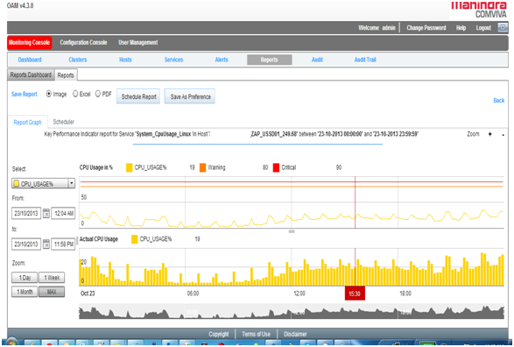
Database Monitoring
Database Monitoring provides visibility on the health of the database and includes:
- Running of activities periodically to check for DB sanity
- Database went down alarm from all modules of CIM
- Detection of errors in tables
Alarms and Recovery
It generates alarms for all system failures. The alarms are categorized on the basis of severity as follows:
- Critical
- Major
- Minor
- Clear
The OAM module has the capability to display alarms within 10 seconds of their occurrence. The alarms include the following details:
- Severity
- Affected component
- Date and time in the format <DD: MM: YYYY HH:MM:SS >
- Description of the alarm
Node Monitoring
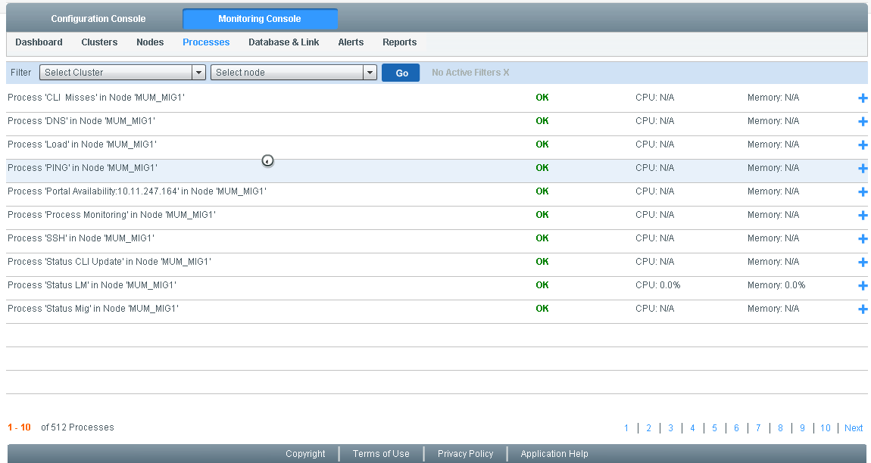
This is an independent module of the OAM, which accepts alarms from the application and forwards them to the relevant media, namely SMS, e-mail and SNMP alarms. Various types of alarms can be sent through the Alarm Manager. Different colors are specified for different types of alarms:
- Red for FATAL alarms
- Orange for MAJOR alarms
- Yellow for Minor Alarms
- Green for Clear Alarms
Alarms
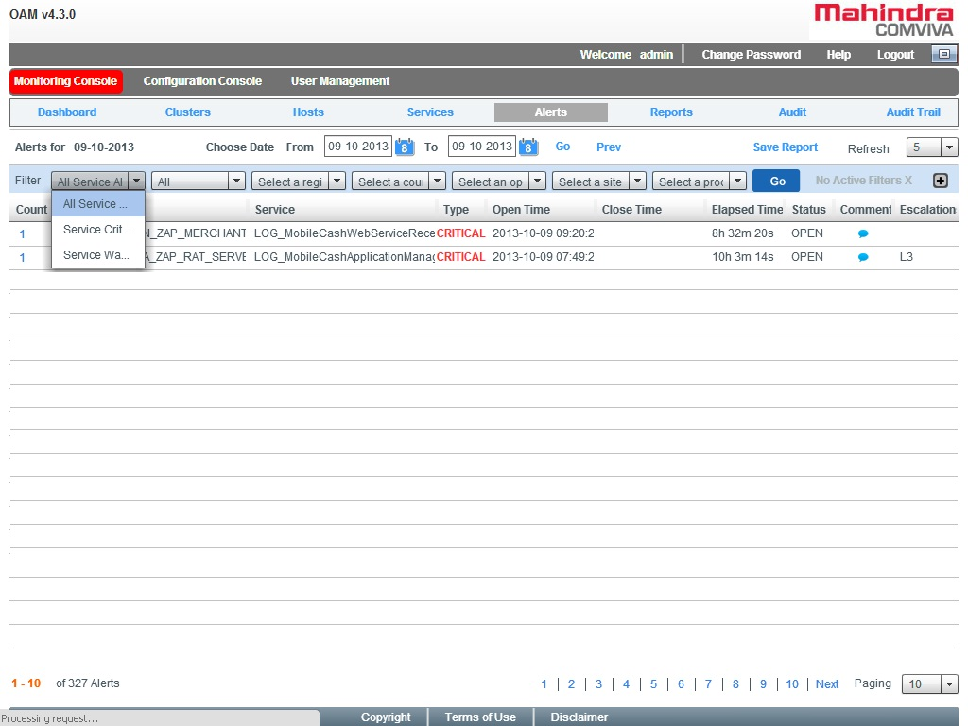
The system generates alarms upon detecting a fault in the system. This includes:
- When critical components fail to respond within an acceptable timeframe
- When critical components are restarted
- On billing transaction failures
- IM Database down
- Database Error
- SMSC Error

Project Specific Scope

RJio Specific requirements and customizations
The details will be updated post IOT sign off.

Applications (USSD)
USSD shall be deployed when RJio is ready to launch the USSD based services. USSD feature shall be discussed and agreed later during USSD deployment.

Migration Scope
Migration is out of scope.

DND functionalities
The proposed solution supports the DND functionality. There are at present 7 categories, which are listed below.
- Banking/Insurance/Financial products/credit cards
- Real Estate
- Education
- Health
- Consumer goods and automobiles
- Communication/Broadcasting/Entertainment/IT
- Tourism and Leisure
The format described below is the DND format in which, DND file is expected from RJio. The file format has two fields. First field describes the MSISDN of the subscriber and next field describes the 7 bit binary information, each bit indicates the DND preferences for each of the category opted by the subscriber. 0 means, subscriber not opted the DND for this category and 1 means, subscriber has opted DND for the category.

The SMS-GW shall fetch the DND file from RJio centralized location on periodic basis and these DND files will have only incremental data.

File format:
MSISDN, DND-PREFERENCE
Description:
MSISDN Subscriber MSISDN with CC
DND_PREFERENCE 7 bit binary data, each bit represents the subscriber preference against each category. 7 bit binary data is represented with categories in sequence; First bit represents Banking/Insurance/Financial Products/Credit Cards-1, Second bit represents Real Estate-2, Third bit represents Education-3, Fourth bit represents Health-4, Fifth bit represents Consumer goods and automobiles-5, Sixth bit represents Communication/Broadcasting/Entertainment/IT-6 and Seventh bit represents Tourism-7.
Example:
919876543210,0100100
In the above example, subscriber “919876543210” has opted DND for 2 categories, i.e. Real Estate (2nd bit) and Consumer goods and automobiles (5th bit) categories.

Charging and Billing
System support pre-paid charging over DIAMETER Ro interface towards IN and post-paid charging by using CDRs which can be pushed to billing system over FTP/SFTP, Unixplus India to share the DIAMETER Ro interface details. Below is the list of charging supported on IM platform. Only Direct debit towards Ro is part of the scope, deferred (reserve commit/cancel) debit is not part of the scope. If any such requirements in future shall be taken as customization which may have commercial implications.
Module | Charging Supported | Offered / Not Offered
SMS Charging | The Platform shall support following types of charging for SMS:  1. Charge per message  2. Visiting MSC / network for originator  3. Originator MSISDN  4. Destination MSISDN  5. Visited MSC / network for recipient  6. Notification  7. SUBMISSION  8. DELIVERY | - Offered  - Offered  - Offered  - Offered  - Offered  - Offered  - Offered  - Offered

- **Only USSD and SMSC are part of the proposed solution and USSD Charging is out of scope. Any additional charging requirements in the future shall be taken as customization which will have commercial implications as applicable.

The postpaid CDR document attached below describes the CDRs generated in the IM module for postpaid subscriber billing.

Reports and Statistics
The Integrated Messaging Reporting tool is a common interface that allows the Operators to generate pre- formatted, statistical and analytical reports with multiple filter criteria for MIS requirements. Reporting is a Web-based administrative application that is used to generate, view, and download service usage and subscription reports. It is an MIS report generation tool that allows collation of volumes of data into coherent reports.
These reports provide insight into service usage data for different channels like SMS and USSD used by the subscriber. A consolidated view of these reports allows the Operators to manage customer services, revenue generation, and sales and marketing efforts.
Unixplus IM reporting tool provides a facility for Reporting and distribution of statistics to pre-specified email addresses as per scheduled delivery timings. Additionally, Administrators can manually request for updated statistics distribution at any time.
The service administrator may specify any number of e-mail addresses as subscribers to the generated reports.
Reports are stored to the predefined directory from which they can be accessed for any processing if required. Reports can also be printed from the web-interface.
The IM reports can be downloaded in following formats:
a) MS-Excel (2003 and 2007 formats)
b) PDF
c) Doc
d) CSV
e) XML
CP Report
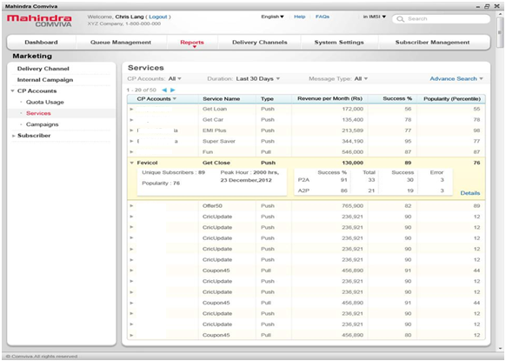

Traffic Report

Standard reports available in integrated messaging platform are attached above. Only USSD and SMSP related reports are part of the scope for Unixplus India. Any additional reporting requirements shall be considered as customizations not considered in this scope of proposal.

- ** Only USSD and SMSP related reports is part of the scope for Unixplus India. Unixplus should provide the templates for each of the reports listed above.

Logs and CDRs
RAFM or BSS system will pull the CDRS from the proposed solution. Below document describes the CDR format for the same.

Standard logs and CDR formats available in integrated messaging platform are attached above. Any additional requirements on CDR or logs shall be considered as customizations not considered in this scope of proposal.

KPI Requirements
Standard KPI reports available in integrated messaging platform are attached above. Any additional KPI requirements shall be considered as customizations not considered in this scope of proposal.

Security Requirements
Security deliverables will be as per RFP requirement or in cases of no specific security requirement from operator. Below table provides information on the security features available.
Business Requirement | Remark
Access to system (administration and CSR) controlled by the use of a username/password | Proposed solution provides the access to system with different user privileges controlled by username and password.
Authentication done to a central user information directory (MS Active directory or SSO) | Proposed solution provides the standard SOX compliance for password and user management policies.
System keeps audit trail of operations performed by users. | Proposed solution provides the audit logs for tracking the changes.
System capable of implementing strong password. (relevant if not integrated to AD) | Proposed solution supports password encryption and strong password functionality.
Access to system function controlled by roles | Proposed solution supports OAM login access level with different user privileges will be defined and restricted with access privileges for few users by Admin user.
Granular permission up to the menu level | Proposed solution provides the access level with different user privileges that can add/delete/modify the menu details.
Alert any intrusion attempt to the system | Alerts shall be provided on intrusion of OS level. Application level is not supported.
Password management capabilities; disable dormant account, auto lock account after x failed logins attempts | Proposed solution supports password management capabilities like locking the user account on configured number of failure attempts and is applicable to non admin users only.
Encryption - All administrative access to the systems should be encrypted, whether it is for running commands (SSH), file transfers (SFTP), GUI’s, etc. | The proposed solution supports the access to the Unixplus integrated messaging solution platform via GUI or FTP will be over secured interfaces and also the parameters parsed for accessing will be encrypted.
FTP Access - FTP users are allowed access only to directories which are required by the respective account | The proposed solution supports the access to the Unixplus integrated messaging solution platform via FTP and will be able to access the directories which are required by the respective account.
Adherence to Unixplus Security Policy - The implementation of application security procedures based on Unixplus security policies is required. The same will be shared during implementation phase. | Any other security compliance other than listed above will be mutually agreed with Unixplus India during scope closure.

- **The security certificates like HTTPS/SSL/SFTP as required shall be procured by Unixplus India.

Data Retention, Archiving and Cleanup
- 7 days for transactions online reports is proposed in the solution.
- 7 days uncompressed EDRs and 3 days of compressed EDRs are proposed in the solution.
- 2 days of uncompressed logs and 5 days compressed logs is proposed in the solution.
- Unixplus India shall take the backup of the data into the Unixplus storage, if the data to be retained post the proposed retention period.

Backup and Restore
Unixplus provides the backup & restores processes, for the system, which has been implemented. The following processes are covered under the Backup and Restore function. Detailed procedure will be shared at the time of implementation.
- Backup & Restoration of executables & configuration files.
- Backup & Restoration of log files.
- Backup & Restoration of database.
- Configuration of Environment Variables.

Implementation and Services
Below is the implementation plan and services.
Tasks | Responsibility | Remarks
Site readiness | Unixplus India | This should be ready before the installation starts
Installation | Mahindra Unixplus | It will be done onsite as well as remotely, whichever is possible
UAT | Unixplus India / Mahindra Unixplus | It will be a shared responsibility.
System Migration | Unixplus India / Mahindra Unixplus | It will can be done remotely or onsite
System Monitoring | Mahindra Unixplus | As per the project scope, system monitoring will be done remotely.

SLA
Related support SLA document applicable for Unixplus IM is shared separately along with the proposal.

Training
After the completion of Acceptance Testing, Unixplus Project Team shall provide Training to designated operator personnel for 3 days in English Language. Training material will be provided by Unixplus in English. Refer training agenda document for more details on the trainings and the scheduled applicable for this, and will be shared post UAT.

Documentation
Unixplus shall provide the following documents at the time of product deployment.
  - PDD
  - OAM Manuals
  - Installation Manual
  - User Manual
  - Training PPT (Overview, Web operations and OAM)

Testing and Acceptance

System Integration Testing
The integration testing shall be done with network nodes and content providers with the protocols mentioned in the section 3.3.10. System integration testing should include the integration with all the mentioned network nodes and testing the message flow is part of the scope.

User Acceptance Procedure
The UAP document will be shared separately, which will include the exit criteria for the project.

Assumptions, Pre-requisites and Dependencies

Major Assumptions and Constraints
            - SIGTRAN network type is considered.
            - Features and functionalities mentioned in the section 2.7 are part of the scope. Any deviation or changes or new additional features required in the future shall be taken as customization, which may have commercial implications.
            - Integration details mentioned in section 3.2.4 are part of scope, if any new interface requirements in future shall be considered as Change Request which may have commercial implications.
            - Integration with external elements or network nodes shall be done with the external element’s or network node’s versions mentioned in section 3.2.4, any changes or upgrades of these elements and nodes in future shall impact the proposed solution and the same shall require re-dimension of hardware, software & customization and/or upgrade of the proposed solution may required to support the same. And this may involve commercial implications
            - DR site is proposed in active-passive setup with N+1 across the site.
            - MT traffic from off-net will not come to SMS and Antispam is not applicable for off-net traffic.
            - A-party and B-party number in Cloudmark requests will be sent prefixed with LRN, so A-party and B-party MNP dip shall be done before Antispam
            - Only Direct debit towards OCS (Ro interface) is part of the scope, deferred (reserve commit/cancel) debit is not part of the scope. If any such requirements in future shall be taken as customization which may have commercial implications.
            - Hardware components, mentioned in the BoQ shall be procured by Unixplus.
              - Hardware is dimensioned for N+1 redundancy, other than backup drives and storage controllers.
            - 3rd party software components, mentioned in the BoQ shall be procured by Unixplus. Below is the list of sample, not limited to, 3rd party software components.
              - RedHat OS 6.x with 64 bit
              - Oracle 12c Enterprise license with columnar DB support
              - Aricent NextGen SIGTRAN+SS7 stack with (MAP+CAP) support
              - LCN DIAMETER Messaging Stack
              - LCN DIAMETER Charging Stack
              - Auto switch over (Global-VIP switch over) license from LB vendor for GR.
            - SSL Certificates as required by the security modules shall be procured by Unixplus.
            - Integration with existing services on Unixplus proprietary interface is in scope as part of the services migration.
            - No changes in stack (SIGTRAN). If any such requirements in the future shall be taken as customization, which may have commercial implications.
            - VGT (Virtual GT) support from STP for GR switch over.
            - Maximum expected delay from the network elements (including MNP, Charging, SRI_SM and Cloudmark) is 3 sec for MO request response. Any further delay from the network will degrade the performance of the system.
            - Maximum Dialogs supported is 1,20,000 per node. Any further dialogs on the system will degrade the performance of the system.
            - Jio network nodes (routers and switches) support BGP.
            - Network and External nodes, as listed below, will support the required TPS from SMSC.
              - IP-SM-GW
              - STP
              - HLR
              - OCS
              - Cloudmark
              - MNP-DB
              - NMS
              - ESMEs/CPs
            - No CP/EMSE wise customizations as part of the proposed solution. If any such requirements in the future shall be taken as customization, which may have commercial implications.
            - The following are the key assumptions used for storage dimensioning:
              - 7 days for transactions online reports is proposed in the solution.
              - 7 days uncompressed EDRs and no compressed EDRs are proposed in the solution.
              - 7 days of uncompressed logs and no compressed logs is proposed in the solution.
              - Unixplus India shall take the backup of the data into the Unixplus storage, if data need to be retained post the proposed retention period.
              - The standard CDR format available is considered in the Scope of work.
            - IM (SMSC and USSD) standard set off reports are part of the scope and any other report requirements are out of scope of the current solution offering.
            - 3 VLANS are considered - 1 for SIGTRAN, 1 for Traffic + management and 1 for OAM
            - Any new addition of VASP assumes that there would be no changes in the interfaces and call flows from what is offered as part of the Unixplus solution. Any changes in terms of data migration from old system, call flows or interface specifications would be out of scope and treated as CRs.
            - Any application specific proprietary protocols/interfaces shall be considered as customization with commercial impact.
            - All documentation shall be provided in English.
            - Unixplus India will provide VPN Access to the systems for Remote Technical Support.
            - Unixplus India will provide access to Unixplus and partner’s personnel with basic logistics and support in the premises during implementation activities.
            - BGP routing for LB failovers shall be taken care by RJIO team.
            - Signaling routing to primary site and failover site shall be taken care by RJIO Team.
            - For DR site, GT shall remain same during the failover of any site however PC shall be different.
            - There shall not be any disconnection, packet loss, and delay between the sites. In case of such scenarios, DB sync shall be impacted.
            - Occasionally due to network latency two sites may go out of sync.
            - Data corruption/loss due to H/W failure is outside the scope of GR solution
            - For point 31, 32 and 33 manual intervention is required.
            - Only DB configuration data shall be synched between sites.
            - No real-time transaction data shall be synched between sites.
            - The SMS which are in queue/RAM will be lost.
            - Once GR is invoked, all outstanding transactions will be lost.
            - Reports for GR site shall be available on DR site setup.
            - All third party systems like Cloud mark, MNP etc shall take care of data sync in case of DR fail over.
            - If retry SMSs and other transaction details stored in DB are not lost then, these messages can be processed, if validity is not expired and retry is configured, once the dead site comes up.

Pre-requisites & Dependencies
Below are the list of pre-requisites and dependencies
            - Require the call flow and the integration details for the existing applications.
            - Pre-requisites from STP
              - Support of two DPC per GT, primary DPC and secondary DPC
              - Support of routing traffic to DR site @Nagpur based on the secondary DPC of the GT.
              - Support of blocking the traffic route on secondary PC, if ASPIA received from SMSC for secondary DPC.
              - Support of restriction of traffic routing from one STP to other mated pair STP cluster, where DR traffic is being served, for same DPC, when DR is invoked for one site.
              - Support of traffic route on secondary DPC, if ASPAC received from SMSC for the secondary DPC, applicable only on site failure.
            - Below details need to e shared before commencing implementation. Assuming, all documents will be received before commercial closure, If any changes or new release to the below details post commercial closure will be taken as CR, which may have commercial implications.
              - PDD for Cloudmark Content Filtering solution along with feature list.
              - DIAMETER interface API details for Cloudmark integration
              - DIAMETER Ro interface API details for OCS integration
              - ENUM interface API details for MNP integration
              - Product release version and vendor details, which SMSC will integrate
                - IP-SM-GW
                - Cloudmark Content Filtering
                - STP
                - OCS
                - MNP
                - NMS
                - ESMEs/CPs
- Number of CPs/EMSEs will be integrating with SMSC
- Min and Max sessions allowed per ESME.
                - Integration with any other network elements, if any.
              - SIGTRAN network architecture diagram
            - Required Bandwidth between GR sites for data synchronization.
            - Hardware components, mentioned in the BoQ shall be procured by Unixplus.
              - Hardware is dimensioned for N+1 redundancy, other than backup drives and storage controllers.
            - 3rd party software components, mentioned in the BoQ shall be procured by Unixplus. Below is the list of sample, not limited to, 3rd party software components.
              - RedHat OS 6.x with 64 bit
              - Oracle 12c Enterprise license with columnar DB support
              - Aricent NextGen SIGTRAN+SS7 stack with (MAP+CAP) support
              - LCN DIAMETER Messaging Stack
              - LCN DIAMETER Charging Stack
              - Auto switch over (Global-VIP switch over) license from LB vendor for GR.
            - SSL Certificates as required by the security modules shall be procured by Unixplus.
            - VGT (Virtual GT) support from STP for GR switch over.
            - Operator shall provide L3 Switch/Router/Firewall and other infrastructure facilities.
            - Jio network nodes (routers and switches) support BGP.
            - Items to be provided by Unixplus India
              - Required hardware, 3rd party software and/or virtual platform.
              - IP addresses – IP subnet needs to be provided to the Unixplus platform
              - E1s – Signaling and Media E1s need to be provided by the Unixplus India
              - Power, E1 and LAN Cables – The cables need to be provided till the rack where Unixplus platform shall be installed.
              - VPN Connectivity to the Platform – Operator needs to provide connectivity to Unixplus platform so that remote debugging and maintenance is possible.
              - Configuration Values for Point Codes, CIC to be provided.
              - Unixplus India Personnel at site to complete Link Testing
            - Unixplus India to provide access to Unixplus and partner’s personnel with basic logistics and support in the premises during implementation activities.
            - To support 3rd party proprietary interface, Unixplus requires interface details along with application logic, call flows and sample request and response details from Unixplus India.

Risks, Impact and Mitigation
- If sufficient bandwidth is not allocated between the sites, then there could be latency on live traffic and this may impact the service and QOS.
- Routing from network side need to be taken care by Unixplus India.
  - Signaling traffic
  - LAN traffic

Responsibility Matrix
S. No. | Action description | Responsibility
1 | Statement of Work Preparation
2 | SOW Signoff
3 | User Interface flow Preparation
4 | User Interface flow Signoff
5 | Final Project Plan Preparation
6 | Project Plan Signoff
7 | User Acceptance Plan preparation
8 | User Acceptance Plan review & approval
9 | Pre- Installation Checklist preparation and deliver to Unixplus
10 | Site Preparation for software deployment
11 | DB Installation for development and live setup.
12 | Public and Private IP assignment for the servers, white-listing of SMSP in <Operator> Network for development and live setups.
13 | Application Installation by Mahindra Unixplus for development and live setup.
14 | Connectivity with different network node
15 | Availability of MSISDN number of the subscriber in each request to SMSP Server.
16 | Availability of external interfaces with usage details to connect to different network node.
17 | SMSP software Installation and configuration
18 | User Manual preparation
19 | System Training (Functional & Operational) - Administration Management
20 | User Acceptance Plan Execution i.e. User Acceptance Testing (UAT)
21 | User Acceptance Signoff
22 | Post Launch Monitoring

Out of Scope
- Any features or functionalities not mentioned in this scope / solution document are to be considered as out of scope.
- Below points are out of scope with respect to Antispam solution and if any such requirements in future shall be taken as CR (Change Request), which may have commercial implications.
  - Analysis of spam/spoof.
  - Daily monitoring on the traffic
  - Applying new filters, based on spam analysis.
  - Ad-Hoc report generation around the traffic patterns/spam/spoof
  - Consulting services to come up with the findings and recommendations
- Below points are out of scope with respect to USSD solution and if any such requirements in future shall be taken as CR (Change Request), which may have commercial implications.
  - Customized Reports
  - Apps/Service configuration
  - Menu changes/configuration
  - 3rd party/CP Integration
- Below points are out of scope with respect to SMSC solution and if any such requirements in future shall be taken as CR (Change Request), which may have commercial implications.
  - Any non-standard interfaces (beyond the list of interfaces supported by existing version of Unixplus)
  - CP/Enterprise Addition, Creation, Modification, Migration and Integration
  - Any customized Reports beyond the standard reports
- If any Interface from Unixplus IM solution to Unixplus India network element is application specific, interfaces other than mentioned in the section 3.2.4, then the same shall be supported considering it as customization which impacts commercial for the additional development efforts to support the proprietary interface.
- Legacy CP/applications migration are not considered as part of this proposal, new applications/CP integration over Unixplus proprietary interfaces is part of the current proposal.
- Charging requirements, other than mentioned in the section 3.3.5, are not part of the scope and if any such requirements in future shall be taken customization with commercial impacts.
- The reports and statistics are supported as mentioned in the section 3.3.6. Any additional changes or new reports support is out of scope and if any such requirement in future shall be taken customization with commercial impacts.
- The logs and edrs are supported mentioned in the section 3.3.7. Any additional changes or new cdr and edr formats support is out of scope and if any such requirement in future shall be taken customization with commercial impacts.
- The KPIs are supported as mentioned in the section 3.3.8. Any additional changes or new KPI support is out of scope and if any such requirement in future shall be taken customization with commercial impacts.
- The IM platform security requirements are supported mentioned in the section 3.3.9. Any additional security requirements or changes in the security requirements are out of scope and if any such requirement in future shall be taken customization with commercial impacts.

Document Change History

Table : Document Change History
Version Number | Description of Changes | Date | Comments
1.0 | Initial Document | 12th June 2015 | Lohitkumar K B
Source: UnixplusTM

Others have estimated increases in SMS revenues from 2012 to 2016, delivering a cumulative 1 trillion in operator revenue during that five-year period, Infonetics
Verizon Messages was launched in early 2013, and received the "Best of Show" award at CITA 2013, PC Mag

