Airtel Africa Mobiquity Offsite backup and data archival

Contents

Contents - 3 -
1. Proposed Architecture - 4 -
2. Proposed BOM - 7 -
Contact Us - 11 -

Confidentiality Statement
Copyright © 2009, Mahindra Comviva Technologies Limited. All rights reserved. This product or document may not, in whole or in part, be copied, photocopied, reproduced, translated, or reduced to any electronic medium or machine readable form, by any means electronic, mechanical, photographic, optic recording or otherwise without prior consent, in writing, of the copyright owner. Statutory declaration under section 52A of the Copyright Act 1957

1. Proposed Architecture

Diagram:

Option 2

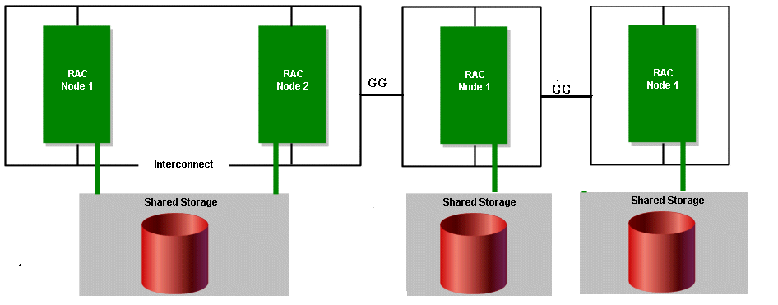
  - PRIMARY DB SERVER:

  - The production database is configured with Oracle 11g RAC / cluster environment using two db nodes for active/active architecture .
  - All the database physical components are redo logs, control files and datafiles, archive logs are stored on external storage .
  - Storage was maintained by Oracle ASM (Automatic Storage Management).
  - Scan name / IP has been configured in database servers to make connection to the production database servers from application and web servers.
  - Three months (Current plus Last two months ) data retention policy will be maintained in the production database as per client requirement.
  - Tape and storage base backup policy has been implemented.

  - STANDBY/REPORTING DB SERVER:

  - The standby server is configured on single node with Oracle RAC 11g.
  - All the database physical components are redo logs, control files and datafiles, archive logs are configured on external storage .
  - Storage was maintained by Oracle ASM (Automatic Storage Management).
  - Replication from primary server to standby server will be done by Golden Gate technology with one directional replication .
  - Three years data retention policy will be maintained in the standby /reporting database as per client requirement.

Oracle Golden Gate is a comprehensive software package for enabling the replication of data in heterogeneous data environments. The product set enables high availability solutions, real-time data integration, transactional change data capture, data replication, transformations, and verification between operational and analytical enterprise systems.

The Oracle GG will be implemented to maintain data integrity and it will take care and manage data replication between the primary and standby/reporting database .

All kind of reports would be generated from the reporting database from web server and client base tool .

  - ARCHIVE/HISTORY DB SERVER:

  - The archive/history server is configured on single node with Oracle RAC 11g.
  - All the database physical components are redo logs, control files and datafiles, archive logs are configured on external storage .
  - Storage was maintained by Oracle ASM (Automatic Storage Management).
  - Replication from standby to archive/history db server will be done by Golden Gate technology with one directional replication .
  - Fifteen years data retention policy will be maintained in the archive/history database as per client requirement.

As per our product requirement two database schema usually configured and created for transaction purpose where more than 600 objects are created like tables, indexes, views, synonyms etc. Among all application objects only some of the important transaction tables are partitioned and purged according to client requirement in the production database.

To maintain 2+1 month retention policy in the production database , The purging process which we perform in every month end won’t replicate and affect to standby server and archive/history db server that will keep and maintain data retention policy for 3years at stnadby and 15 years at archive database server by Golden Gate technology .

In similar fashion the purging process which we perform on standby server after keeping data of 3 years at standby db server won’t replicate and affect to Archive db server by Golden Gate technology .

We need to disable and enable the DDL/DML operation in oracle GG at standby and history database server during the implementation stage to maintain the retention policy as per the requirement .

2. Proposed BOM

1) | Logs Size
 | TPS |  |  | Raw Space
 | For 25 TPS |  |  | 10 TB
 | For 50 TPS |  |  | 20 TB
2) | Production Database |  |  | Raw Space
 | For 25 TPS |  |  | 5TB
 | For 50 TPS |  |  | 10TB
3) | Reporting Database |  |  | Raw Space
 | For 25 TPS |  |  | 10TB
 | For 50 TPS |  |  | 20TB
4) | Archival Database |  |  | Raw Space(15 years)
 | For 25 TPS |  |  | 53TB
 | For 50 TPS |  |  | 101TB

Disk Sizing
1) | With 25 TPS (Log size, production database & reporting database)
 | Total space required is 25 TB
 | 28 x 900 GB SAS
2) | With 50 TPS (Log size, production database & reporting database)
 | Total space required is 50 TB
 | 56 x 900 GB SAS
3) | With 25 TPS (DB Archival)
 | Total space required is 53 TB
 | 60 x 900 GB SAS
4) | With 50 TPS (DB Archival)
 | Total space required is 101 TB
 | 114 x 900 GB SAS
Optional
Disk Sizing Of Archival database with 2TB SATA
1) | With 25 TPS (DB Archival)
 | Total space required is 53 TB
 | 25 x 2TB SATA
2) | With 50 TPS (DB Archival)
 | Total space required is 101 TB
 | 50 x 2TB SATA
BOM
1) | Functional Bill of material for upgrade of 25 TPS(Log size, production database & reporting database) (25TB)
 | Part number | Description |  | Qty
 | DS2246-10.8TB-QS-R5 | DSK SHLF,12x900GB,6G,QS |  | 2
 | X423A-R5 | DSK DRV,900GB,10K,2.5",DS2246, |  | 4
 | X6561-R6 | Cable,Ethernet,2m RJ45 CAT6 |  | 4
 | X5526A-R6 | Rackmount Kit,4-Post,Universal,R6 |  | 1
 | X800K-R6 | Power Cable India,South Africa,R6 |  | 2
 | X6536-R6 | Cable,Cntlr-Shelf/Switch,5m,LC/LC, |  | 2
2) | Functional Bill of material for upgrade of 50 TPS(Log size, production database & reporting database) (50TB)
 | Part number | Description |  | Qty
 | DS2246-21.6TB-EN-R6 | DSK SHLF,24x900GB,6G,EN,-C |  | 1
 | DS2246-10.8TB-QS-R5 | DSK SHLF,12x900GB,6G,QS |  | 2
 | X423A-R5 | DSK DRV,900GB,10K,2.5",DS2246, |  | 8
 | X6561-R6 | Cable,Ethernet,2m RJ45 CAT6 |  | 4
 | X5526A-R6 | Rackmount Kit,4-Post,Universal,R6 |  | 3
 | X800K-R6 | Power Cable India,South Africa,R6 |  | 6
 | X6536-R6 | Cable,Cntlr-Shelf/Switch,5m,LC/LC, |  | 8
3) | Functional Bill of material for new storage 25 TPS(DB Archival) (53TB)
 | Part number | Description |  | Qty
 | F2240A-2-24X900-R5 | FAS2240-2,HA,24x900GB,Dual CTL |  | 1
 | DS2246-10.8TB-QS-R5 | DSK SHLF,12x900GB,6G,QS |  | 2
 | X423A-R5 | DSK DRV,900GB,10K,2.5",DS2246, |  | 2
 | X6561-R6 | Cable,Ethernet,2m RJ45 CAT6 |  | 6
 | X5526A-R6 | Rackmount Kit,4-Post,Universal,R6 |  | 3
 | X800K-R6 | Power Cable India,South Africa,R6 |  | 6
 | X6536-R6 | Cable,Cntlr-Shelf/Switch,5m,LC/LC, |  | 4
 | X1150A-R6 | CARD Mezzanine 2-port 8G FC |  | 2
 | Softwares
 | SW-CIFS-C | SW,CIFS,-C |  | 2
 | SW-FCP-C | SW,FCP,-C |  | 2
 | SW-ISCSI-C | SW,iSCSI,-C |  | 2
 | SW-NFS-C | SW,NFS,-C |  | 2
4) | Functional Bill of material for new storage 50 TPS(DB Archival) (101TB)
 | Part number | Description |  | Qty
 | FAS3220A-BASE-R6 | FAS3220 HA System with Dual Controllers |  | 2
 | DS2246-21.6TB-EN-R6 | DSK SHLF,24x900GB,6G,EN,-C |  | 3
 | DS2246-10.8TB-QS-R5 | DSK SHLF,12x900GB,6G,QS |  | 2
 | X423A-R5 | DSK DRV,900GB,10K,2.5",DS2246,
 | X6553-R6-C | Cable,Cntlr-Shelf/Switch,2m,LC/LC,Op,- |  | 16
 | X6559-R6-C | Cable,SAS Cntlr-Shelf/Shelf-Shelf/HA, |  | 12
 | X6560-R6-C | Cable,Ethernet,0.5m RJ45 CAT6,-C |  | 6
 | X6562-R6-C | Cable,Ethernet,5m RJ45 CAT6,-C |  | 14
 | X1132A-EN-R6-C | ADPT 4-Port FCP 8Gb Target Adapter PCIe,EN,-C |  | 2
 | X5526A-R6-C | Rackmount Kit,4-Post,Universal,-C,R6 |  | 6
 | Softwares
 | SW-FCP-C | SW,FCP,-C |  | 2

BOM for offsite backup
S.no | Description |  | Qty
1 | Server 2 CPU 4C , 32 GB RAM and 8*900 GB |  | 1
2 | Symantec Backup exec 12 .0 for Linux |  | 1
3 | Tape Library T 3100 |  | 1
4 | Data cartridge -20 No for LTO 5 |  | 1
5 | Cleaning cartridge |  | 1

