Introduction

In today's world corporate 24x7xForever uptime environment, a practical Disaster Recovery (DR) solution must fulfill the following objectives:
- Address all potential disasters including sudden outages and rolling disasters
- Achieve established recovery time objectives (RTO) and recovery point objectives (RPO)
- Provide effective data protection during each phase of DR: pre-, during, and post-disaster

Power failures, fire, flood, etc., can cause sudden unplanned outages that wreak havoc on day-to-day operations.

Assumption

- Two sites – Primary and Standby (DR) site shall be configured on different geographical location
- Standby site shall act as Primary site incase of DR
- Establish recovery time will be 15-60min
- Standby site will be 100% similar to the Primary site

Pre-requisite

- Availability of connectivity with external systems like SMSC, IN, Billing system, VAS platforms at Primary and Standby site
- Availability of network connectivity between Primary site and Standby site
- Availability of adequate bandwidth between Primary site and Standby site to synchronization of storage. For 1Million transaction a day, data size of 5GB (approx) will get changed on storage on daily basis (excluding archive log files). In Peak hour data size changes would be 1 GB
- Availability of Same H/W on Primary and Standby Site
- Availability of Storage level replication option

Hardware

The same set of hardware will require on Primary and Standby Site to configure equally transaction capable site

Current System Architecture

PreTUPS system comprises of
- Application Servers (N+1)
- Database Servers, MIS/Reporting Database Server
- Web Servers/Load Balancer
- Backup sever
- SMSC, IN system
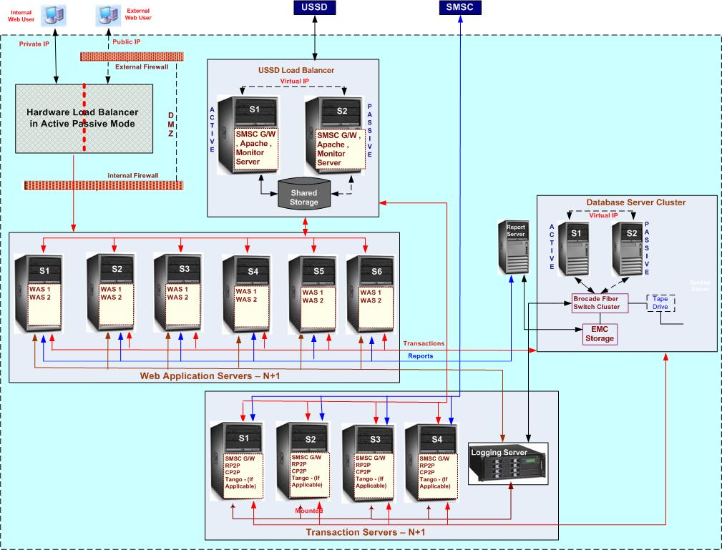
Current System Architecture Diagram

Proposed System Architecture - DR

The PreTUPS application shall be configured on two sites with active (Primary) and Standby site (DR). Each site shall be configured to run the application with 100% capability/functionality. Standby site shall act as primary site in case the primary site crashes or is not functional.

DR strategy for various PreTUPS system components shall be as following

Application Servers
- PreTUPS application servers shall be pre-installed in DR Site
- Connectivity with various network elements like (IN systems, SMSC, billing system, VAS platforms) will be pre-established on DR-Site but shall not be activated. The connectivity shall be activated only when DR site is made primary site.

Application servers process the request however the transactions are recorded on database. In case of DR, the application logs shall be started afresh.

Database Servers
A database change for every transaction is recorded on primary site and it’s requiring to replicate to standby site. There are following option are available to replication the database changes.

Option 1 : Data Guard
Oracle provides technology to manage the standby database by using data guard, a changes of every transaction recorded in primary database gets replicated on standby site automatically. Data guard has capability to create, maintain standby databases to enable production databases to survive disasters and data corruptions - if the production (primary) database becomes unavailable because of a planned or an unplanned outage, application can switch to standby database to the production role, thus minimizing the downtime associated with the outage.
Synchronous and asynchronous replication options are available. In asynchronous replication options, standby site (DR) is lagging behind the content at the primary site by 15-30min with the possibility of the loss committed business transactions.

Reference Site - BTSL has successfully implemented DR solution using Oracle Data Guard at Orange, Ivory Coast.

License Requirement – Oracle Software license will be required on DR site. For Sun M5000, 8 CPU dual core, 12 qty Oracle license shall be required.

A dedicated DBA is required to maintain the DR site.

Option 2: Storage Level Replication Option
Storage level option, EMC-MirrorView supports the propagation of data between EMC (CLARiiON) storage systems at separate locations. Remote storage (DR) mirroring facilitated recovery in the event of failure affecting the server or the production system. Synchronous and asynchronous replication options are available.
Synchronous and asynchronous replication options are available. In asynchronous replication options, standby site (DR) is lagging behind the content at the primary site by 15-30min with the possibility of the loss committed business transactions.

A dedicated storage administrator is required to maintain the DR site.

License Requirement – Storage replication software Mirrorview shall be required.

Bandwidth requirement for 4.5Million transaction a day

Oracle Data Guard
50Mbps of redundant link between primary and standby site (DR), latency not more than 10milli seconds. 10 GB data transfer is required during the peak business hours.

Storage Level Replication Option
Dark Fiber

BTSL has not conducted the POC for Storage level replication. BTSL is also exploring the other data replication software like SharePlex.

Backup
Separate set of backup servers shall be configured for DR site.

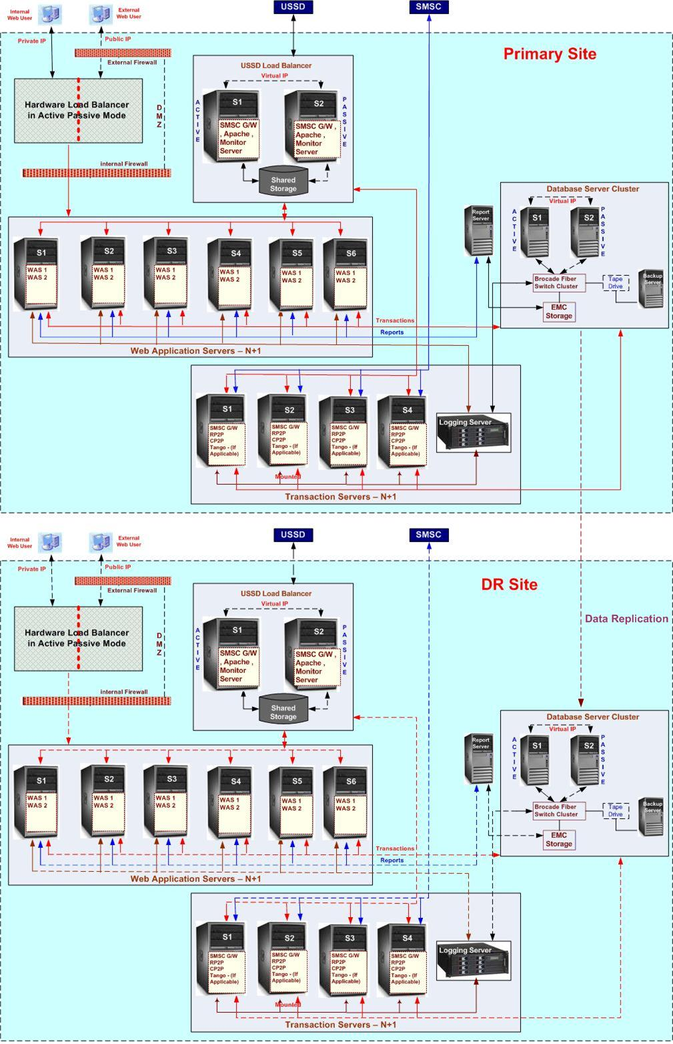
Primary and Proposed Standby Site Architecture Diagram (DR)

Disaster Recovery Approach

Scenario – Primary Site Down: Standby Site acts as a Primary Site
Following steps shall be performed manually
- Ensure that DR site data is up to last committed transaction. If it’s not the case, a call needs to be taken to start DR site.
- In case of Data Guard -Start the database of Standby Site
- In case of storage level replication option – Stop the replication and start the database
- Start application service of Standby site and stop the application of primary site (if available)
- When DR application server connect to SMSC, SMSC shall send requests to Standby Site (DR)
- Route the Public IP of Web to Web server on Standby Site (DR)

- In case of standby site (DR) is lagging behind the content at the primary site with the possibility of the loss committed business transactions

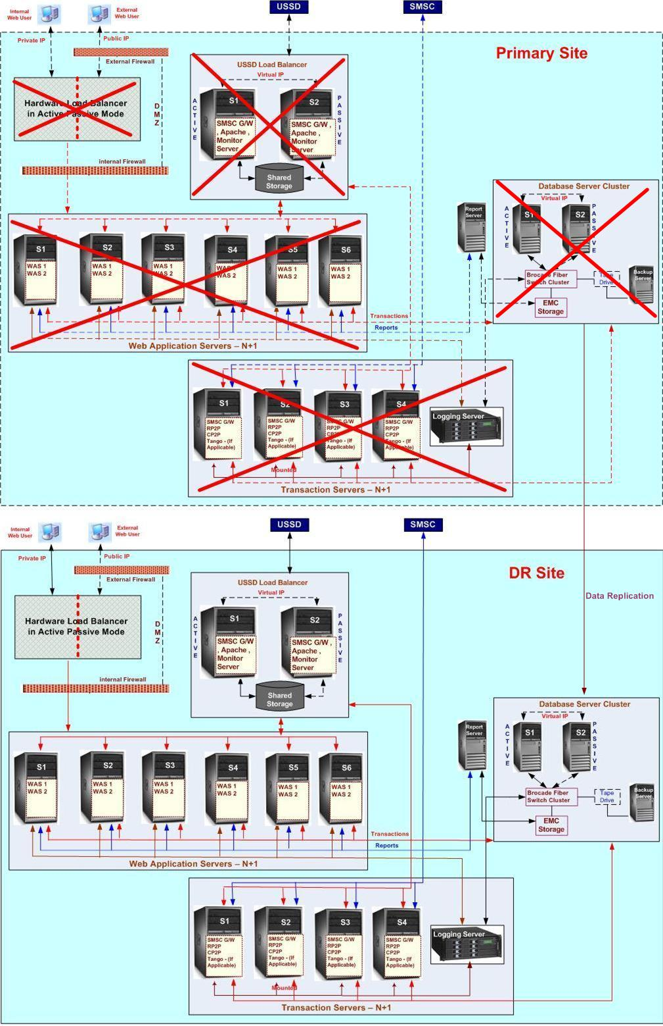
Failover Architecture diagram

Scenario – Primary site up, Standby site switch to Primary site
Following steps shall be performed manually
- Stop the application server of Standby Site
- Stop the database of Standby Site
- In case of Oracle Data Guard, Primary and standby database is require to configure
- Sync the database storage from Standby site to Primary site
- Start the database of Primary site
- Start the storage level replication from Primary site to standby site
- Start the application of Primary site and connect to SMSC(SMSC shall send requests to Primary Site)
- Route the Public IP of Web to Web server on Primary Site

Implementation Strategy
Install the Application, database, storage, and web server on standby site
Open the network connectivity with various network elements like (IN systems, SMSC) to application server
Install the application
Create the test database
Test the application using simulator
For Database Replication - Oracle Data Guard
- Stop the production application
- Take a database cold backup
- Move the cold backup at DR site
- Configure the Oracle Data Guard – Setup the replication between primary and standby site
Start the application

For Database Replication – Storage level replication option
Install the replication software on production site
Set the replication between Production and Standby site
Start the application

A detail activity plan shall be created after finalizing the SOW.

UAT
Oracle Data Guard and storage level replication option provides the option to test the replication.
Following test case can be performed to test the replication
Test Cases
- Stop the application at primary site
- Generate the user balance report at primary site
- Wait 15 to 30 min
- Open the database at standby site
- Generate the user balance report at standby site
Success Criteria- Primary and standby site report should match
- Shutdown the database at DR site and resume the replication
- Start the application at primary site

Reference
Annexure A (Host level Replication)

Annexure B (Storage level replication).

